Activity 8.1.1 Borders in Cultures
Materials: Miras, transparent / tracing paper

Around the world and across time people have strived to increase the beauty of buildings, fabrics, woven baskets, belts, pottery, jewelry, and other objects where there could be a border. In architecture a border is sometimes called a frieze. Often such designs have repeating elements that make them more appealing, coherent, rhythmic, and manageable to construct. There are several examples from different cultures, eras, and locations below and on the next page.

Human creativity can produce an infinite number of such border designs. However, to mathematicians or artists who look at the structure of a design, there are just a very small number of types. Study the dozen designs below.

- In what ways are they all alike?
- In what ways are some different from others?

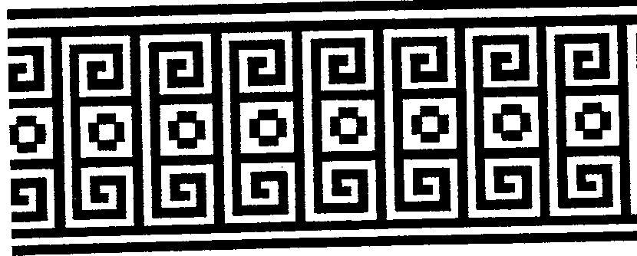
A. Greece
(Hargittai, p. 136)

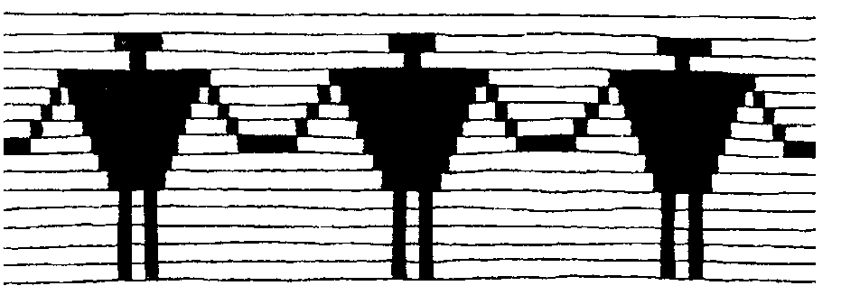
B. Onondaga (Native North America)
(Hargittai, p. 138)

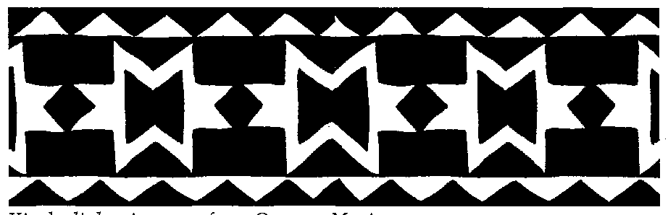

C. Oaxaca, Mexioc
(Hargittai, p. 138)

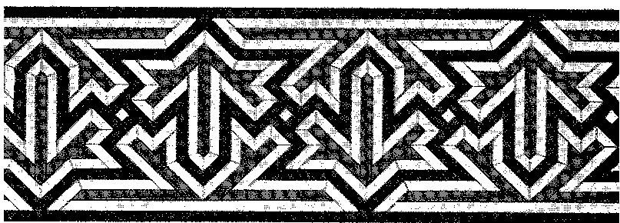
D. Arabic wall mosaic
(15th-16th centuries)
(Hargittai, p. 139)
E. Iran (Persia)
(Hargittai, p. 140)

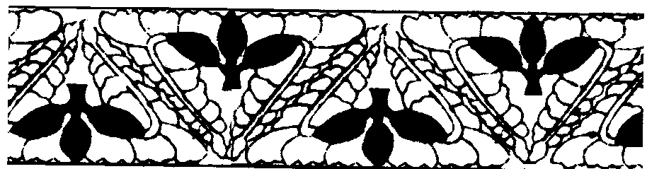
F. Japan
(Hargittai, p. 141)

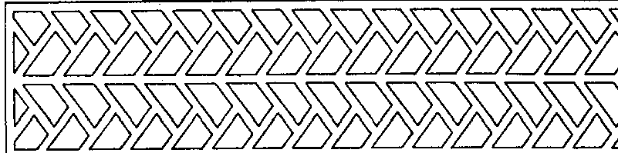

G. Szechwan province
China (Hargittai, p. 142)

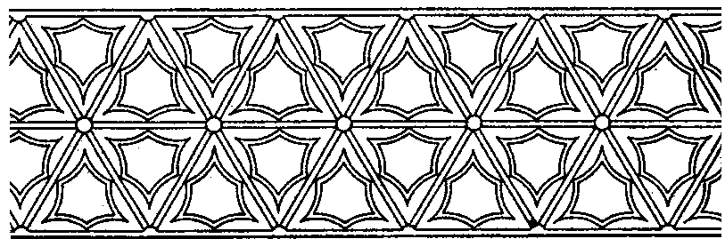
H. Chekiang province
China (Hargittai, p. 142)

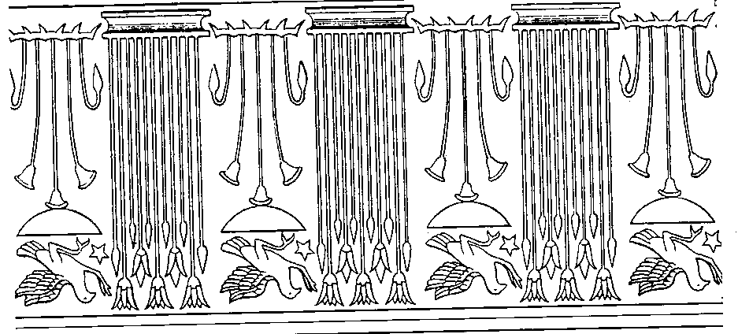
I. Ancient Egyptian temple
(Harigittai, p. 137)

J. Mozambique
(Gerdes, p. 140)

K. Basari (Senegal)
(Gerdes, p. 137)
L. Mexico
(Harigittai, p. 138)
In questions 3 and 5 use your mira.
- Find designs that have a horizontal line of symmetry. [You can place a mirror midway along the strip and see the top and bottom reflected on each other]
- Is it possible for a design to have more than one horizontal line of symmetry? Explain.
- Find designs that have a vertical line of symmetry. [You can place a mirror vertically through the design and the left and right parts are reflections of each other.]

- If a design has one vertical line of symmetry, must it have more than one? Explain.
- For which designs can you find rotations of 180 degrees (half-turn symmetry)? Use tracing paper to trace one part that you see repeating. Then find a center for the rotation, make the half-turn and see whether the tracing falls on its image.
- If a design has one center of 180° rotation, must it have more than one? Explain.
- Is there any design without any mirror symmetry or half-turn symmetry but that still seems to repeat itself? In this group, are some more special than others? Try to describe how each type repeats.

References

Gerdes, Paulus. Geometry from Africa: Mathematical and Educational Explorations. Washington, D.C.: Mathematical Association of America, 1999.

Harigittai, István and Magdolna Hargittai. Symmetry: A Unifying Concept. Bolinas, CA: Shelter Publications, 1994.

