**Activity 8.3.5 Matrices and Cable Television**

Have you even turned on your television and flipped to a channel you don’t pay for, hoping to see a cool movie or PayPerView event? How is it that the person next door to you is able to watch HBO but you are not? It is all based on matrices.

In its simplest form, cable (and satellite) televisions providers use the same basic process to allow or restrict you from viewing certain content. Every household is fed the same content, but only some families have the key to unlock that content. In this case, matrices are used to encrypt and decipher this content stream so you can have access to certain channels. Cable companies digitally supply these keys directly to the modem or television box without you even realizing it. That’s what makes it so easy to simply call and change you cable package…instantly you have access because they can very quickly send you the deciphering code.

Let’s consider a very simplistic version of this. Pretend that the content that we want to send is the simple message “Thank You”. As we know, digital signal is just a bunch of numbers that are streamed, so we are going to change my message into numbers, using a common cipher called the letter-number cipher. It assigns the letter A, the number 1, B gets 2, C gets 3…, Z gets 26 and a space gets 0. So, Thank You converts to 20-8-1-14-11-0-25-15-21. As we have learned, matrices are a way of arranging numeric information, so we are going to create a 3 x 3 matrix to store these numbers. We will call this matrix A.



Clearly, this is not a very secure code. In fact, it hasn’t even been encrypted yet. The encryption matrix, B, is used to change this data into an encrypted form. Without knowledge of the encryption matrix, it would be really hard to figure out the message. We can choose any matrix that can be multiplied by matrix A. However, since we are going to want to provide the deciphering matrix later, this matrix must have an inverse and must be able to be multiplied by matrix A. So, that means the matrix must be __________________ and have size 3 x 3. That limits our choices for M, so we will create a 3 x 3 matrix and call it B.



To encode the message we want to send, we simply multiply A by B, and get the coded matrix C:



Now, this is a much more difficult “code” to break. Notice how the numbers have changed. The space is no longer 0 and the A is no longer the smallest non-zero whole number. This would be very hard to crack, unless you know the deciphering matrix.

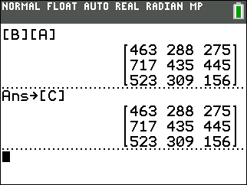

If B is the encrypting matrix, then ___________ would be the deciphering matrix. If you have not already done so, put the two matrices, A and B, into your calculator and generate matrix C. Store this matrix in [C].

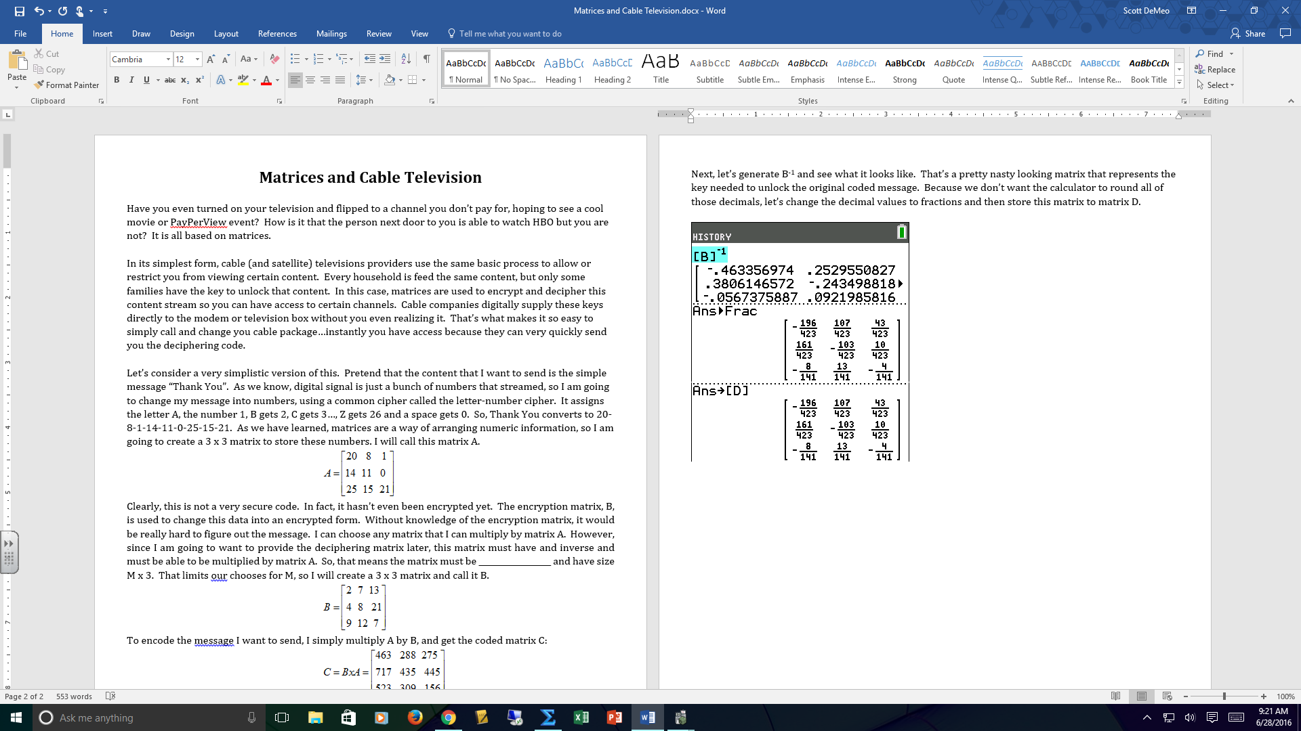Next, let’s generate B-1 and see what it looks like. That’s a pretty nasty looking matrix that represents the key needed to unlock the original coded message. Because we don’t want the calculator to round all of those decimals, let’s change the decimal values to fractions and then store this matrix to matrix D.

So, now [D] is our decoding matrix and [C] is our encoded matrix. To generate the original message, we should multiply _____ by ____. Doing so, will give us our original message back.

Verify that this is true on your calculator.

**Practice Problems:**

For each of the following, you have given an encrypted message that uses the letter-number cipher. Use the decoding matrix to find the message, and write it below the problem.

**Encrypted Message Encoding Matrix Decoding Matrix**

1.   

**Decoded Matrix**

 MESSAGE:

Hint: You know this to be true!

**Encrypted Message Encoding Matrix Decoding Matrix**

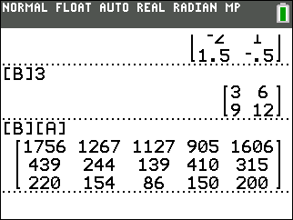2. *C =*  

**Decoded Matrix**

 MESSAGE:

Hint: Very popular show on television.

**Encrypted Message Encoding Matrix Decoding Matrix**

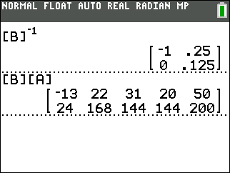3. *C =*  

**Decoded Matrix**

 MESSAGE:

Hint: MVP

Now it’s your turn to create a coded message. If you have access to the internet, go to <http://rumkin.com/tools/cipher/numbers.php> to help generate matrix A, you letter-number cipher. Then, create a square matrix, B, as your cipher. Use that to generate your coded matrix, C. Challenge a friend to break your code by giving them only your coded matrix, C, and your cipher matrix, B. If they need a hint, give them one.

Letter-Number Cipher Matrix Cipher Matrix

[A] = [B] =

Coded Message Decoding Matrix

[C] = [B]-1 =

MESSAGE:

**Extension:** See if you can make your message harder using a different type of cipher. Explore other cipher methods and use them in your cipher matrix to recode your message.