**Unit 6: Investigation 6 (3 Days)**

**Trigonometric Equations and Identities**

**Common Core State Standards**

F.TF.8 Prove the Pythagorean identity (sin A)2 + (cos A)2 = 1 and use it to calculate trigonometric ratios.

F.TF.9 (+) Prove the addition and subtraction formulas for sine, cosine, and tangent and use them to solve problems.

**Overview**

By applying the Pythagorean Theorem to a right triangle with an angle of measure t in standard position, students will deduce the Pythagorean Identity: sin2(t) + cost2(t) = 1. Students will be able to use the identity to find sin(t), cos(t) and tan(t), given sin(t), cos(t), or tan(t) and the quadrant of angle t. If there is time, students will also prove that the sin(a + b) ≠ sin(a) + sin(b) by counterexample, and then learn the angle sum identities.

**Assessment Activities**

**Evidence of Success: What Will Students Be Able to Do?**

* Students will be able to write equivalent expressions for the Pythagorean Identity.
* Students will find two of the trigonometric values of an angle given the third trigonometric value and the quadrant that the angle is in.
* (+) Students will give an algebraic and graphical counter example to show that

sin(a + b) ≠ sin(a) + sin(b) and cos(a + b) ≠ cos(a) + cos(b).

* (+) Students will find the exact trigonometric value of the sum of two angles.

**Assessment Strategies: How Will They Show What They Know?**

**Exit Slip 6.6.1** will have studentssimplify (cos(x) − 1)(cos(x) + 1) and 1 - sin2t , apply the Pythagorean identity in a concrete example and use one of the co-function relationships.

**Exit Slip 6.6.2** will give students the informationsin(t) = 12/13 and 90º < t < 180º and ask them to find cos(t) and tan(t) two ways.

**Journal Prompt 1** Asks students to discuss whether the operators ‘absolute value’, or ‘square root’ distribute over addition like multiplication distributes over addition. ((+) If your class has done Activity 6.6.3 you can extend to also discussing does sin (a + b) = sin a + sin b?)

**Activity 6.6.1** **Doing Algebra with Trigonometic Functions** is a series of algebra manipulations that help students explore and practice the co-function and the Pythagorean identities developed in the launch.

**Activity 6.6.2 Find the Other Two** will give students the information : the sin(t) = 3/5 and have them work in groups to find as many pieces of information as they can from these facts.

**Activity 6.6.3 Angle Sum Formulas (+)** will ask students to determine whether or not sin(30° + 60°) = sin 30° + sin 60° and to apply the sum and difference identities for the sine and cosine functions.

**Launch Notes**

**Discovering the Pythagorean Identity**

This launch is an exploratory activity that will provide opportunities for you to reinforce important facts about right triangles as students develop the co-function relationship and the Pythagorean Identity. Be sure you are having fun listening to all the observations and connections that the students will come up with.

**Group Activity –Launch** Have students brainstorm as many Pythagorean Triples as possible in small groups and then share in large class. After each student works with their stickie that has one Pythagorean triplet and they join others that have the same values for either the sine and cosine of angle ‘t’ have them answer together in group, “ What is it about these triangles that gives you the same sine value? Similarly, all the triangles have the same cosine value.” Direct each group to explain why some of the triangles in their group have the same sine and some have the same cosine values, yet other triangles have the values for sine and cosine reversed. “Why is sin(t) for some sketches equal to cos(t) for other sketches?” Tell each group to draw one triangle similar to the ones they have so that the new triangle has a hypotenuse of 1. See launch notes below for a more detailed description.

Have students brainstorm as many Pythagorean Triples as possible. For a few of the triplets, confirm that they determine a right triangle by confirming that a2 + b2 = c2. Be sure that several of the triplets are multiples of each other: ex. 6-8-10 and 9-12-15 are multiples of 3-4-5. Assign a different triplet to each student. Give each student a sticky note for them to sketch their right triangle in standard position on the coordinate plane with one of the acute angles (call it ‘t”) at the origin and one leg on the positive x axis. Students do not need to know the measure of angle ‘t’. Label the lengths of the sides. Write the sin(t) and cos(t) on the sticky note next to their triangle sketch. (Fractions should be simplified.)

Ex:

10 sin(t) = $\frac{6}{10}=\frac{3}{5}$

t 6 cos(t) = $\frac{8}{10}=\frac{4}{5}$

8

Now have students stand up, move to different corners of the classroom to join other students that have the same values for either the sine and cosine of angle ‘t’. In effect, all students with similar triangles will be grouped together regardless of the orientation of the triangle. Tell the students to post their stickies on the wall so everyone in the group can see the different triangles. Draw the students’ attention to all the triangles that have equal sine values. What is it about these triangles that gives you the same sine value? Similarly, all the triangles have the same cosine value. (Answer: the triangles are similar, the central angle “t” for each triangle is equal in measure, the sides are proportional, and the trig functions are an invariant for similar triangles). Direct each group to explain why some of the triangles in their group have the same sine and some have the same cosine values, yet other triangles have the values for sine and cosine reversed. Why is sin(t) for some sketches equal to cos(t) for other sketches? (Answer: Depending on the orientation of the triangle, one or the other of the acute angles will be the central angle ‘t’. The two acute angles in a right triangle are complementary, and the sine of an angle equals the cosine of its complement.)

Tell each group to draw one triangle similar to the ones they have so that the new triangle has a hypotenuse of 1. They need to label the measures of the legs. Use directed questions to guide them to dividing each side of the triangle by the length of the hypotenuse. (Question: How can I change a number like ‘13’ into 1? Answer: Divide by 13, or multiply by the reciprocal”. (Question: If I divide each side of the triangle by 13 will I have a triangle that is similar to the original one?)

Now have the students take their seats for a whole class discussion. On the board in front of the room, draw a rough sketch of several of the triangles with hypotenuse = 1 and a leg on one coordinate axis in front of the room, or have someone from each group draw their triangle on the coordinate axis on the board. Show that the hypotenuses form radii of a unit circle. Ask students what are the coordinates of the endpoints of each radius. Shown are 3 examples of triangles:



Have each group verify the Pythagorean Theorem with the sides of some of the triangles. Then have them verify that the x and y coordinates of the points on the unit circle corresponding to the lengths of the horizontal and vertical legs satisfy the equation of the unit circle x2 + y2 = 1. Remind students that the x coordinate is the cosine of the angle t and the y coordinate is the sine of the angle t. Substitute cos(t) for x and sin(t) for y into the equation for the unit circle to obtain the Pythagorean Identity. To summarize, the group started with the Pythagorean Theorem for right triangles, and then moved to similar triangles to the unit circle and identified the legs of the triangle with the sine and cosine and the hypotenuse as 1. Note that by odd and even symmetry, this line of reasoning holds for angles in each of the other three quadrants.

We now have this equivalence: a2 + b2 = c2 x2 + y2 = 1 (cos(t))2 + (sin(t))2 = 1 Then write the identity in the customary exponent form for trigonometric functions: sin2t + cos2t = 1 explaining the exponent notation.

Now that students have seen the Pythagorean Identity for specific values, you can review and summarize with the following general summary. Sketch the following on the board: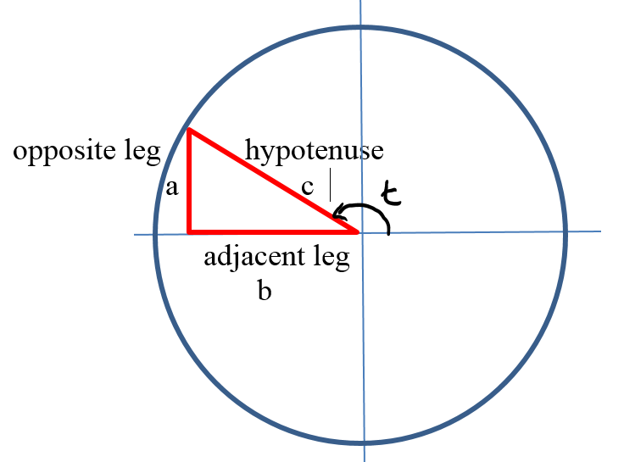

Elicit the following equations from students:

a2 + b2 = c2

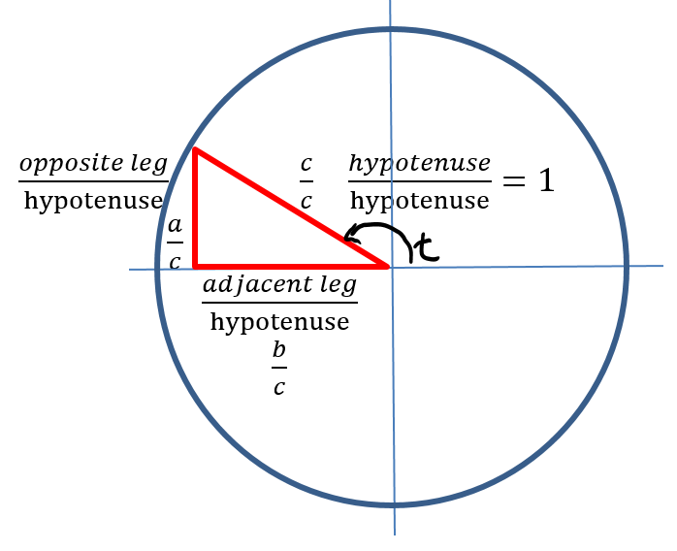

On your sketch, divide each side of the triangle by the letter ‘c’ in equation and in the sketch. Similarly, divide each word by the word ‘hypotenuse’. The result is a similar triangle with the hypotenuse and the radius = 1.

Show in symbols what you drew in your sketch:

$${\left(\frac{a}{c}\right)}^{2}+{\left(\frac{b}{c}\right)}^{2}={\left(\frac{c}{c}\right)}^{2}$$

${\left(\frac{opposite leg}{hypotenuse}\right)}^{2}+{\left(\frac{adjacent leg}{hypotenuse}\right)}^{2}={\left(\frac{hypotenuse}{hypotenuse}\right)}^{2}$

Now rewrite each of the ratios of the leg to the hypotenuse as a trigonometric ratio.

The equation will be

**(sin (t))2 + (cos (t))2 = 1**

Tell them this is the Pythagorean Identity. Note that t can be any real number, not only the measure of an acute angle. It is called an identity because it is true for every single value of the occurring variable where both sides of the equation are defined. The Pythagorean Identity is true for all real numbers.

Or you can elicit a2 + b2 = c2

Sin t = a/c and cosine t = b/c and **(sin (t))2 + (cos (t))2 =**

**Teaching Strategies**

**Activity 6.6.1** **Doing Algebra with Trigonometric Functions** is a series of algebra manipulations that help students explore and practice the co-function and the Pythagorean identities developed in the launch. Before distributing Activity 6.6.1, consider having a class discussion about how the graphs of y = cos(x) and y = −sin(x - 90°) are equivalent using a 90° horizontal shift right and a reflection about the x axis. Since the sine function is odd, we have −sin(x - 90°) = sin(90°- x), one of the cofunction identities. Then have them check by calculator that sin(5°) = cos(85°). This discussion will prepare them for exercise #5 in activity 6.6.1 that explores the cofunction identity cos(x - 90°) = sin(x).

**Activity 6.6.2 Find the Other Two:** Tell students that the sin(t) = 3/5.

Have them work in groups to find as many pieces of information as they can from these facts. Expect to see drawings of a reference triangle with vertical leg = 3/5 and hypotenuse 1, others will draw a triangle with one leg = 3 and the hypotenuse = 5. Others may label the y coordinate of a point on the unit circle. Encourage students to find other information – a missing leg, the other coordinate on the unit circle, e.g. challenge them to find the cos(t) and the tan(t). If no one thought to use the Pythagorean identity with 3/5 substituted in for sin(t), you could give the following hint: “Being in algebra class, I would try to find an equation, so I could substitute in what I know, and solve for what I want to find.Does anyone know an equation that relates the sine and cosine of an angle?” **Activity 6.6.2 will** have students explore ways to find two trigonometric values given another trigonometric value and the quadrant the angle lies in.

**Activity 6.6.3 Angle Sum Formulas (+).** Challenge the students to determine whether or not sin(30°+ 60°) = sin 30° + sin 60°. Some students may draw the angles on the coordinate plane, others will evaluate each of the 3 terms, and will see that 1 ≠ 1/2 + $\sqrt{3}$/2. Derive the angle sum formula on the board for students, or provide a scaffolded proof for them to fill in the blanks, working in groups. Then assign **Activity 6.6.3 Angle Sum Formulas (+)** thatprovides practice with the sum identity. Students will also derive and use the double angle formulas for the sine and cosine.

**Journal Prompt 1**

Imagine that you overhear some classmates talking about the distributive property of multiplication over addition . They start to wonder if other operators distribute over addition, and they note that $\left|a+b\right|=\left|a\right|+\left|b\right|$ provided a and b are each greater than zero. For example, $\left|3+1/2\right|=\left|3\right|+\left|1/2\right|.$ On the other hand exponents do not distribute over addition: ${(2+3)}^{3}≠2^{3}+3^{3}$. Help your classmates answer the following questions. Be sure to justify your answer.

a. Does absolute value distribute over the sum of any real numbers?

b. Does the square root operator distribute over the sum of any real numbers?

Does $\sqrt{a+b}=\sqrt{a}+\sqrt{b}$?

c. (+)Does the cosine operator distribute over the sum of any two real numbers? Does cos(a + b) =cos(a) +cos(b)?

d. Name two other operators and explain whether or not the operation distributes over addition

Students might respond to a. NO because │5 + -2│ = 3 and │5│ +│-2│ = 7 pat b also no with a counter example and part c NO. For d. students might mention oppositing over addition (yes) or cubing over addition (no).

**Differentiated Instruction (For Learners Needing More Help)**

Provide a scaffolded activity sheet for Activity 6.6.1 that guides students through examples of the required manipulation skills using x’s and y’s. If necessary fill in a number for one of the variables so the equation is more concrete. Then have them model the manipulation with the trigonometric expressions. For example, ask student to solve for y2: x2 + y2 = 1; then ask them to solve (sin α)2 + (cos α)2 = 1 for (cos α)2

**Differentiated Instruction (Enrichment)** Have students find the other two Pythagorean Identities by dividing (sin α)2 + (cos α)2 = 1 by

1.cos(α), then simplify

2. sin(α), then simplify.

And then establish that these new equations do indeed define identities by proving they are identities but note these have excluded real numbers.

You may or may not want to introduce secant, cosecant and cotangent.

Assign problems using these newly found identities: if tan α = 2, find cosα

**Closure Notes**

In this investigation, students will see that idea of mathematical equivalence continues to pervade our work in trigonometry. Concepts presented in Unit 1 are applied to trigonometric functions: creating new functions by combining old ones, and transforming functions. Algebraic manipulation with trigonometric expressions and functions sometimes require their own special formulas such as the angle sum formulas. As students come to see that the trigonometric functions do not distribute over sums or products, hopefully they will appreciate how special the distributive property of multiplication over addition truly is. In the case of the sine, cosine or tangent of the sum of two numbers, special formulas have to be followed.

**Vocabulary**

Angle sum and difference formulas (+)

Co-function (e.g. sine and cosine are co-functions)

Complementary angles

Identity

Pythagorean Identity

**Resources and Materials**

**Activities 6.6.1 and 6.6.2 should be done in this investigation**

Activity 6.6.1 Doing Algebra with Trigonometric Functions

Activity 6.6.2 Find the Other Two

Activity 6.6.3 Angle Sum Formulas (+).

Sticky notes – preferably the larger 3 by 5 size

Pencil, paper and calculator.