Activity 6.6.1 Doing Algebra with Trigonometric Functions

Operating with Trigonometric Functions is much the same as operating with any algebraic expression. With trigonometry, you can also simplify further using the Pythagorean Identity

sin2(x) + cos²(x) = 1.

Solve as indicated:

1. a. Solve for x²: x² + y² = 1 b. Solve for x: x² + y² = 1

c. Solve for sin²(x): sin²(x) + cos²(x) = 1 d. Solve for sin(x): sin²(x) + cos²(x) = 1

e. Solve for cos²(x): sin²(x) + cos²(x) = 1. f. Solve for cos(x): sin²(x) + cos²(x) = 1.

NOTE: The equations you obtained in parts 1c-1d are useful to recognize. These are new identities, that means that the equations are true for all real numbers. Use them along with the identity ‘sin²(x) + cos²(x) = 1’ to rewrite trigonometric expressions.
Simplify:
2a. Multiply: (1+ x)(1– x) (1+sin(x))(1 – sin(x))

b. (x + 3)² (sin(x)) + cos(x))²

(sin(x) – cos(x))²

c. Does sin²(x) + cos²(x) equal (sin(x)+cos(x))² ? Explain in words and symbols.

d. Try to answer quickly, just by observation: What is sin²3 + cos²3? _____

3 a. Factor: x³ + xy² ( sin³(x)) + sin(x) ∙(cos²(x))

Factor:
b. x² – y² cos²(x) – sin²(x)

c. 4x² – 9y² 4 – 9sin²(x)

d. 1 – x⁴ factor, then simplify using a trigonometric identity: 1 – cos⁴(x)

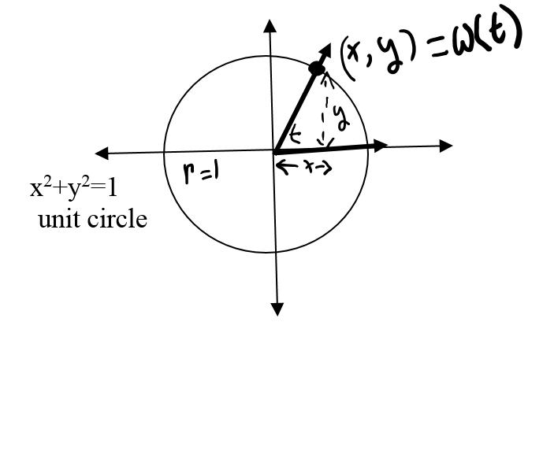
4. On the unit circle the x coordinate of the point W(t) is the cos(t), the y coordinate is sin(t) and the ratio of the coordinates $\frac{y}{x}$ is tan(t).
This gives us another useful identity:
$$tan⁡(t)= \frac{y}{x}=\frac{sin⁡(t)}{cos⁡(t)}$$

Sometimes, it helps to rewrite
$tan⁡(t)$ as $\frac{sin⁡(t)}{cos⁡(t)}$

Simplify:
a. cos(t)∙tan(t)

b. $\frac{(\frac{3}{5})}{3}$ $\frac{tan(x)}{sin(x)}$

Simplify:
c. $\frac{(\frac{1}{3})}{(\frac{1}{6})}$ $\frac{(\frac{1}{cos(x)})}{(\frac{1}{sin(x)})}$

d. Add and simplify
$\frac{5}{3}+\frac{3}{5}$ $\frac{sin(x)}{cosx}+\frac{cos(x)}{sin(x)}$

e. Subtract and simplify
${( \frac{x}{y} )}^{2}-\frac{1}{y^{2}}$ $\tan^{2}(x)-\frac{1}{\cos^{2}(x)}$

f. Divide sin²(x) + cos²(x) = 1 by cos²(x) and simplify to discover another Trigonometric Identity.

5. Recall that sine and cosine are co-functions, meaning that the sine of an angle is the cosine of its complement. Let’s see what this means for a particular angle measure x = 30º.
a. Let x equal the angle 30º, and find the following:
- sin(30º) = ______
- complement of 30º is 90º- 30º= ____
- cos(90º - 30º) = cos( ____ º) =
- Notice that the sin(30º) = cos(90°-30º)
- In general, sin(x) = cos(90º-x)

b. Use the sketch of the right triangle to answer the following:
- Explain why angles A and B are complementary angles. B

c
a

- sin(A)=____ cos(B)=_____ A b
- sin(B)=____ cos(A)=____

c. Now show that sin(x) = cos(90°-x) by graphing:
- First sketch a graph of y=cos(x - 90°) by using a horizontal shift of the parent function y = cos(x).

- What function does the graph of y = cos(x - 90°) look like? ________________
- On the same coordinate axis, graph y = sin(x). Do the graphs of y = cos(x - 90°) and y = sin(x) appear to be equal? _______
- Show that the cos(x - 90°) = cos(90°- x).You may want to use the fact that cosine is an even function and, therefore, cos(x) = cos(-x).

To summarize: We have shown that the graph of y = sin(x) appears to equal the graph of y = cos(x-90º). We have also shown that, cos(x−90º) = cos(90º−x). Therefore, by the transitive property of equality, it seems reasonable to think that cos(90º−x) is equal to sin(x).

A similar demonstration may be used to show that sin(90°-x) = cos(x) (using the fact that y = sin(x) is an odd function and -sin(x-90º) = sin(-1$∙($90°-x))
6. The co-function identities are written:

sin(90°−x) = cos(x) cos(90°− x) = sin(x)

sin($\frac{π}{2}$− x) = cos(x) cos($\frac{π}{2}-$x) = sin(x)

Fill in the blanks

a. sin(25°) ≈ .4226; cos(65°) =________

b. cos(10°) ≈ .9848; sin(____°) = .9848

c. sin$(\frac{π}{6})$ = cos(_____) = _______

d. sin(120°) ≈ −.8660. Use your calculator to find cos(90°- 120°):______

e. Do the co-function identities seem to hold for all real numbers, not just acute angles with measures less than π/2?

f. Find cos$(\frac{5π}{3})$ ______. What is $\frac{π}{2}-\frac{5π}{3}$ ? __________ Find the sine of this number._____

g. Sin($-\frac{3π}{4}$) = cos(_____) =______

h. Fill in the following blanks with decimal approximations using a calculator in radian mode.

cos(2) = sin(________) = ____________

