Activity 6.4.3 Graphs from Equations and Equations from Graphs

In the Activities 6.4.1 Move It! Trig and 6.4.2 Stretch it! Trig you learned to apply transformations to the graphs of the three parent functions f(x)=sinx, f(x)=cosx and f(x) = tanx.

The three transformations you learned are indicated by the parameters a, b and d in the general equation g(x)=a·sin(bx) + d .

1. Fill in the blank:
- Which parameter applies to the input variable of a function? (This is an inside change; it changes the input of the function.) ___

- When the change to a parent function is to the “inside” does the graph change vertically or horizontally ________________ ?

- Which two parameters apply to the output variable ?(This is an outside change; the change is outside of the parenthesis in the notation ‘f(x)’.)___ ___

- When the change to a parent function is to the “outside” does the graph change vertically or horizontally ________________ ?

- Which parameter is being added or subtracted from the value of the function? ___

- When a parameter is added to or subtracted from the parent function, is the graph a stretch or shift of the parent function? ____

- Which two parameters are multiplying the function or the input variable? ___ ___

- When a parameter multiplies the parent function or input variable is the graph a stretch or shift of the parent function? ______

2. Answer the questions. Please write with full sentences.

a. What is the effect of parameter ‘a’ on the graph of the parent function? Note what happens to the parent function as ‘a’ increases or decreases in magnitude. Note also what happens to the parent function if ‘a’ is positive or negative.

b. What is the effect of parameter ‘b’ on the graph of the parent function?

c. What is the effect of parameter ‘d’ on the graph of the parent function?

3. Fill in the blank with the following words : amplitude, midline, period.

To find the __________________ divide 2$π$ by ‘b’ that is the coefficient of x. You can also divide 360° by the coefficient of x. The coefficient of x tells how many full periods fit into an interval of 2π (or how many periods fit into 360°).

One way to find the ____________________ of a sinusoidal function, is to take half the distance from the maximum value to the minimum value.

The line y = d is the _______________ of the sinusoidal function. Half the values are above the midline, and half the values are below the midline.

A detailed graph of a sinusoidal functions shows
- the midline of the function and the equation of the midline.
- the x and y coordinates of the maximum and minimum points of the function
- the x and y coordinates of a point where the function intersects the midline.

One a separate sheet of paper, sketch a detailed graph of the following (Assume x is in degrees).

4. $y=3sinx-4$

5. $y=-2sin⁡(3x)$

6. $y=4\sin\left(\frac{1}{3}x\right)-2$

7. $y=5cosx+1$

8. $y=-2cos⁡(12x)$+2

9. $y=tanx-1$

On a separate sheet of paper, sketch a detailed graph the following using radians.

10. $y=-1sin⁡(2x)$

11. $y=\sin\left(2x\right)+1$

12. $y=-3cos⁡(\frac{1}{2}x)$ +4

13. $y=-1tan⁡(\frac{1}{2}x)$

14. $y=cos⁡(\frac{π}{2}x)$ - 2

15. $y=6\sin\left(4πx\right)-5$

Find an equation for each graph. It helps to identify the amplitude, period and midline. Then you can determine the parameters a, b and d in the equation such as: y= a∙cos(bx) + d

16. Equation__________________________

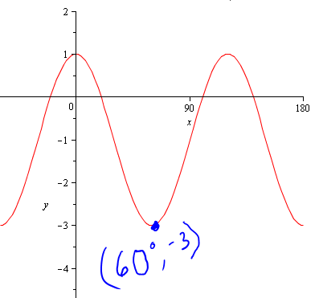

17. Equation__________________________

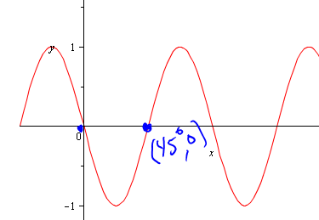

18. (Assume that the parameter ‘a’ is ‘1’.) Equation__________________________

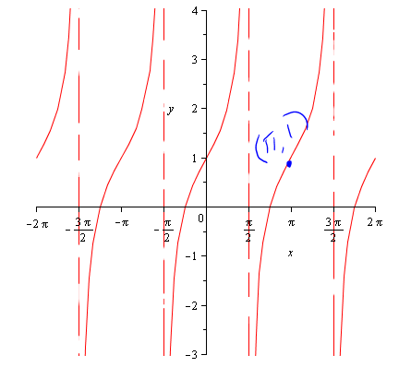

19. Equation__________________________

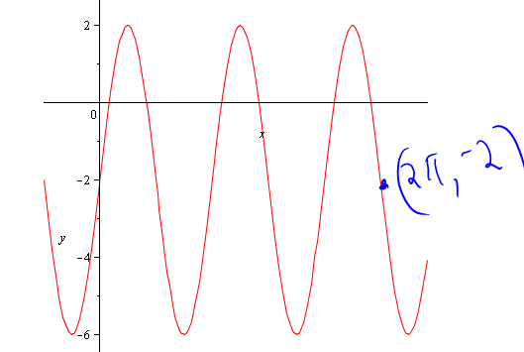

20. Equation__________________________

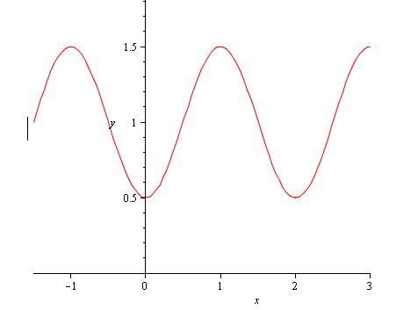

21. Equation__________________________

