**Activity 6.4.1(+) Move It! Trig**

In this activity, we will be exploring the transformations that can be imposed upon the sine, cosine and tangent functions. Understanding, not memorizing, what graphical changes happen will be a key to understanding transformations on all families of functions as discussed in Unit 1.

In an effort to build a quality hand construction of a sinusoidal graph – that means a sine or cosine function, - you should have at least 5 points. You saw these 5 values when you graphed the Ferris wheel heights as a function of time. Within one period of the function, you want the turning points (where the function attains its maximum and minimum values). You also want the points where the graph crosses the midline before, between and just after the maximum and minimum points. In terms of the Ferris wheel ride, you want the 5 points (time, height) that correspond to the rider being at the 3 o’clock position, and at the noon, 9 o’clock, 6 o’clock and again at the 3 o’clock position as she rides the Ferris wheel.

**Part 1: Investigating Vertical Shifts**

1. For the parent function y = sin(x) these 5 points mark the start (0,0) and end (2π, 0) of a period and divide the period into quarters along the x axis

|  |  |
| --- | --- |
| $f\left(x\right)=sinx$ | |
| ***x*** | ***y*** |
| 0 |  |
|  |  |
| π |  |
|  |  |
| 2π |  |

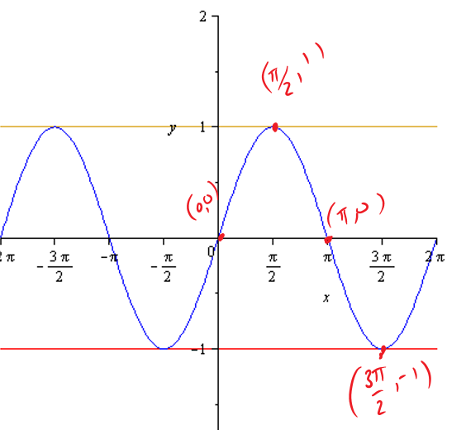

a. Generate a table of 5 values for y = sin(x). After you have completed the given table above, label the maximum and minimum points (turning points) on the graph. Some have been placed on the graph for you.

Notice that the horizontal lines y = 1 and y = -1 form an ‘envelope’ for the graph. That is, the y coordinates of the graph never goes higher than 1 nor lower than -1.

b. The horizontal lines for y = 1 and y = -1 have been sketched for you.

c. Sketch a vertical line segment from the peak in one of the ‘hills’ to the midline and from the bottom of one of the ‘valleys’ indicating the amplitude for y = sin(x). Indicate the length of this line segment that is the amplitude of the sine function.

d. What is the equation of the midline of y = sin(x)? _____

e. At x = 0, is the function increasing or decreasing?____

f. The highlighted part of the graph is an iconic period of y = sin(x). Describe the behavior of this single period of the graph of y = sin(x) .

g. Note the symmetry of the graph of y = sin(x). As you move equidistantly left or right along the x-axis away from the origin the output values are opposite of each other. That is, $f\left(\frac{π}{3}\right)=$_________, and $f\left(\frac{-π}{3}\right)=$_________.

Is this type of symmetry called even or odd symmetry? _______?

3. Explore what happens to the parent function  if “k” units are added to it: the new function is  , where k is “outside” of the function.

Create a table of values for the 4 given values of k. Then plot your values and draw a smooth curve to approximate the transformed quadratic function. On each graph, include the graph of the parent function. Label the two functions on your graph  and  respectively.

Suggestion: before you draw the wave, draw 3 dotted horizontal lines; one each for the midline, y = maximum value and y = minimum value. Sketch the curve for -2π ≤ x ≤ 2π.Be sure to include the coordinates of at least one point on the x- and y-axes for scaling.

|  |  |
| --- | --- |
|  | |
| ***x*** | ***y*** |
| 0 |  |
|  |  |
|  |  |
|  |  |
|  |  |

|  |  |
| --- | --- |
|  | |
| ***x*** | ***y*** |
| 0 |  |
|  |  |
|  |  |
|  |  |
|  |  |

|  |  |
| --- | --- |
|  | |
| ***x*** | ***y*** |
| 0 |  |
|  |  |
|  |  |
|  |  |
|  |  |

|  |  |
| --- | --- |
|  | |
| ***x*** | ***y*** |
| 0 |  |
|  |  |
|  |  |
|  |  |
|  |  |

4. . What do all of the transformations of the type y = sin(x) + k have in common? In other words, what can you say as a general rule about the effect on the graph of y = sin(x) for given values of “k” when k is a value added or subtracted outside the argument of the function? Assume that k is positive. (The argument of a function is the input of the function. It is what is in the parentheses.)

5. a. Graph the parent function y = cos(x) on the interval from -2π ≤ x ≤ 2π.

b. Label the 5 points at x= 0, $\frac{π}{2}$, π, $\frac{3π}{2}$, and 2π .

|  |  |
| --- | --- |
| $f\left(x\right)=cosx$ | |
| ***x*** | ***y*** |
| 0 |  |
| $\frac{π}{2}$ |  |
| $$π$$ |  |
| $$\frac{3π}{2}$$ |  |
| $$2π$$ |  |

c. Sketch dotted horizontal lines for y = 1 and y = -1.

d. Right after x = 0, is the function increasing or decreasing?

e. Is y = cos(x) an even function or an odd function?_______ Explain in full sentences.

f. In full sentences describe the behavior of one period of y = cos(x) starting at (0, 1).

6. Use what you learned about  to graph two full periods of the following functions using translations. Suggestion: before you sketch the wave, determine the midline, the maximum and the minimum values. Sketch in the dotted horizontal lines for the midline, y = maximum value and y = minimum value. Then plot the 3 points at the beginning of a period, the end of the period, and halfway through the period.

a.

b.

c.

7. Graph the parent function $f\left(x\right)=tanx$ by filling in the table and plotting points.

Recall that tan(x) is the slope of the terminal ray of angle x in standard position. Use what you know about the slope to answer the following questions and fill in the table of values.

If the answer is “not defined” you can abbreviate to ND. Not defined is the same as Does Not Exist, so you can write DNE, also.

1. What is the slope of a horizontal ray? _______
2. Name two values of x for which tan(x) = 0. __________
3. What is the slope of a vertical line?_________
4. Name two values of x for which tan(x) undefined. ______________
5. Sketch dotted vertical lines in the graph to represent a vertical asymptote for the x values that make tan(x) undefined.
6. What is the slope of the terminal ray of an angle that is 45º or $\frac{π }{4} radians?______$
7. Name another angle has slope 1. ________
8. What is the slope of the terminal ray of an angle that is 135º or $\frac{3π }{4} radians?______$
9. Name another angle has slope -1._______

|  |  |
| --- | --- |
| $f\left(x\right)=tanx$ | |
| ***x*** | ***y*** |
| 0 |  |
| $\frac{π}{4}$ |  |
| $\frac{π}{2}$ |  |
| $\frac{3π}{4}$ |  |
| π |  |
| $\frac{5π}{4}$ |  |
| $\frac{3π}{2}$ |  |
| 2π |  |
| 2π |  |

1. The period is _____.
2. Is $f\left(x\right)=tanx$ an even or an odd function?_______

l. At x = 0, is the graph of $f\left(x\right)=tanx$ increasing or decreasing?________

m. Write the equations for 4 of the vertical asymptotes. Your answer should be

of the form “x = c”

_____________ _________________ ________________ _______________

8. Use translations to graph the following tangent functions. Sketch a dotted line for the midline. Indicate the vertical asymptotes. Indicate the points where the graph intersects with the midline.

a. $g\left(x\right)=tan⁡(x)+2$

b. $h\left(x\right)=tan⁡(x)-1$

**Part 2 (+): Investigating Horizontal Shifts**

9. a. Sketch a graph of y = sin(x − 45***º***) by filling in the table and plotting points.

|  |  |
| --- | --- |
| ***y=sin(x***−***45º)*** | |
| ***x*** | ***y*** |
| 0 | - $\frac{-1}{\sqrt{2}}$ |
| 45 º |  |
| 90 ***º*** |  |
| 135 º |  |
| 180 ***º*** |  |
| 225 ***º*** |  |
| 270 ***º*** |  |
| 315 ***º*** |  |
| 360 ***º*** |  |
| 405 ***º*** |  |

b. The function y = sin(x) is equal to 0 and increasing at x = 0. We can think of (0,0) as the “starting point” for the graph of y = sin(x). For what value of x is the graph of y = sin(x − 45º) equal to 0 and increasing?

c. Make a conjecture about how the value of $k$ added on the “inside” of the function transforms the graph of $f(x)$ to the graph of $g\left(x\right)=f(x-k)$. Be sure to take the sign of “k” into account.

Generalize what you learned about  to graph two full periods of the following functions using translations. Suggestion: before you sketch the wave, determine the midline, the maximum and the minimum values. Sketch in the dotted horizontal lines for the midline, y = maximum value and y = minimum value. Then plot the 3 points at the beginning of a period, the end of the period, and halfway through the period.

10. $h\left(x\right)=sin(x-30°)$

11. $j\left(x\right)=sin⁡(x+π)$

12. $k\left(x\right)=cos⁡(x-60°)$

13.

14.

15.

16. + 1

17.

18.

19.



21. + 1.5

22.