**Unit 7: Investigation 4 (2 or 3 Days)**

**Conditional Probability**

**Common Core State Standards**

* CP-3 Understand the conditional probability of *A* given *B* as *P*(*A* and *B*)/*P*(*B*), and interpret independence of *A* and *B* as saying that the conditional probability of *A* given *B* is the same as the probability of *A*, and the conditional probability of *B* given *A* is the same as the probability of *B*.
* CP-5 Recognize and explain the concepts of conditional probability and independence in everyday language and everyday situations. *For example, compare the chance of having lung cancer if you are a smoker with the chance of being a smoker if you have lung cancer.*
* CP-6 Find the conditional probability of *A* given *B* as a fraction of *B*’s outcomes that also belongs to A, and interpret the answer in terms of the model.

**Overview**

Students were informally introduced to the concept of conditional probability in Investigation 3. In this investigation, the notion of conditional probability is formalized. Students learn several formulas for computing conditional probability. In cases where outcomes in the sample space are equally likely or events are represented by area probability models, students calculate the conditional probability of *A* given *B* as the fraction of *B*’s outcomes that also belong to *A*. From here, they derive the general formula for  Using algebraic manipulation, students derive the General Multiplication Rule from the formula for conditional probability. Then they use the General Multiplication Rule to calculate  for several sets of events *A* and *B*. In addition, students learn how to apply the General Multiplication Rule to tree diagrams.

**Assessment Activities**

**Evidence of Success: What Will Students Be Able to Do?**

* In situations in which outcomes are equally likely, determine  as the ratio of the number of outcomes in to the number of outcomes in *A*.
* Use an area probability model for two events *A* and *B* to calculate  by determining the fraction of *B*’s area that overlaps with *A*.
* More generally, determine as the ratio of  to *P*(*A*).
* Use the General Multiplication Rule to find .
* Understand how the General Multiplication Rule can be used with tree diagrams.

**Assessment Strategies: How Will They Show What They Know?**

* **Exit Slip 7.4.1** asks students to apply the formula for conditional probability to a situation involving household income and region of the country.
* **Exit Slip 7.4.2** asks students to draw a tree diagram of two random processes and to label probabilities along the branches. Then students use the General Multiplication Rule to find several probabilities.
* **Journal Entry** asks students to show that when two events are independent the General Multiplication Rule is equivalent to the Multiplication Rule for Independent Events.

**Launch Notes**

Investigation 7.3 concluded with an informal look at conditional probability. In this investigation, we deepen students’ understanding of conditional probability and provide some methods and formulas for computing conditional probabilities.

Here’s a scenario that will help students understand conditional probability. Suppose you are planning for an outdoor party. You have a cooler filled with the following drinks. (The first question in Activity 7.4.1 will use this same situation.)

* 10 Cokes
* 12 Diet Coke
* 6 Mountain Dew
* 6 Ginger Ale
* 10 lemon seltzer
* 6 lime seltzer

(Note that Coke, Diet Coke and Mountain Dew all contain caffeine. Coke, Mountain Dew, and Ginger Ale contain sugar, whereas the other three use sugar substitutes and are considered “low in calories”)

Ask the following questions (or similar questions that you make up) as part of this discussion.

1. a. You reach into the cooler and without looking, you pull out a can. What is the probability that you get a lime seltzer? (0.12)

b. You reach into the cooler and without looking, you pull out a can. One of your friends says, I didn’t know you drank seltzer. Now, what is the probability that you are holding your least favorite drink, a lime seltzer? (*P*(lime seltzer| seltzer) = 6/16 = 3/8).

c. Did knowledge that you had grabbed a seltzer increase, decrease, or leave unchanged the probability that you grabbed a lime seltzer? (increased)

2. a. You throw the seltzer back into the cooler and again reach in and without looking you grab a can. Another friend says, you must be staying away from sugary drinks. What is the likelihood that you are holding your favorite drink, a Diet Coke? (*P*(Diet Coke | not a sugary drink) = 12/28 = 3/7 )

b. Compare the probability in (a) with the probability of reaching into the cooler and randomly selecting a Diet Coke. Did knowledge that you grabbed a non-sugary drink increase, decrease, or leave unchanged the probability of getting a Diet Coke?

(*P*(Diet Coke) = 12/50 = 6/25 = 0.24; the information about the drink not being a sugary drink nearly doubled the probability that you were holding a Diet Coke.)

**Teaching Strategies**

In answering questions 1 and 2 in the launch discussion, students calculated conditional probabilities. They should have discovered that knowing something about the outcome of a random process can change the probability that a particular outcome occurs. Share with your students the following meaning of a conditional probability.

A **conditional probability** assesses the likelihood of an event based on the knowledge that another event has occurred.

In **Activity 7.4.1 Conditional Probability: The Fraction of B’s outcomes that overlap with A** question 1continues with the situation described in the launch discussion. Students are asked to calculate a somewhat more complicated conditional probability involving the cans from the cooler. This leads to a formula for calculating conditional probabilities in cases where outcomes are equally likely. Students apply the formula to events associated with rolling a pair of dice. In order to deal with situations for which outcomes need not be equally likely, students are presented several area probability models. Using these models, students determine the probability of *A* given *B* as the fraction of *B*’s area that overlaps with *A*. At the end of the activity, students derive the general formula for calculating conditional probability: $P\left(A | B\right)= \frac{P(A∩B)}{P(B)}$.

You may choose to complete **Activity 7.4.1**, question 1 as a whole class activity. If so, before moving on to question 2, challenge students to come up with a formula for conditional probability that works for question 1 of this activity as well as for the questions that were part of the launch discussion. If students need some help, try the following question and Venn diagram to help students discover a formula for equally likely outcomes. Let *A* be the event of selecting a low calorie drink and *B* be the event of selecting a cola. Below is a Venn diagram representing the sample space (the contents of the cooler).

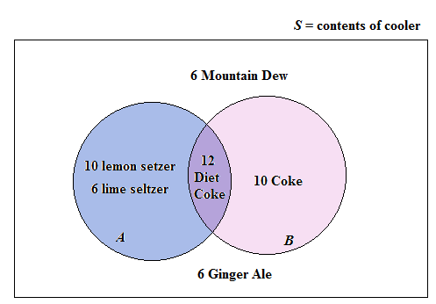

In determining , students should focus on the fact that *B* has occurred. Based on that information, we restrict the sample space to the contents of *B*, the 22 cans of Diet Coke and Coke. From here, students may be able to figure out that is the ratio of the number of elements in to the number of elements in *B*. In other words,  is the ratio of the number of cans in the purple region of the Venn diagram to the number of cans inside the circular region representing *B*. At this point give students the formula that follows question 1.

**Group Activity**

Have students work in small groups to act out the scenario from the launch. Use the template Unit7_Investigation4_group.docx. Cut out sets of drink cards and attribute cards. (Suggestion: run them off on different colors of paper or card stock). One student draws from the attribute pile. A second student draws from the drink pile until she finds a card with the given attribute. The group then figures out the probability of drawing that type of drink, given that it has the given attribute. Repeat the process and rotate roles.

**Conditional Probability: Equally Likely Outcomes**

In cases in which individual outcomes are equally likely, given two events *A* and *B*,



provided the number of outcomes in *B* is positive.

Check that students were able to complete questions 9 and 10 of **Activity 7.4.1**. The formula for conditional probability that they derive in question 9, will appear at the beginning of **Activity 7.4.2**. We state it below so that you can review the formula with the class before students begin the next activity.

**Conditional Probability**

The conditional probability of *A* given *B*, written as , can be calculated by dividing the probability that both events occur by the probability that *B* occurs:



Notice that we need  in order to calculate .

**Differentiated Instruction (For Learners Needing Help)**

Give students a set of 50 drink cards made from the template Unit7_Investigation4_group.docx. Have them pick an attribute and draw a circle to represent a Venn diagram. Place the cards inside or outside the circle and then determine probabilities and conditional probabilities by counting, e.g. P(coke) vs. P(coke| contains sugar).

**Activity 7.4.2 Calculating Conditional Probabilities with a Formula** begins with the above formula for calculating conditional probability that students derived in the previous activity. Students return to the experiment of rolling a pair of dice and observing the sum on the sides that land face up. Students discover that the conditional probability that a particular event occurs often differs from the unconditional probability. For the situation in which , students prove that events *A* and *B* are independent. The activity concludes with two real-word applications of conditional probability, one involving blood type and the other involving 12th-grade students’ driving practices. **Activity 7.4.2** may be assigned for homework, thus reducing the number of days needed to complete this investigation.

**Exit Slip 7.4.1** may be assigned any time after students have completed **Activity 7.4.2**.

**Activity 7.4.3** asks students to derive the General Multiplication Rule (see below) from the formula for conditional probability. Students apply the General Multiplication Rule to find the probability that two events both occur and the probability that at least one of two events occurs. The activity ends with applications involving tree diagrams. Students multiply probabilities along a branch of a tree diagram to get the probability of the outcomes associated with the branch.

In question 1 of **Activity 7.4.3** **General Multiplication Rule** students are asked to derive the rule from the formula for conditional probability. Stop the activity after students have completed question 1 to discuss this rule.

**General Multiplication Rule**

, provided *P*(*B*) > 0.

Make sure that students understand that the rolls of *A* and *B* can be reversed in the General Multiplication Rule. In other words, also works. What is important is that the conditional information matches with the unconditional probability as shown below:

$P\left(A∩B\right)=P\left(B | A\right)P(A)$ or $P\left(A∩B\right)=P\left(A | B\right)P(B)$

***A***’s match ***B***’s match

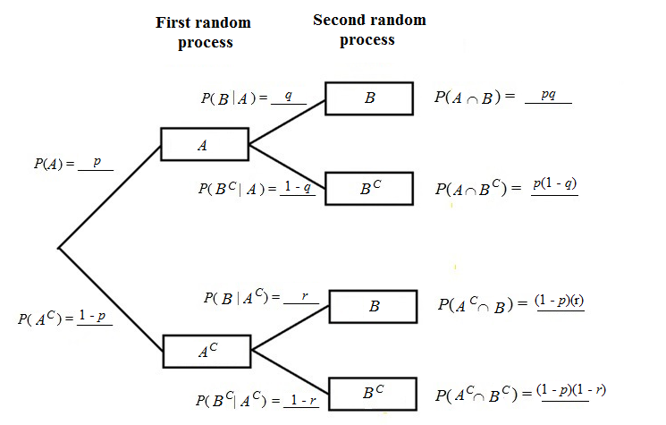In questions 4 and 5, students work with tree diagrams. Check that students understand that when they multiply probabilities along a branch of a tree diagram, they are applying the General Multiplication Rule. Here is a generic form of a tree diagram involving events *A* and *B*. Notice that multiplying the probabilities along the top branch gives . After rearranging terms in this multiplication, we get the General Multiplication Rule. The same is true for multiplying the probabilities along the other branches.

For a challenge, ask students to Extend the General Multiplication Rule to three events (see description below).

**Differentiated Instruction (Enrichment)**

Extend the General Multiplication Rule to three events, *A*, *B*, and *C*, by creating a formula for finding . Then apply your formula in this situation: Suppose a jar contains marbles – 3 white, 2 blue, and 5 red. If you draw three marbles from the container one at a time without replacement, what is the probability of selecting all red marbles?

Answer: . Let *A*, *B*, and *C* be the events of drawing a red marble on the first, second, and third draws, respectively. Then *P*(*A*) = $\frac{5}{10}$, *P*(*B*|*A*) = $\frac{4}{9}$, and = $\frac{3}{8}$. Applying the above formula, $P($ A $∩B∩C)=\frac{60}{720}=\frac{1}{12}$.

Students may use a tree diagram to analyze the enrichment challenge. Here’s how part of that tree diagram would look. (Only the top branch is actually needed.)

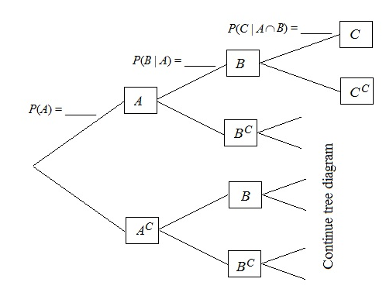

Multiplying the probabilities along the top branch gives the following extension to the General Multiplication Rule: .

**Exit Slip 7.4.2** should be assigned after students complete **Activity 7.4.3.**

**Journal Entry** Recall the General Multiplication Rule for calculating the probability that two events *A* and *B* both occur. Show that when *A* and *B* are independent, the General Multiplication Rule gives the same results as the Multiplication Rule for Independent Events. Look for students to recognize that when *P*(*A*|*B*)=*P*(A) is substituted into the General Multiplication Rule, $P\left(A∩B\right)=P\left(A | B\right)P\left(B\right),$ 
 the result is $P\left(A∩B\right)=P(A)P\left(B\right),$ which means *A*. and *B* are independent.

**Closure Notes**

Students revisit the Multiplication Rule for Independent Events. When two events *A* and *B* are independent, then  = *P*(*B*). However, in cases where two events *A* and *B* are dependent, students learn that the conditional probability  is not equal to the unconditional probability *P*(*B*). Students work with formulas for calculating conditional probability in cases where outcomes are equally likely and in cases where an area probability model is provided. Then they are presented the general formula for conditional probability:

.

Solving this equation for  leads to the General Multiplication Rule. At the end of this investigation, students apply the General Multiplication Rule to situations that can be represented by tree diagrams.

**Vocabulary**

**Conditional Probability:** Assessment of the likelihood of an event based on the knowledge that another event has occurred.

**General Multiplication Rule:** , provided *P*(*B*) > 0.

**Resources and Materials**

Activity 7.4.1: Conditional Probability: The Fraction of *B*’s Outcomes That Overlap with *A*.

Activity 7.4.2: Calculating Conditional Probability from a Formula

Activity 7.4.3: The General Multiplication Rule

Exit Slip 7.4.1

Exit Slip 7.4.2

Journal Entry

Cards for group activity from template Unit7_Investigation4_group.docx.