Unit 7: Investigation 1 (4 Days)

Sample Spaces

Common Core State Standards
- CP-1. Describe events as subsets of a sample space (the set of outcomes) using characteristics (or categories) of the outcomes, or as unions, intersections, or complements of other events (“or,” “and,” “not”).
- CP-7. Apply the Addition Rule, P(A or B) = P(A) + P(B) – P(A and B), and interpret the answer in terms of the model.
- S-MD 7. (+) Analyze decisions and strategies using probability concepts (e.g., product testing, medical testing, pulling a hockey goalie at the end of a game).

Overview

Students are presented several situations involving random processes and discuss how likelihoods that certain events will occur might influence their decisions. This discussion sets the stage for defining random processes, sample spaces, events, and probability. Students use set notation to define sample spaces and events. They form new events from unions, intersections, and complements of other events. Working with area models for probability, students discover two rules of probability, the General Addition Rule and the Complement Rule.

Assessment Activities

Evidence of Success: What Will Students Be Able to Do?
- Given the description of a random process (or a sequence random processes), specify the sample space.
- Use set notation to specify an event.
- Determine the union and intersection of two (or more) events.
- Determine the complement of an event.
- Use probability to assess the likelihood that a particular event will occur.
- Use the General Addition Rule to find the probability of the union of two events.
- Use the Complement Rule to find the probability that an event does not occur.

Assessment Strategies: How Will They Show What They Know?
- Exit Slip 7.1.1 asks students to find unions, intersections, and complements of events.
- Exit Slip 7.1.2 asks students to use the rules of probability covered in this Investigation to calculate probabilities of several events, which are represented by an area probability model.
- Journal Entry asks students to explain how Venn diagrams are used.

Launch Notes

Introduce the concept of random processes and probability by providing students with some examples where being able to assess the likelihood that some event occurs could be useful in making a decision. Start with the situations below and then invite students to add other examples to this list.

- You haven’t studied for tomorrow’s test.

(a) A local meteorologist says there is a 70% chance that by morning there will be a foot or more of snow on the ground. Do you stay up late to study for the test or go to bed?

(b) Suppose instead, a local meteorologist reports that he expects only a dusting of snow. However, he warns that there is one weather model that projects over a foot of snow. He thinks the likelihood of that happening is only around 10%. Do you stay up late to study or go to bed?

- You buy a new cell phone. If your new phone is damaged, or stolen within the next two years, a replacement phone would be really expensive. (After two years you would quality for a phone upgrade at a reduced price.)

(a) Would you assess the chances of your new phone being damaged or stolen in the next two years as low, moderate, or high?

(b) Should you buy an insurance plan for your new phone?

- The Connecticut lottery’s Mega Millions’ jackpot is reaching a record payout. Should you encourage your parents to rush out to play Mega Millions in hopes of winning this super big jackpot? By the way, the chances of winning the jackpot are posted as being 1 out of 258,890,850.

These examples provide insight into three concepts that will be covered in this Investigation – sample space, events, and probability.

Teaching Strategies

Use the situations discussed during the launch of this investigation to introduce the concept of a random process and sample space.

Random process: A process that can result in a variety of outcomes, but you don’t know which outcome will occur in advance.

Sample space: The set of all possible outcomes of a random process.

We often designate the sample space as S and describe it using set notation: S = {list of outcomes of random process}.

Spend some time discussing possible sample spaces for the situations suggested by your students during the launch discussion. Then move on to a discussion of Situation 1. There are several sample spaces relevant to the random process of snowfall. Here are some examples:
- Sample Space 1: S = {snowfall is above 12 inches, snowfall is below 12 inches}.
- Sample Space 2: S = {snowfall is sufficient to cancel school, snowfall is not sufficient to cancel school}.
- Sample Space 3: The amount of snow in inches that have accumulated by morning. This sample space is an interval from 0 to around 36 inches (or whatever you decide is the highest possible snowfall total for a snow storm in Connecticut).

Both of the first two sample spaces involve only two outcomes, whereas Sample Space 3 involves an interval of possible values. So, it is possible for sample spaces to contain either a finite number of outcomes or an infinite number of outcomes. From your students’ point of view, Sample Space 2 is probably the one they most care about.

In addition to the random process of school cancellation connected with snowfall, there is a second random process in Situation 1—namely, whether or not the student decides to prepare for the next day’s test. The outcomes of the two random processes can be described by the tree diagram below (which you can find in the PowerPoint presentation: Tree Diagram of Two Random Processes).

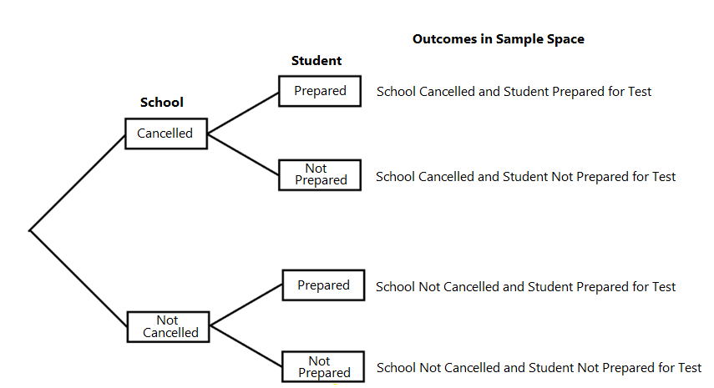

After this discussion, students are prepared to begin Activity 7.1.1.

Activity 7.1.1 Sample Spaces gives students an opportunity to determine sample spaces associated with a variety of random processes, including Situations 2 and 3 from the launch discussion. In situations where two or more random processes are involved, students can use tree diagrams to help identify all possible outcomes. In the last question, students arrange outcomes from two random processes in a two-way table and then use the table to determine the sample space.

Group Activity

Have students work on Activity 7.1.1 Sample Spaces in small heterogeneous groups of 2 or 3 students.

You may want to conclude Activity 7.1.1, by reviewing the solution to question 7. If students had trouble finding the sample space from the two-way table, encourage them to make a tree diagram of the possible outcomes (similar to the one below). Then check that students can match the cells in the table with the outcomes listed in the tree diagram. (Both tree diagram and table can be found on the PowerPoint presentation: Solution Question 7, Activity 7.1.1.) In particular, students should notice that the top branch in the tree diagram corresponds to the second column of the table and the bottom branch to the third column of the table.
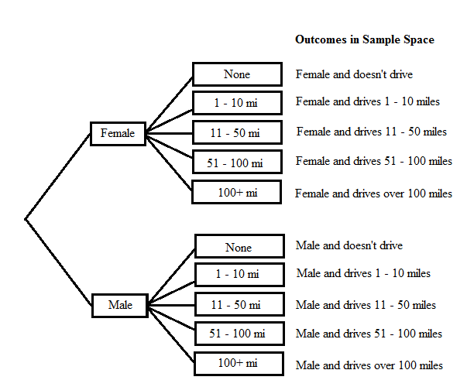

Driving | Female | Male
None | Female and doesn’t drive | Male and doesn’t drive
1 – 10 miles | Female and drives 1 – 10 miles | Male and drives 1 – 10 miles
11 – 50 miles | Female and drives 11 – 50 miles | Male and drives11 – 50 miles
51 – 100 miles | Female and drives 51 – 100 miles | Male and drives 51 – 100 miles
Over 100 miles | Female and drives over 100 miles | Male and drives over 100 miles

Next, return to the three situations from the launch discussion. In each of these situations there is an event, an outcome or set of outcomes, that is of particular interest.

Event: Any subset of a sample space; in other words, any collection of outcomes from a sample space. An event could also be the empty set with no outcomes or the entire sample space S.

Notation: An event is often designated by a capital letter near the beginning of the alphabet, such as event A or event B. The sample space, which is also an event, is generally designated as S.

For example, in Situation 1, we might be most interested in the event of having school cancelled regardless of whether or not the student studied for the test. We can express this event as A = {school cancelled and student studied for test, school cancelled and student did not study for test}.

In Activities 7.1.2 – 7.1.4 students form new events by determining the complement of an event or the union or intersection of two events.

Activity 7.1.2 Visualizing Unions, Intersections, and Complements uses Venn diagrams to help students visualize intersections, unions and complements. Toward the end of the activity, students use a Venn diagram to help them identify events formed from combinations of intersections, unions and complements.

Group Activity

Have students work on Activity 7.1.2 in small groups of two or three students. Working as a group will give students an opportunity to discuss unions, intersections, and complements using their own words.

If students do not have time to finish this activity in class, question 5 can be assigned for homework.

Activity 7.1.3 It’s All In the Cards provides an opportunity for students to use standard playing cards to physically form a sample space. From there, students can sort a subset of their cards into a pile to form an event and the remaining cards into another pile to form the complement of that event. To find the union of two events, students just combine the cards from the two events into a single pile. To find the intersection of two events, students can identify the cards in both events.

The sample space used in Activity 7.1.3 consists of 10 cards. One group of students should be given the Kings, Queens, Jacks, 10s and 9s from the red cards (diamonds, hearts); another group can use the Kings, Queens, Jacks, 10s and 9s from the black cards (clubs, spades).

Differentiated Instruction (For Learners Needing More Help)

Activity 7.1.3 is designed to help students who struggle with the abstract definitions of complement, union, and intersection. Students form a sample space from a group of playing cards. Then they physically separate out various events and their complements, and form unions and intersections.

Activity 7.1.4 Rolling a 12-sided Die asks students to determine complements, unions, and intersections of two or more events using set notation. In questions 7 – 10, students verify De Morgan’s laws (without first being told about De Morgan’s laws). This activity can be done in class or assigned for homework.

Caution: Be sure students don’t confuse set C with the superscript ^{C} used to indicate complement.

After students have completed Activity 7.1.4, introduce De Morgan’s laws, which students have verified in questions 7 – 10. (Students will revisit De Morgan’s laws in Activity 7.1.5, but this time using Venn Diagrams.)

De Morgan’s Laws

Assign Exit Slip 7.1.1, which asks students to find the union, intersection, and complements of events. You can choose to have students complete the entire exit slip or select one of the two questions.

Activity 7.1.5 Venn Diagram Challenge begins with a Venn diagram verification of De Morgan’s laws. Next, students are asked to specify a combination of events (unions, intersections, complements) that would result in given shaded regions in a Venn diagram.

Returning to the launch discussion of Situations 1–3, it is now time to focus on assessing the likelihood that certain events will occur—in other words, it is time to begin the discussion of probability.

Probability: The probability that event A occurs is designated as P(A), and is a number between 0 and 1. The closer P(A) is to 0, the less likely it is for event A to occur. The closer P(A) is to 1, the more likely it is for event A to occur.

While probabilities are numbers between 0 and 1, we often express them as percentages. For example, the likelihoods of snow given in Situations 1(a) and (b) of the launch discussion were expressed as percentages.
- In Situation 1(a) the meteorologist reported a 70% chance of a foot or more of snow. If we let event A = {a foot or more of snow by morning}, then we can express this likelihood as a probability by replacing the percentage by its decimal equivalent, P(A) = 0.7.
- In Situation 1(b) the meteorologist reported a 10% chance of a foot or more of snow. Ask students what probability is assigned to event A in this situation. (Students should report that P(A) = 0.1.)

Give students an opportunity to discuss the meaning of a 70% chance of a foot or more of snow compared to a 10% chance. Don’t correct any misinterpretations of probability at this point. Students’ concepts of probability should evolve over the course of this unit. (In Investigation 2, students will write a journal prompt on this topic.)

One way to represent a probability is with a Venn diagram in which areas of events are proportional to the probability that they occur.

Activity 7.1.6 Area Models for Probability uses Venn diagrams to introduce area probability models. In this case, the Venn diagrams are drawn to scale so that the areas of the shapes representing events are proportional to the probabilities that the events will occur. In this activity, students discover two rules of probability, the General Addition Rule and the Complement Rule.

General Addition Rule: Given events A and B, .
Complement Rule: Given event A, .

Group Activity

Students should work on Activity 7.1.6 in small groups of 2 or 3 students. This way they can check each other’s work as well as discuss applying the General Addition Rule and the Complement Rule. Question 5 can be assigned for individual homework if students do not have sufficient time to complete the activity.

Differentiated Instruction (Enrichment)

For Activity 7.1.6 assign question 6, which asks students to construct an area model given probabilities of certain events.

Differentiated Instruction (Enrichment)

Ask students to use an area probability model to extend the General Addition Rule for the union of two events () to the union of three events. Give them this prompt to start:
$P\left(A∪B∪C\right)=P\left(A\right)+P\left(B\right)+P\left(C\right)- ⋯$
Answer:
$P\left(A∪B∪C\right)=$$$P\left(A\right)+P\left(B\right)+P\left(C\right)- P\left(A∩B\right)-P\left(B∩C\right)-P\left(A∩C\right)+P\left(A∩B∩C\right).$$

Assign Exit Slip 7.1.2, which gives students an opportunity to practice applying the rules of probability covered in Activity 7.1.6 to calculate the probabilities of several events.

If you do not have access to the Internet in your classroom, assign for homework the video “Introduction to Probability” from Unit 18, Against All Odds: Inside Statistics. The web page can be found at: www.learner.org/courses/againstallodds. (Otherwise, this video can be shown in class as part of the launch of Investigation 2.)

Closure Notes

Summarize the key points covered in this investigation. The investigation began with examples of random processes. From there, we formed sample spaces from all possible outcomes of the random processes. We focused on particular events, subsets of the sample spaces. We introduced the concept of probability to assess how likely it was for these events to occur. We formed new events by taking the complements, unions, and intersections of other events. Then we used the General Addition Rule and the Complement Rule to calculate probabilities of events formed from unions and complements of other events. Up to this point, we have not discussed how to assign probabilities to events. That topic will be covered in Investigation 2.

Journal Entry
Explain how Venn diagrams are used to show relations among sets. Look for students to explain, possibly with illustrations, the concepts of union, intersection, and complement.

Vocabulary

Area probability model: A Venn diagram drawn so that the proportion of any event’s area to the area representing the sample space equals the event’s probability.

Event: Any subset of a sample space.

Intersection of two events: The intersection of two events is the set of all elements in common to both A and B.

Probability: A number between 0 and 1 used to quantify likelihood for processes that have uncertain outcomes (such as tossing a coin, selecting a person at random from a group of persons, tossing a ball at a target, or testing for a medical condition).

Random process: A situation in which the possible outcomes are known but we do not know which of these outcomes will occur prior to the completion of the process.

Sample space: The set of all simplest outcomes that can occur as the result of a random process.

Union of two events: The union of two events is the set of all elements in A or B (which includes the elements in common to both A and B).
Resources and Materials

Activity 7.1.1 Sample Spaces
Activity 7.1.2 Visualizing Unions, Intersections, and Complements
Activity 7.1.3 It’s All in the Cards
Activity 7.1.4 Rolling a 12-Sided Die
Activity 7.1.5 Venn Diagram Challenge
Activity 7.1.6 Area Models for Probability
Exit Slip 7.1.1
Exit Slip 7.1.2

Web site: www.learner.org/courses/againstallodds
PowerPoint presentations:
Tree_Diagam_Two_Random_Processes(Investigation_1).pptx
Solution_Question 7Activity_7_1_1.pptx

Sufficient decks of standard playing cards for Activity 7.1.3. (Sample spaces are formed from the red Kings, Queens, Jacks, 10s and 9s or the black Kings, Queens, Jacks, 10s and 9s.)

