Activity 7.6.3 Imperfect Testing

In 2007 Texas legislators voted to budget money to randomly test high school athletes for use of performance enhancing substances. In 2015, Texas legislators voted to stop the testing program because only 0.26% of the athletes, a total of 40 athletes, had positive test results. In addition, some of the athletes who initially tested positive, had negative test results on follow-up tests and were allowed to continue playing high school sports. As of 2015, only Illinois and New Jersey continue to randomly test high school athletes for use of performance enhancing substances.

Testing for use of banned substances does not always give correct results. Here are the four possibilities of what can happen:
- A true positive means the test results are positive (indicating use of banned substances) and the person tested has used banned substances.
- A false positive means the test results are positive but the person tested has not used banned substances.
- A true negative means the test results are negative (indicating no use of banned substances) and the person tested has not used banned substances.
- A false negative means the test results are negative but the person tested has used banned substances.

Imagine that your entire class has been tested for use of performance enhancing substances. Your teacher will hand out the test results via Hershey Kisses.
- If you receive a Hershey’s Kiss with a silver (or white) ribbon, the test results are negative. You will be allowed to participate in all school sports activities.
- If you receive a Hershey’s Kiss with a gold (or yellow) ribbon, the test results are positive. You will be banned from all school sports activities.

1. Untie the ribbon and unwrap the outer foil from your Kiss. If you have a plain chocolate Kiss in a silver wrapper, then you are not a substance user. If you have an almond chocolate Kiss in a gold wrapper, then you are a substance user.

a. At least one of the students in your class had a positive test result but found that he/she had a plain chocolate Kiss. What is this type of test result called? In light of the fact that this student is not a substance user, how do you think he/she feels about being banned from all school sports activities?

b. At least one of the students in your class had a negative test result but found that he/she had an almond Kiss. What is this type of test result called? How do you think this student feels about his/her test results?

c. Suppose the student in (b) starts bragging about his/her test results. How do you think students with true negative test results feel about the student in (b)?

The Kiss test for performance enhancing substances followed the following guidelines:
- Approximately 30% of the Kisses were almond chocolate Kisses (substance users), and around 90% of the almond Kisses were tied with a gold ribbon (positive test results). The other 10% were tied with a silver ribbon.
- Approximately 70% of the Kisses were plain chocolate (non-users), and around 80% of these were tied with a silver ribbon (negative test results). The other 20% were tied with a gold ribbon.

2. Let U be the event of use of banned substances by students, and “+” the event that a test is positive (indicating substance use) and “” the event that a test is negative (indicating no substance use).

a. Express all of the percentages in the Kiss test guidelines above as probabilities. Then enter these probabilities in the appropriate blanks of the tree diagram in Figure 1.

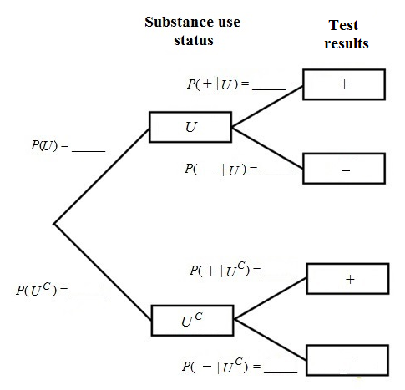

Figure 1. Tree diagram of substance use status and test results.

b. What is the probability of a true positive test result? What is the probability of a false positive test result? (Hint: Use the General Multiplication Rule.)

c. What is the probability of a true negative test result? What is the probability of a false negative test result?

d. Suppose a student is selected at random, what is the probability that the test result will be positive?

e. Suppose a randomly selected student tests positive for substance use. What is the probability that this student is actually a substance user? In other words, find . (Hint: Use the formula for computing conditional probability.) Interpret your solution.

3. Suppose that the percentage of substance users is only 11% instead of the 30% given in the Kiss test guidelines. That means the percentage of nonusers is 89%. Rework question 2 with this change.

4. In the 1970’s a group of children in Lyme Connecticut developed a severe form of arthritis. It took until the 1980’s to discover that the cause of the disease, now known as Lyme disease, was deer tick bites from ticks infected with borrelia burgdorferi bacteria. One commonly administered test to check whether a patient has Lyme disease is known as ELISA (enzyme-linked immunosorbent assay). Unfortunately, the test is not perfect. It correctly identifies patients with Lyme disease (test results are positive) 93% of the time. However, it gives false positive results (test is positive for patients who do not have Lyme disease) 8% of the time.

a. Let L be the event that a randomly selected Connecticut resident has Lyme disease. Let “+” be the event that ELISA indicates the person being tested has Lyme disease and “” be the event that ELISA indicates the person being tested does not have Lyme disease. Assume that in Connecticut the prevalence of Lyme disease is 2% of the residents. Figure 1 shows a tree diagram of this two-stage process. Fill in the blanks with the appropriate probabilities.

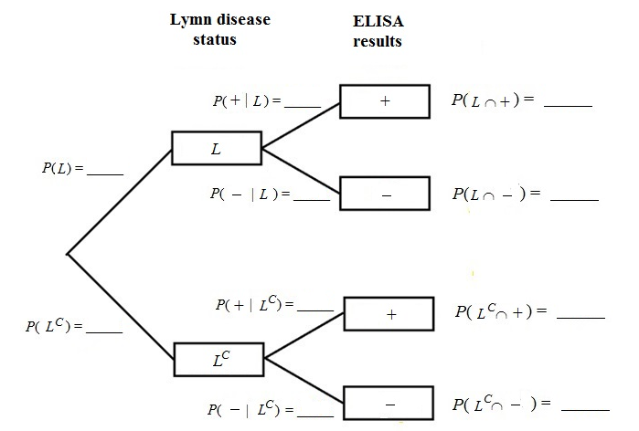

Figure 1. Tree diagram of Lyme-disease status and ELISA-results status.

b. Based on probabilities from your tree diagram in (a), what is the probability that a randomly selected Connecticut resident’s ELISA result is positive? What is the probability that the test is negative?

c. Some people who test positive for Lyme disease do not have Lyme disease. Suppose that a randomly selected Connecticut resident tests positive for Lyme disease. Should the person be worried? To answer this question, determine the probability that the person actually has Lyme disease. In other words, find . (Recall the formula for conditional probability.)

d. Suppose that a randomly selected Connecticut resident tests negative for Lyme disease. Determine the probability the person has Lyme disease even though the test result was negative.

5. Most people go to the doctor’s office to be tested for Lyme disease only when they suspect that they have been bitten by a tick or because they have symptoms of Lyme disease. Suppose that the prevalence of Lyme disease among patients who go to the doctor specifically to be tested for Lyme disease is 18%. Repeat question 4 for those people who go to the doctor specifically to be tested for Lyme disease.

