**Activity 7.6.1 Should You Play?**

***Part I: Analyzing Two Bets***

Consider the following two bets.

* Bet A pays $20 if you win and you have a probability of 1/2 of winning.
* Bet B pays $5,000 if you win and you have a probability of 1/10 of winning.

Suppose that it costs $5 to place bet A and $50 to place bet B. Table 1 shows a probability model for bet A. Notice that the net winnings in the top row are the winnings minus the cost to play the game.

|  |  |  |
| --- | --- | --- |
| Net winnings | $15 | -$5 |
| Probability | $$\frac{1}{2}$$ | $$\frac{1}{2}$$ |

Table 1. Probability model for bet A.

1. In Table 2 enter a probability model for bet B.

|  |  |  |
| --- | --- | --- |
| Net winnings |  |  |
| Probability |  |  |

Table 2. Probability model for bet B.

2. Next, you will find the average payoff of the two bets over many, many plays.

a. Bet *A* produces $15 half the time in the long run and costs $5 half the time. So, what would be the average payoff?

b. Bet *A* produces $4950 one-tenth of the time in the long run and costs $50 nine-tenths of the time. So, what would be the average payoff?

c. If you were placing these bets many times, which bet would you choose? If you were placing only one bet, which bet would you choose? Explain.

If you have a probability model in which the outcomes are numeric, then you can generalize the process that you used in question 2 in order to get a formula for computing the average value, which is also referred to as the **expected value** or **mean value**.

**Expected Value or Mean Value**

|  |  |  |  |  |
| --- | --- | --- | --- | --- |
| Outcome |  |  | ... |  |
| Probability |  |  | ... |  |

The expected value is the sum of the outcomes times their probabilities. This is expressed by the following formula:

Expected value = $x_{1}p_{1}+ x_{2}p_{2}+ ⋯+x_{n}p_{n}$

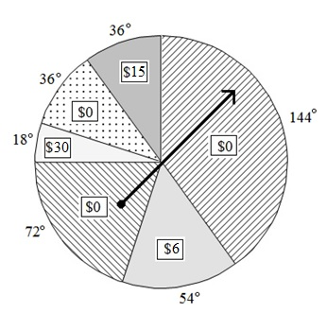***Part II: Senior Class Sponsored Carnival***

The senior class at a high school is planning a carnival to earn money for a class gift that they intend to present to the school at graduation. Descriptions of the planned carnival games are given in the questions 3–6 below.

3. Spinner challenge: Players pay $5.00 to play. A player spins the spinner (See Figure 1.). If the spinner lands on $0, the player loses his/her $5.00. If the spinner lands on a positive dollar amount, then the player wins that amount, but must subtract $5.00 to calculate his/her net winnings.

Figure 1. Spinner used for one carnival game.

a. Make a probability model for the spinner challenge. Record the possible outcomes (net winnings) and the probabilities associated with those outcomes in Table 3. Assume the spinner is perfectly balanced and use the central angles (printed along the outside of spinner) to assign the probabilities.

|  |  |  |  |  |
| --- | --- | --- | --- | --- |
| Net winnings |  |  |  |  |
| Probability |  |  |  |  |

Table 3. Probability model for spinner challenge.

b. Find the expected value of the game (from the player’s point of view).

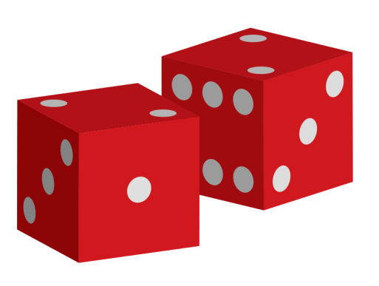4. Dice Challenge: Players pay $5 to play. Roll the pair of dice. If the sum of the spots on the sides landing face up is less than 7, the player wins the amount of the sum in addition to getting his/her $5 back. Otherwise, the player loses the $5 he/she paid to play the game.

a. Make a probability model for the dice challenge.

[Public domain dice clip art. ]

b. Find the expected value of the game (from the player’s point of view).

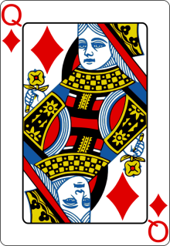

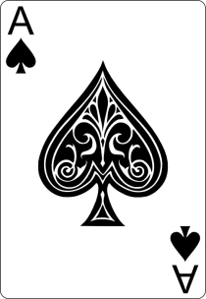5. Card Challenge: Players pay $5 to play. A regular deck of 52 playing cards is shuffled. The player draws a card at random from the deck. If the card is a face card (Jack, Queen, or King), the player wins $10. If the player draws an Ace, the player wins $15. If the player draws a numbered card that is a heart, the player wins $9. (These are the gross winnings. You will have to subtract the cost to play the game to find the net winnings.) Otherwise, the player is out his/her $5.

a. Make a probability model for the card challenge that shows the net winnings and associated probabilities.

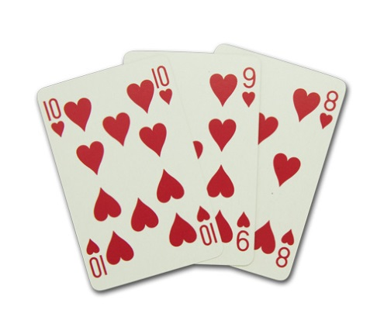

b. Find the expected value of the game (from the player’s point of view).

[public domain images]



6. Box Challenge: Players pay $1 to play. One of the boxes contains $5 and the rest are empty. If the player opens the box with the $5, he/she keeps the money. (In this case, the $5 is the gross winnings.) If the player selects an empty box, the player loses his/her $1.

a. Make a probability model for the box challenge.

b. Find the expected value of the game (from the player’s point of view).

7. Now let’s analyze the games.

a. Which of the games in questions 3–6 would be the best game for players? How much should a player expect to win (or lose) if he/she plays this game 50 times?

b. Which game should the seniors be pushing players toward in order to earn the most money toward their class gift?

c. If the expected value of a game is $0, then the game is called a fair game. If the player plays this game many, many times, he/she would expect to break even, not winning any money but also not losing any money. Are any of the games in questions 3–6 fair games?

d. Suppose that each game in questions 3–6 was played 100 times during the carnival. Approximately how much money should the senior class expect to earn?

e. Some of the games in questions 3 – 6 are advantageous for the players or are fair games. Modify these games so that the expected winnings (from the player’s point of view) are negative. What is the expected value of each of your modified games?

f. Repeat question (a) but substitute the modified games from (e) for the games that originally had a positive or zero expected value.