Activity 7.5.1 Gender and Political Preference

Based on a recent General Social Survey (GSS) poll:
(1) 58% of Democrats were female
(2) 49% of females were Democrats
(3) 20% of the respondents were female and Democrats
In this activity, you will explore various types of percentages such as those above. So, take a few minutes to think about what each of these percentages tells you about women’s political preferences. Your teacher will assign each student in class a political preference. (Chances are you will not be assigned your actual political preference.)

Part I: Analysis of Class Data

1. Summarize the results from the class data in Table 1. Table 1 is called a two-way table because it classifies students on two variables, gender and political preference. For Table 1 the row variable is gender and the column variable is political preference.

Frequency | Democrat | Independent | Republican | Total
Female
Male
Total
Table 1. Students classified by gender and political preference.

2. Let’s begin analyzing the class data by calculating marginal percentages. These percentages involve one question (or variable) at a time. They are called marginal percentages because they are calculated from the totals (highlighted in gray) out on the margins of Table 1.

a. Begin with the marginal percentages for gender. Male students should move to one side of the classroom and females to the other, forming two groups. Count the number of students in your group. Then determine your group’s relative frequency and percentage within the class. Record your answers in Table 2 and on the class data sheet. Then record the answers from the other group to complete Table 2. (Round percentages to one decimal place.)

 | Relative Frequency | Percent
Female
Male
Total
Table 2. Percentages for gender.

The two percentages in Table 2 taken together form a marginal distribution, in which the percentages sum to 100%.

b. Next, tackle the marginal percentages for political preference. Form three groups: the Democrats stand in one group, the Independents in another, and the Republicans in a third. (Stay in these groups for question 3.) What percentage of the class is Democrats? What percentage is Independent? What percentage is Republican? Record your answers in Table 3. (Round percentages to one decimal place.)

 | Democrat | Independent | Republican
Relative Frequency
Percent
Table 3. Percentages for political preference

c. Represent the marginal percentages for political preference in a bar chart. Start with axes and labeling similar to what is shown in Figure 1. Then draw rectangular bars (of equal width) above each category. The heights of the bars should be the percentages. (Feel free to color the bars to make your graphic display more visually interesting.)

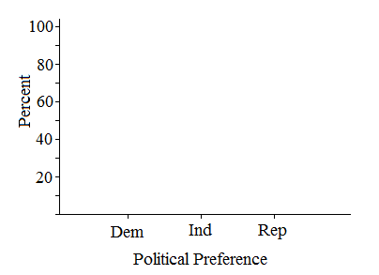

Figure 1. Bar chart representing the marginal percentages for Political Preference.

Next, you will move on to calculating percentages of the types reported in (1) – (3) at the beginning of this activity.

3. Students in the class should still be in three groups according to political preference.

a. Within your group, determine the percentage of males and females. Record your group’s percentages in Table 4 and on the class data sheet. Then record the percentages from the other two political preference groups in Table 4.

Percent | Democrat | Independent | Republican
Female
Male
Total
Table 4. Percentages of males and females within each political preference.

b. You have just calculated three sets of conditional percentages for gender, one for each of the possible outcomes for political preference. In Column 1, the condition is Democrat. Explain why the percentages in column 1 sum to 100%.

c. Based on your percentages in (a), which political party has a higher percentage of females, the Democratic Party or the Republican Party? Support your answer with appropriate percentages.

4. For this question, students should rearrange themselves in two groups, males on one side of the classroom and females on the other.
a. Within your group, determine the percentage of Democrats, Independents, and Republicans. Record your group’s percentages in Table 5 and on the class data sheet. Then record the other group’s percentages in Table 5.

Percent | Democrat | Independent | Republican | Total
Female
Male
Table 5. Percentages of Democrats, Independents, and Republicans within each gender.
b. You have just calculated two sets of conditional percentages for political preference, one for the females and the other for the males. In Row 1, the condition is female. Explain why the percentages in row 1 sum to 100%.

c. Represent the two sets of conditional percentages for political preference, one for females and one for males, in a bar chart. Start with axes and labeling similar to what is shown in Figure 2. Add an appropriate scale to the vertical axis. Then draw rectangular bars (of equal width) above each category. The heights of the bars should be the percentages from Table 5. (Feel free to color the bars.)
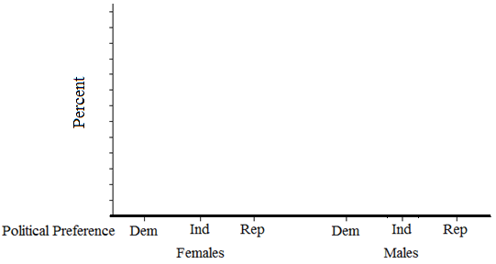

Figure 2. Conditional percentages for Political Preference for females and males.

d. Based on your percentages in (a) and bar chart in (c) do the political preferences of the females in class differ from the political preferences of the males in class? Explain. Support your answer by comparing appropriate percentages.

5. There is one final type of percentage that has not been discussed, the total percentage or joint percentage. For this percentage, there is only one group – the whole class. However, the sample space consists of all possible combinations of outcomes from the two variables, gender and political preference.

a. List the sample space for the two variables.

b. Find the relative frequencies for each of the outcomes in the sample space. Convert these to percentages and record them in the white cells in Table 6. Show your calculations.

Percent | Democrat | Independent | Republican | Total
Female
Male
Total
Table 6. Joint percentages for Sex and Political Preference.

c. Sum the row and column entries to complete Table 6. How do the percentages in the bottom row and last column in Table 6 relate to other percentages calculated for this activity?

Part II: Data from 12th Grade Students Participating in a ‘Monitoring the Future’ Survey

The political preferences of students in your class were assigned by your teacher and hence, don’t reflect the actual political preferences of students in your class. Next, you will analyze real data on students’ political preferences and gender.

6. Each year the study Monitoring the Future: A Continuing Study of American Youth surveys 12th-grade students on a wide range of topics related to behaviors, attitudes, and values. Participants’ responses to the following two survey questions are summarized in Table 7.

1. What is your gender?
2. How would you describe your political preference?

The question on political preference allowed participants to respond “No Preference” or “Don’t Know” in addition to the choices of Democrat, Independent, and Republican.

a. Complete the last row and last column of Table 7. (In other words, calculate the marginal totals.)

Frequency | Democrat | Independent | Republican | No Pref/DK | Total
Female | 1537 | 690 | 1351 | 2866
Male | 1380 | 869 | 1683 | 2560
Total
Table 7. Classifying responses from 12th grade students by Sex and Political Preference.

b. How many students answered both questions?

c. Were the number of females and males who responded to the survey roughly equal, many more females, or many more males? Explain.

7. Marginal percentages for political preferences:
a. Make a table that contains the marginal percentages for political preference. Show your calculations. (Round percentages to one decimal place.)

b. Represent the marginal percentages for political preference with a bar chart.

c. Based on your answers to (a) and (b), write a few sentences describing the political preferences for U.S. 12th-grade students.

8. Political preferences within genders:

a. Construct a table of the conditional percentages of political preference within each gender (similar to what you did for Table 5 in question 4(a)). Show your calculations. (Report percentages to one decimal place.)

b. Represent the two sets of conditional percentages for political preference, one for females and one for males, in a bar chart.

c. Based on your percentages in (a) and bar chart in (b) are the political preferences of 12th grade females in the U.S. similar to the political preferences of 12th grade males? Explain. Support your answer by comparing appropriate percentages.

9. To conclude this activity, we return to the types of percentages at the beginning of the activity. Using the frequencies in Table 7 calculate the following percentages. Show your calculations.

a. What percentage of the Democrats were female?

b. What percentage of the females were Democrats?

c. What percentage of the students who participated in this survey were female and Democrats?

