**Activity 7.4.3 General Multiplication Rule**

In Activity 7.3.1, you were introduced to the Multiplication Rule for Independent Events:

If *A* and *B* are independent events, then 

Using this rule, you can calculate the probability that two events both occur by multiplying their individual probabilities. But what can be done to find when *A* and *B* are dependent?

1. From Activity 7.4.2, you know that $P\left(A | B\right)=\frac{P(A∩B)}{P(B)}$. Solve this equation for  by multiplying both sides of the equation by *P*(*B*). This new formula is the General Multiplication Rule, which can be used to calculateeven when *A* and *B* are dependent.

2. Given *P*(*A*) = 0.4, *P*(*B*) = 0.8, and , determine the following probabilities.

a. 

b. 

3. Suppose you have a container that holds 5 red marbles, 8 blue marbles, and 7 green marbles. You select two marbles from the container one at a time without replacement. Let *A* be the event of selecting a green marble on the first draw and *B* be the event of selecting a green marble on the second draw.

a. Explain why the probability that *B* occurs depends on whether or not *A* has occurred. Use conditional probability notation in your explanation.

b. The event of selecting green on both draws can be expressed as . Use the General Multiplication Rule from question 1 to find .

c. What is the probability of selecting blue marbles on both draws?

4. Before completing the purchases of new cell phones, customers are asked whether or not they want to buy insurance in case their phone is lost, stolen or damaged within the first two years after purchase. Buying the insurance adds to the cost of the phone. However, if a customer’s phone is lost, stolen or damaged, the insurance will pay much of the cost of the replacement phone. Suppose that 75% of customers purchase insurance. Of the customers who purchase insurance, 30% report their phones as lost, stolen or damaged within two years of purchase. Of the customers who did not purchase insurance, only 20% report their phones as lost, stolen or damaged within two years of purchase.

a. Let event *I* be the event that a randomly selected customer purchased insurance and event *L* be the event that the customer’s phone was lost, stolen or damaged. Figure 1 displays a tree diagram showing all possible outcomes. Convert the percentages above to probabilities and then use them to fill in the blanks for the probabilities below. (You will also need to use the General Multiplication Rule.)

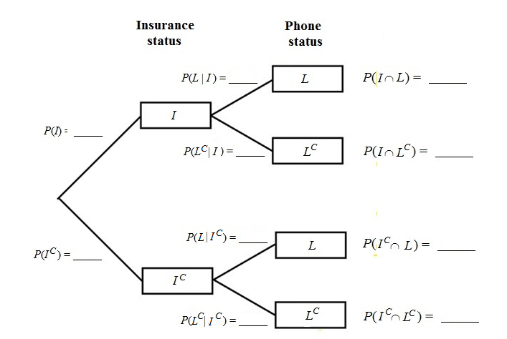

Figure 1. Tree diagram of two random processes related to cell phones.

b. How does the General Multiplication Rule work for tree diagrams?

5. The goal of the Mars One mission is to establish a human settlement on Mars. To date there have been 202,586 applicants from around the world to join Mars One. A survey of high school students found that 18% said that they would be interested in going to Mars even though it would be a one-way trip. Of those interested in going to Mars, only 20% were seniors. Of those who were not interested in going to Mars, 40% were seniors.

a. Let *M* be the event that a randomly chosen high school student was interested in going to Mars and *SR* be the event of being a senior. Convert the percentages above to probabilities. Then create a tree diagram for this situation (similar to the one in   
question 4).

Using information from your tree diagram, find the following probabilities.

b. What is the probability that a randomly selected student is not interested in going to Mars?

c. What is the probability that a randomly selected student is not interested in going to mars and is not a senior?

d. What is the probability that a randomly selected student is a senior?

e. What is the probability that a randomly selected student is not a senior?