**Activity 7.4.1 Conditional Probability:**

**The Fraction of *B*’s Outcomes That Overlap with *A***

1. Suppose for an outdoor party you have a cooler filled with the following drinks:

* 10 Cokes*
* 12 Diet Coke*(low)
* 6 Mountain Dew*
* 6 Ginger Ale
* 10 lemon seltzer (low)
* 6 lime seltzer (low)

* these drinks have caffeine. (low): these drinks are low in calories

a. You grab a can at random from the cooler. What is the probability that you grabbed a low calorie drink (Diet Coke or seltzer)? Explain how you got your answer.

b. You grab a can at random from the cooler. Knowing that lime seltzer is your least favorite drink, a friend says “Lucky you! You didn’t grab a lime seltzer.” Given this information, now what is the probability that you grabbed a low calorie drink? In other words, find *P*(low calorie drink | not lime seltzer). Explain how you got your answer.

In question 1, each can in the cooler is equally likely to be selected. Let *A* be the event of randomly selecting a low calorie drink and *B* be the event of grabbing a can that is not a lime seltzer. In 1(b) you computed  without using a formula. In situations of equally likely outcomes, the formula below can be used to compute .

**Conditional Probability: Equally Likely Outcomes**

In cases in which individual outcomes are equally likely, given two events *A* and *B*,



provided the number of outcomes in *B* is positive.

2. Let *A* be the event of randomly selecting a low calorie drink and *B* the event of randomly selecting a can that is not a lime seltzer. Determine the number of outcomes in $A∩B.$ Determine the number of outcomes in *B*. Then calculate using the formula above. Compare your answer with that of question 1b.

3. Let *A* be the event of randomly grabbing a cola (either Coke or Diet Coke) from the cooler and *B* be the event of randomly grabbing a non-caffeinated drink (Ginger Ale or seltzer). Find.

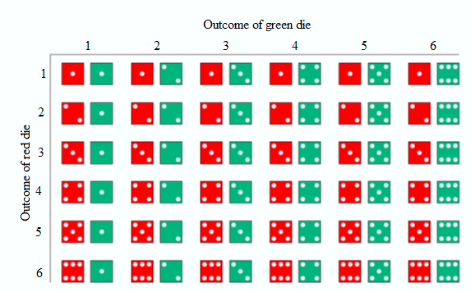

Figure 1. Sample space for rolling a pair of fair dice.

4. Consider the experiment of rolling a pair of dice. Figure 1 shows the sample space. Each of these outcomes is equally likely. Let *A* be the event that the sum of the spots on the sides landing face up is less than 5 and *B* be the event of rolling doubles.

a. Use the Multiplication Rule for Independent Events to classify events *A* and *B* as independent or dependent.

b. Suppose you are told that event *B* has occurred. How many outcomes are in *B*? How many outcomes are in ? Use this information to find using the formula above.

c. Did knowing that *B* had occurred increase, decrease, or leave unchanged the likelihood that *A* occurs? Explain.

5. Consider the experiment of rolling a pair of dice. Figure 1 shows the sample space. Each of these outcomes is equally likely. Let *A* be the event that the sum of the spots on the sides landing face up is 7. Let *B* be the event that at least one of the dice is a 2.

a. Use the Multiplication Rule for Independent Events to classify events *A* and *B* as independent or dependent.

b. Suppose you are told that event *B* has occurred. How many outcomes are in *B* (list them and then count)? How many outcomes are in ? Use this information to find using the formula above. (If you round the probabilities, round to at least two decimal places.)

c. Did knowing that *B* had occurred increase, decrease, or leave the unchanged the likelihood that *A* will occur? Explain.

6. In question 5, you should have found that . But what about  and *P*(*B*). Could these probabilities be equal? Calculate  and compare its value to *P*(*B*). (If you round the probabilities, round to at least two decimal places.) Show your work.

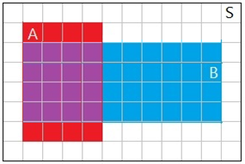Up to this point, the outcomes in the sample spaces were equally likely to occur. Next, you will tackle the situation where individual outcomes may not be equally likely. In order to visualize the conditional probabilities, you will work with area probability models.

Figure 2. Area probability model (from Activity 7.3.1, question 8).

7. Events *A* and *B* are represented by the area probability model in Figure 2. The sample space is represented by the rectangular region labeled as *S*. In Activity 7.3.1, question 8, you determined that events *A* and *B* were dependent. Recall your probability calculations:

,

 , 

. So, *A* and *B* are dependent events.

a. Suppose that you are told that *B* has occurred. Hence, you know that the outcome lies in rectangle *B*.  can be calculated by determining the fraction of *B*’s area that overlaps with *A*. In other words,



Determine . Show your calculations.

b. Next, suppose that you are told that *A* has occurred. So, you know that the outcome lies in rectangle *A*.  can be calculated by determining the fraction of *A*’s area that overlaps with *B*. Determine . Show your calculations.

c. Just from looking at Figure 2, explain why you would expect .

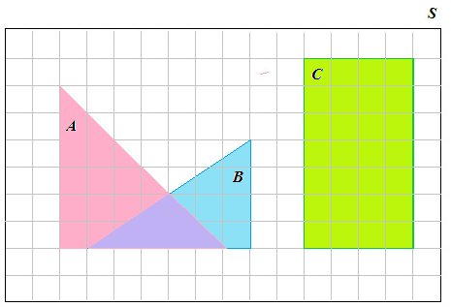

Figure 3. Area probability model (from Activity 7.1.6, question 5).

8. a. Refer to the area probability model in Figure 3. Find  by finding the areas of *B* and  (in terms of the number of small squares covered by each region).

b. Find *P*(*A*), which is the fraction of *S*’s area that is covered by *A*.

c. Compare  to *P*(*A*). Did knowing that *B* had occurred increase, decrease, or leave unchanged the probability that *A* will occur?

d. Find . Why should you not be surprised by this result?

9. We can use the formula from the area probability model to find a general formula for conditional probability. Begin with the formula based on the area probability model.



a. Divide the numerator and denominator by the area of *S*. Explain why this does not change the value of .

b. Now replace the fraction in the numerator by an equivalent probability. Do the same for the denominator. You should now have a formula for in terms of non-conditional probabilities. Write your formula.

10. Based on a major study of automobile accidents, the following probabilities were determined. The probability that the driver was wearing a seatbelt was 0.72. The probability that the driver was wearing a seatbelt and survived the crash was 0.71. What is the probability that the driver survived the crash given the driver was wearing a seatbelt? Show your calculations.