**Activity 7.3.1: Independence and the Multiplication Rule**

In this activity, you will examine a probability rule for independent events. Recall the definition of independent events:

Two events are **independent** if the occurrence of one does not affect the probability of the other. If two events are not independent, then they are **dependent**.

If you flip a coin twice, the result on the first flip is independent of the result on the second flip.

1. Consider the situation where a coin is flipped twice.

a. Let *A* be the event of getting heads on the first flip. What is P(*A*)?

b. Let *B* be the event of getting heads on the second flip. What is P(*B*)?

c. Draw a tree diagram that illustrates the sample space of flipping a coin twice.

d. Given that the outcomes in the sample space for flipping a coin twice are equally likely, determine the probability of getting a head on the first flip and a head on the second flip. In other words, find the probability of getting HH, which is the event .

e. Verify that . (Check that your answer to (d) is the product of your answers to (a) and (b).)

The results in 1(e) are not a fluke. When two events are independent, the probability that both events occur together is the product of the individual probabilities for each event. This is called the Multiplication Rule for Independent Events.

**Multiplication Rule for Independent Events**

If *A* and *B* are independent events, then . Moreover, if for any events *A* and *B*, , then *A* and *B* are independent. If not, then *A* and *B* are dependent.

2. Sonia has a container with 5 blue marbles, 3 red marbles and 2 green marbles. Sonia draws a marble, and records its color. She returns the marble to the container before drawing a second marble and recording its color. Let *A* be the event that Sonia chooses a red marble on the first draw and *B* be the event that Sonia chooses a blue marble on the second draw.

a. Explain why *A* and *B* are independent events.

b. Use the Multiplication Rule for Independent Events to find the probability of drawing a red marble on the first draw and a blue marble on the second draw; in other words, find .

3. Roll a fair die. Let *A* be the event of rolling an even number and *B* be the event of rolling a number greater than 3.

a. Express events *A*, *B*, and using set notation.

b. Using what you have learned from Investigation 2, find *P*(*A*), *P*(*B*) and .

c. Use the Multiplication Rule for Independent Events to determine whether *A* and *B* are independent or dependent.

4. Roll a fair die. Let *A* be the event of rolling an even number and *B* be the event of rolling a multiple of 3. Repeat question 3.

5. Roll a fair die. Let *A* be the event of rolling an odd number and *B* be the event of rolling a number greater than 2. Repeat question 3.

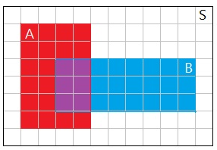

6. a. Two events *A* and *B* are represented by rectangular regions in the area probability model below. The sample space is represented by the rectangular region labeled as *S*. Use areas of regions in the diagram to determine *P*(*A*), *P*(*B*) and .

Figure 1. Area model for probability.

b. Use the Multiplication Rule to decide whether *A* and *B* are independent.

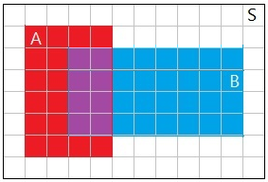

7. Repeat question 6 using the area probability model in Figure 2.

Figure 2. Area model for probability.

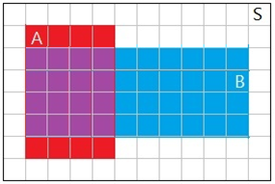

8. Repeat question 6 using the area model in Figure 3.

Figure 3. Area model for probability.

9. Joel is a member of his local Y’s swim team and plays on his school’s basketball team. On Saturday the swim team is having a dual meet during the day. His school’s basketball team is playing a game in the evening. Joel thinks his swim team is better than the rival team and assesses the probability that his team wins at 0.7. On the other hand, he assesses the probability that his school basketball team will win at only 0.4. Assume that the outcomes of the swim meet and basketball game are independent events.

a. What is the probability that Joel’s swim team and basketball team will both win?

b. What is the probability that both teams lose? What, if anything, do you need to assume?