Activity 7.2.2 Approximating Probability Using Data
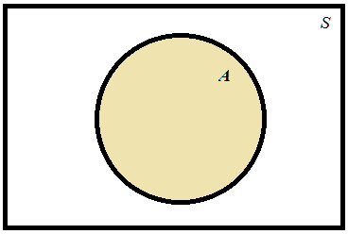

Figure 1. Area probability model representing event A.

If the area model shown in Figure 1 is drawn to scale, then the probability that A occurs can be computed as follows:

In this activity, you will determine the probability that certain events occur from area probability models. Then you will collect data and use the data to estimate the probability of these same events. In particular you will look at the relationship between the estimated probabilities and the actual probability as sample size increases.
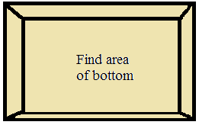
1. You will be given an open rectangular box. Find the dimensions of the inside bottom of the box (See Figure 2.). Then calculate its area. Be sure to record the units both for the lengths and for the area.

Figure 2. Rectangular open box.

2. Cut out 4 different geometric shapes (all four must be able to fit inside the box without overlapping. At least one of the shapes must be a circle and one must be a triangle. Measure the dimensions of your shapes and find their areas. Record this information in Table 1. (Be sure to specify the units both for the recorded measurements and for the areas.)

 | Geometric shape | Measurements | Area
Shape 1 | Circle
Shape 2 | Triangle
Shape 3
Shape 4
Table 1. Shapes to be glued to bottom of box.

After completing Table 1, arrange and then glue your cut-out shapes to the inside bottom of the box. Make sure that none of your shapes overlap.

3. Imagine dropping a small bean into the box. Use the areas you have calculated to estimate the following probabilities. (Report your answers to three decimal places.)

a. The probability that the bean lands on the circle.

b. The probability that the bean lands on the circle or the triangle.

c. The probability that the bean lands on one of the geometric shapes glued to the bottom of the box.

Next, you will collect data and use the data to estimate the probabilities in 3(a–c).

4. a. Count out 20 beans and put them into a paper cup. Imagine shaking the beans and letting them randomly fall into the box. Your task will be to count the beans that land on each of your shapes. However, first, you will have to decide how to count the beans that lay partially on a shape. Describe your strategy.

b. Using your strategy from (a), let the beans fall randomly into the box and count the number of beans landing on each shape. Complete the second row of Table 2.

c. Put the 20 beans from the box back into your cup and add another 20 beans. Shake the beans and let them randomly fall into the box. Then complete the third row of Table 2.

d. Repeat the pattern of adding 20 more beans and then letting them randomly fall into the box. Use the data collected to complete the remaining entries in Table 2.

Number of beans | Number landing on circle | Relative frequency landing on circle | Number landing on circle or triangle | Relative frequency landing on circle or triangle | Number landing on any of the four shapes. | Relative frequency landing on any of the four shapes
20
40
60
80
100
120
140
160
180
200
220
240
260
Table 2. Counts and relative frequencies of beans landing on shapes.

e. How close are the relative frequencies to the probabilities that you calculated for question 3?

5. a. Make a scatterplot of the number of beans landing on either the circle or the triangle versus the number of beans dropped into the box. Use the grid in Figure 3. You will need to add a label and appropriate scaling to the vertical axis.
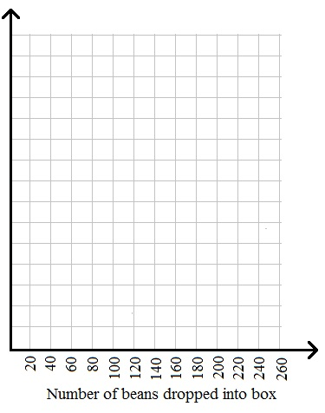

Figure 3. Scatterplot of number of beans landing on circle or triangle versus number of beans.

b. Describe the overall pattern of the dots.

6. a. Make a scatterplot of the relative frequencies of beans landing either in the circle or triangle. Use the grid in Figure 4. You will need to add a label and appropriate scaling to the vertical axis. Connect consecutive dots in your scatterplot with line segments. Add a horizontal line at the value of the probability you calculated for 3(b).

Figure 4. Scatterplot of relative frequency of beans on any of the shapes versus number of beans in the box.

b. What happens to the estimates for probability (relative frequencies) as the number of beans increases?

7. a. Make a scatterplot of the number of beans landing on any shape versus the number of beans dropped into the box. Use the grid in Figure 5. You will need to add a label and appropriate scaling to the vertical axis.

Figure 5. Scatterplot of number of beans on any of the shapes versus number of beans in the box.

b. Describe the overall pattern of the dots.

c. Draw a line that you think best describes the pattern of the dots in your scatterplot in (a). What is the slope of your line? How close is this slope to the probability from your area probability model in question 3(c)?

8. a. Make a scatterplot of the relative frequency of beans landing on any shape. Use the grid in Figure 6. You will need to add a label and appropriate scaling to the vertical axis. Connect consecutive dots in your scatterplot with line segments. Add a horizontal line at the value of the probability you calculated for 3(c).

Figure 6. Scatterplot of proportion of beans on any of the shapes versus number of beans in the box.

b. What happens to the estimates for probability as the number of beans increases?

