**Activity 7.1.5 Venn Diagram Challenge**

1. a. Draw a Venn diagram representing . Explain the process you used to get your answer.

b. Draw a Venn diagram representing . Explain the process you used to get your answer.

c. What do you notice about your Venn diagrams in (a) and (b)?

2. Draw a Venn diagram of each of the following events.

a. 

b. 

c. What do you notice about your Venn diagrams?

3. Describe each shaded region using symbols *A*, *B*, *C*, , , and complement. (There may be more than one way to express the each answer.)

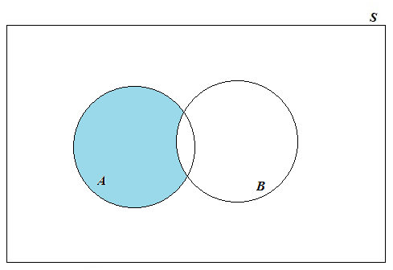a.

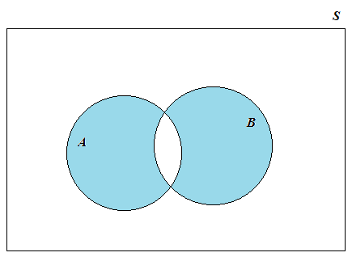

b.

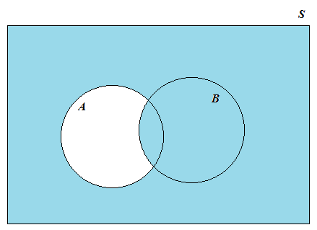

c.

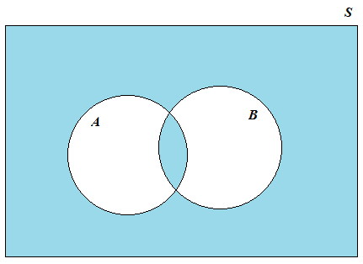d.

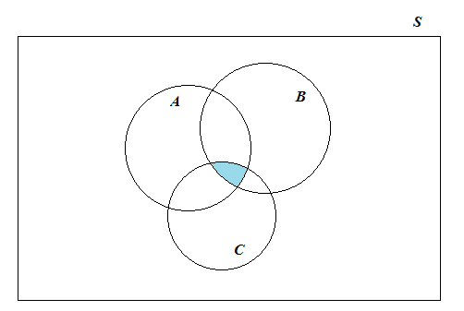

e.

f.

