**Activity 7.1.4 Rolling a 12-Sided Die**

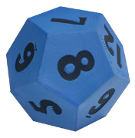

Imagine rolling a twelve-sided die. The outcome is the number on the side facing up. The sample space is *S* = {1, 2, 3, 4, 5, 6, 7, 8, 9, 10, 11, 12}. Consider the following events:

* *A* = {1, 2, 3, 4, 5, 6}
* *B* = {3, 6, 9, 12}
* *C* = {2, 4, 6, 8, 10, 12}
* *D* = {1, 3, 5, 7, 9, 11}

1. Draw a Venn diagram that represents events *A*, *B*, *C*, and *D* in the sample space *S*. Record the outcomes in the appropriate regions of your Venn diagram.

Use set notation to specify the events in questions 2 – 9. (Feel free to use your Venn diagram from question 1 to help find these events.)

2. 

3. 

4.  (Hint: First find .)

5. 

6. 

7. 

8. (Compare with your answer to 7.)

9. 

10.  (Compare with your answer to 9.)