**Activity 7.1.2 Visualizing Unions, Intersections, and Complements**

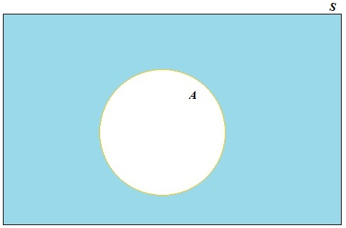

A Venn diagram may be used to visualize a sample space and events. It may also be used to determine outcomes in combinations of events.   
  
To make a Venn diagram, start with a rectangle. The area inside the rectangle represents the sample space, *S*.   
  
Next, draw a shape to represent an event. In Figure 1 event *A* is represented by the white circular region. A second event, represented by the colored region outside of *A*, is the complement of *A*, which is denoted as .



Figure 1. An event *A* in sample space *S*.

*Definition*

Given an event *A*, ***A* complement**, denoted , is the set of all outcomes in the sample space that are not in *A*.



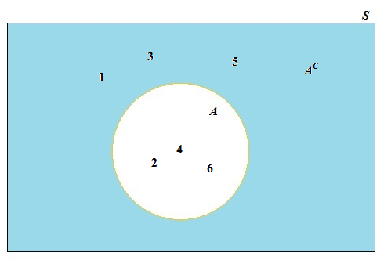

Take, for example, the experiment of rolling a die. Let event *A* be rolling an even number.   
  
In Figure 2, we record the outcomes in *S* in the appropriate regions of the Venn diagram. The outcomes of *A* = {2, 4, 6} are recorded inside the white circular region.   
  
That leaves the outcomes in *S* that are not in *A* for the colored region. Hence, = {1, 3, 5}.



Figure 2. Representing the outcomes  
 for rolling a die in a Venn diagram.

1. Roll two dice and let the sample space be the sum of the spots on the sides that land face up. Let *A* be outcomes that are less than 6.

a. Draw a Venn diagram to represent the sample space with events *A* and *AC.*Record the outcomes in *S* in the appropriate regions of your Venn diagram.

b. Express events *A* and *AC* using set notation.

2. A supermarket sells three types of milk: whole, reduced fat (either 1% or 2%) and fat free (skim). The manager is interested in customer preferences and records the milk selected by the next two customers.

a. Determine the sample space for this situation. Use W, R, and F for whole, reduced fat, and skim milk, respectively. To simplify writing the outcomes, specify each outcome with two letters, the type of milk selected by customer 1 followed by the type of milk selected by customer 2. (Feel free to draw a tree diagram to help identify all possible outcomes.)

b. Let *A* be the event in which both customers select the same type of milk. Let *B* be the event that neither customer selects whole milk. Use set notation to specify each of these events.

c. The Venn diagram in Figure 3 represents events *A* (the circular region on the left) and *B* (the circular region on the right). The overlap of the two circular regions represents the outcomes that events *A* and *B* have in common. This is called the intersection of *A* and *B*, which is denoted . Find event . Write the outcomes of inside the purple region of the Venn diagram in Figure 3.



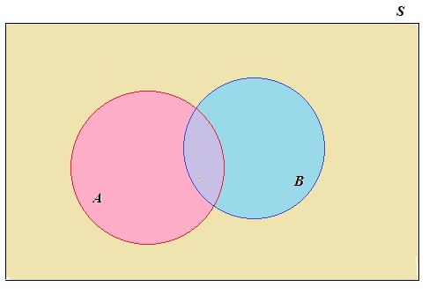

Figure 3. Two events with outcomes in common.

d. Record the remaining outcomes from the sample space in the appropriate regions of your Venn diagram from question 2(c).

e. The union of *A* and *B*, denoted , is the set of outcomes in *A* or *B* or both. Look at your Venn diagram from (d). Use set notation to specify event.



Before moving on to other questions, take a moment to review the definitions of intersection and union, which provide two ways to construct new events from other events.

*Definition*

The event *A* **intersection** *B*, denoted , is the set of all outcomes in both *A* and *B*.



The event *A* **union** *B*, denoted , is the set of all outcomes in *A* or *B* or both.

3. Figures 4(a) and 4(b) show two events, *A* and *B.* In each figure a region representing the combination of these events is shaded.

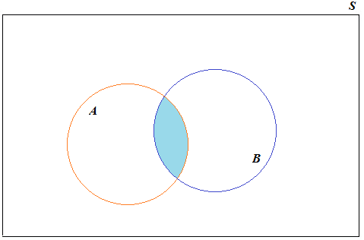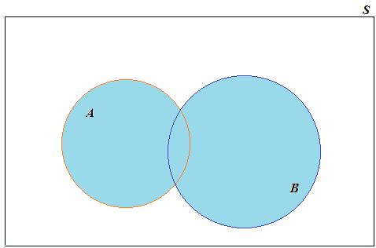

(a) (b)

Figure 4. A combination of events *A* and *B*.

a. Which figure, 4(a) or 4(b), shows a shaded region that represents ?



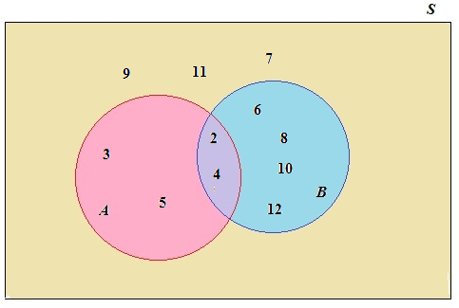 b. Which figure, 4(a) or 4(b), shows a shaded region that represents?  
  
  
  
4. Return to the situation involving rolling two dice from question 1. Let *A* be the event that the sum is less than 6 and *B* be the event that the sum is even. The sample space together with events *A* and *B* (represented by circular regions) are pictured in Figure 5.



Figure 5. Venn diagram depicting events *A* and *B*.

Use the Venn diagram in Figure 5 to find the events in (a – e). Identify the region(s) on the Venn diagram representing the event. Then use set notation to specify the outcomes in the event.

a. *A* b.



c. d.



e.



5. Residents of the U.S. who are legally allowed to work are assigned Social Security Numbers (SSN). You randomly select a student from your school and record the last digit of his/her SSN provided he/she has a SSN. You record “no SSN” if the student does not have a SSN.

a. Find the sample space for this situation.

b. Consider the following events:

* *A*: Student has a SSN and the last digit is even.
* *B*: Student has a SSN and the last digit is odd.
* *C*: Student has a SSN and the last digit is greater than 4.

Draw a Venn diagram using three circular regions to represent events *A*, *B*, and *C*. Record the outcomes from the sample space in the appropriate regions in the diagram.

Use your Venn diagram in (b) to help find the events in (c – g). Specify each event using set notation.

c. d.



e. f.



g.

