Unit 6: Investigation 6 (3 Days)
Geometry on the Sphere

CCSS:

G-GMD.4. Identify the shapes of two-dimensional cross-sections of three-dimensional objects, and identify three-dimensional objects generated by rotations of two-dimensional objects.

Overview

Students are introduced to geometry on the surface of a sphere, which has different properties than a plane surface. They learn about spherical coordinates and their relationship to latitude and longitude. They learn that the shortest path between two points lies along a great circle and that the sum of the interior angles of a triangle is greater than 180° (but less than 540’). They also see applications of spherical geometry to map making and global positioning systems (GPS).

Assessment Activities

Evidence of Success: What Will Students Be Able to Do?

- Use spherical coordinates to locate a point on any sphere; longitude and latitude to locate a point on Earth.
- Recognize that the shortest path between two points on a sphere lies on a great circle.
- Understand how the sum of its interior angles is related to the area of a spherical triangle.
- Recognize that any projection of a spherical surface onto a plane involves some distortion of size or shape.
- Understand how the properties of spheres are used in GPS.

Assessment Strategies: How Will They Show What They Know?

- Exit Slip 6.6.1 has students find the distance between two points on a sphere.
- Exit Slip 6.6.2 has students find the area of a triangle given the radius of the sphere and the measure of its interior angles.
- Journal Entry 1 has students explain why only two numbers are needed to locate a point on a sphere.
- Journal Entry 2 has students explain how spherical geometry is used in everyday life.

Launch Notes

Students generally think of a sphere as a solid (for example a baseball or a basketball). In this investigation we want them to focus on the surface. One way to get them to see this is to view the sphere as a solid of rotation. This idea was first introduced in question 10 of Activity 6.4.2 where students rotated a semicircle about its diameter.

We can think of a sphere as formed by a double rotation. First one rotates a compass around a center to obtain a circle; then one rotates the half of the circle around a diameter to obtain a sphere. This means that one needs two angles to determine the position of a point on a sphere. Any point on the sphere can be characterized by two numbers, $φ$ representing the angle through which the compass turned and $θ$ the angle through which the semicircle was rotated.

For a classroom demonstration of this concept, take a paper plate and pierce it in two places with a skewer or a long knitting needle. Then rotate the plate around the axis.

Note to Teachers on Mathematical Background

The spherical geometry introduced in this investigation is the first example students may encounter of a non-Euclidean geometry. The shortest path between two points on a sphere is obtained by drawing a great circle (whose radius is the same as the radius of the sphere) going through the two points. The term geodesic is used to generalize the concept of straight line to curved surfaces. For a sphere, the geodesics are the great circles.
When two great circles intersect we define the measure of the angle formed as equal as that of the plane angle formed by tangents to the circles at the vertex. The sum of the interior angles of a spherical triangle is not 180°, but a number between 180° and 540°. More precisely the sum of the angles is 180(1+4f), where f is the quotient between the surface of the triangle and the surface of the sphere.

What makes spherical geometry non-Euclidean is the fact that there are no parallel geodesics on the sphere, there are no circles of arbitrary size (since the maximum radius for a circle is the radius of the sphere), any pair of similar triangles are congruent. and two geodesics that are perpendicular to a third one intersect in two points.

Spherical geometry is related to elliptic geometry, which, together with hyperbolic geometry, was historically one of the first examples of non-Euclidean geometry. Since the sphere is a two-dimensional Riemannian manifold, i.e. a smooth surface, it is also one of the most intuitive examples used in higher geometry to understand surfaces and their properties.

Teaching Strategies

Activity 6.6.1. Coordinates on a Sphere introduces students to spherical coordinates and the idea that one only needs two numbers to find the position of a point on a sphere. For this purpose the 3-D graph tool of Geogebra is used. Since a sphere is part of three dimensional space, one starts with looking at the x, y, and z coordinates on a sphere. Then one observes that instead of using the Cartesian coordinates, one can use the radius of the circle, the angle $φ$ (phi) that the radius makes with the positive z-axis, and the angle $θ$ (theta) that the projection of the radius onto the xy-plane makes with the positive x-axis. These two angles are closely related to latitude (degrees north or south of the equator) and longitude (degrees east or west of the prime meridian). Bring in a globe to show the class how this works. Students can use Google Maps to determine their precise location (latitude and longitude) as well as other places on Earth. An interdisciplinary connection is made with geography, a subject that is not well understood by many students.

Group Activity
Have students work in groups to find the latitude and longitude of various cities around the world. Make sure they identify the country and continent where the cities are located.

Differentiated Instruction (For Learners Needing More Help)
For students who struggle with information overload, you may want deemphasize the spherical coordinates and limit this activity to longitude and latitude, focusing on questions 10 and 11. If a student skips spherical coordinates, then he or she should not be assigned questions 5, 7 and 8 in Activity 6.6.2.
Having a concrete model of Earth will help these students. See materials section below on how each student may make one.

Journal Entry 1
Show why it is enough to only use two coordinates to find the position of any point on the sphere. Look for students to recognize that although the sphere is a three-dimensional figure, its surface is two-dimensional and like the plane needs only two coordinates. Alternatively think of the radius as the third coordinate, but since it is the same for every point on the sphere, it does not need to be specified.

In Activity 6.6.2 Geodesics on a Sphere students learn that the shortest path between two points lies on a geodesic. On a sphere, the geodesics are great circles. The equator is a great circle as are the circles containing the meridians. Other than the equator, circles with through points with the same latitude are not great circles. Beijing, China, and Denver, Colorado, USA, are two cities with the same latitude, but the shortest route between them does not lie along that latitude as can be demonstrated using a globe. Students apply their knowledge of arc length to find distances along great circles. They also use a web site that will give the great circle distance between any two locations on Earth.

Following Activity 6.6.2 you may give Exit Slip 6.6.1.

Students are now ready for Activity 6.6.3 Triangles on a Sphere. As the picture below page demonstrates, the sum of the interior angle measures in a spherical triangle is greater than 180°. Students can discover this using a GeoGebra Tube file and by drawing intersecting great circles on plastic spheres. They can also discover that there is an upper limit, 540°, to the sum of the interior angles and that the sum of the interior angle measures is related to the size of the triangle. We define spherical excess as the number of degrees the angle sum minus 180°. Denoting this quantity as E we find that the area of a spherical triangle is give by $\frac{E}{720°}∙4πr^{2}$, with E measured in degrees.

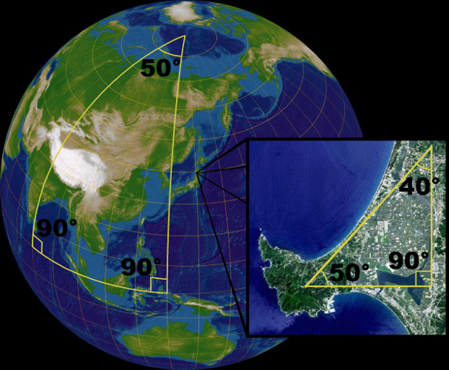

Illustration of spherical geometry, where the angles of a triangle do not sum to 180°. The globe is an orthographic projection centered on Japan at 135°30′ E, 36° N. The inset map is of Oga Peninsula, Akita, Japan at 139°52′ E, 39°56′ N. Landsat image with high-resolution data from Space Shuttle. (Author: Lars H. Rohwedder, used under the GFDL and CC-By-SA license).

Differentiated Instruction (Enrichment)
Here are some extension questions from Activity 6.6.3 that can be used to challenge students.
- Rewrite the formula for the area of a spherical triangle when E is measured in radians. (It becomes Area = Er²)
- A lune is defined as a figure bounded by two great circles. Find a formula for the area of a lune. (Let the degree measure of the angle between the circles be $α.$ Then the area of the lune is $\frac{α}{360°}4πr^{2}$.)

Following Activity 6.6.2 you may give Exit Slip 6.6.2.

In Activity 6.6.4 Projecting a Sphere onto a Plane students are shown how one projects parts of the globe onto the plane, creating maps, suggesting the fact that the sphere is, in fact, a 2-dimensional surface. Two cylindrical projections, Mercator and Gall-Peters, are contrasted. The Mercator projections distorts the sizes are as we get closer to the poles; for example, Greenland seems as big as half of Africa on a Mercator world map, when in reality it is one fourteenth the size of Africa. With the Gall-Peters projection, on the other hand, area is preserved but shapes are severely distorted near the poles. Students should use an actual globe or the one created from the template described in the materials section below to make these comparisons.

An application of spherical geometry is found in Activity 6.6.5 How Global Positioning Systems (GPS) Work. You may introduce the activity with this video: https://www.youtube.com/watch?feature=player_embedded&v=3zRlbboMvb0.
The video introduces the principle of trilateration. The activity starts with a two dimensional world in which one’s location can be determined precisely by finding the point where three circles intersect. They then extend this idea to three dimensions where at least four spheres are needed to pinpoint one’s exact location. One of these can be Earth itself. In practice more than three satellite signals are used since Earth is not a perfect sphere and locations on its surface vary in altitude. The system currently in use relies on 24 satellites in orbits about 11,000 miles above Earth. Time is synchronized with atomic clocks.

Knowing the distance of one’s location from each satellite leads to a system of quadratic equations in three variables. To keep algebraic manipulation to a minimum, in question 3d students are asked to set up but not solve a system. In question 3e students verify that the solution satisfies the system.

Journal Entry 2
Explain to someone who has not taken this course how spherical geometry is used in our everyday lives. Look for students to discuss general principles behind map making or GPS.

Closure Notes

In this investigation students learned how to think of a sphere as a surface and not as a solid. Ask them to discuss in what ways spherical and plane geometry are alike and in what ways they are different.

Vocabulary

Equator
great circle
geodesic
latitude
longitude
meridian
Prime Meridian

projection
sphere
spherical coordinates
spherical excess
spherical triangle
surface of revolution
trilateration
Resources and Materials

Internet

1. On-line spherical geometry models: one of the most widely used software is the “Spherical Easel” http://merganser.math.gvsu.edu/easel/applet.html . It lets the user draw lines, points, circles segments, one can measure angles and lengths (in two ways) and experiment with transformations. Angles and arcs arc measured in radians.

2. GeoGebra file to measure angles of spherical triangles: https://tube.geogebra.org/student/m698865.

3. Video explaining how GPS works:
https://www.youtube.com/watch?feature=player_embedded&v=3zRlbboMvb0
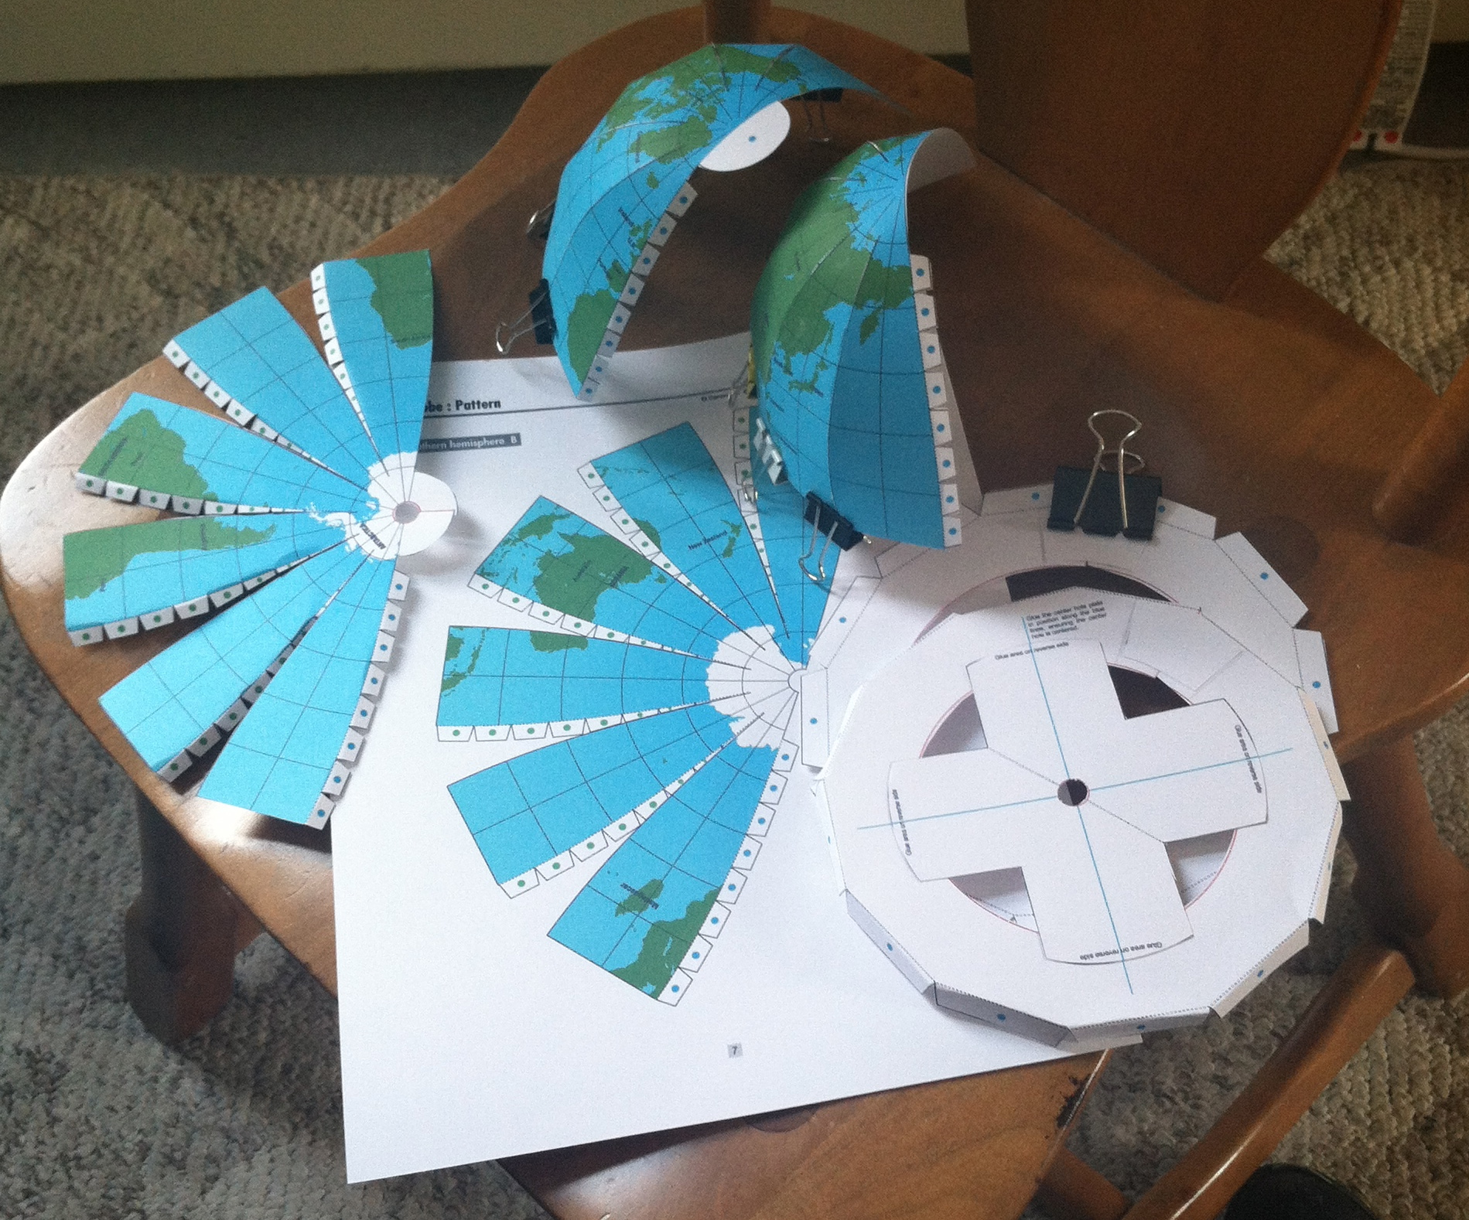
Note: An important mathematical vocabulary word in this file is misspelled. See if your students catch it!

Hands on

1. Paper plates with skewers or large knitting needs to demonstrate sphere as a solid of revolution.

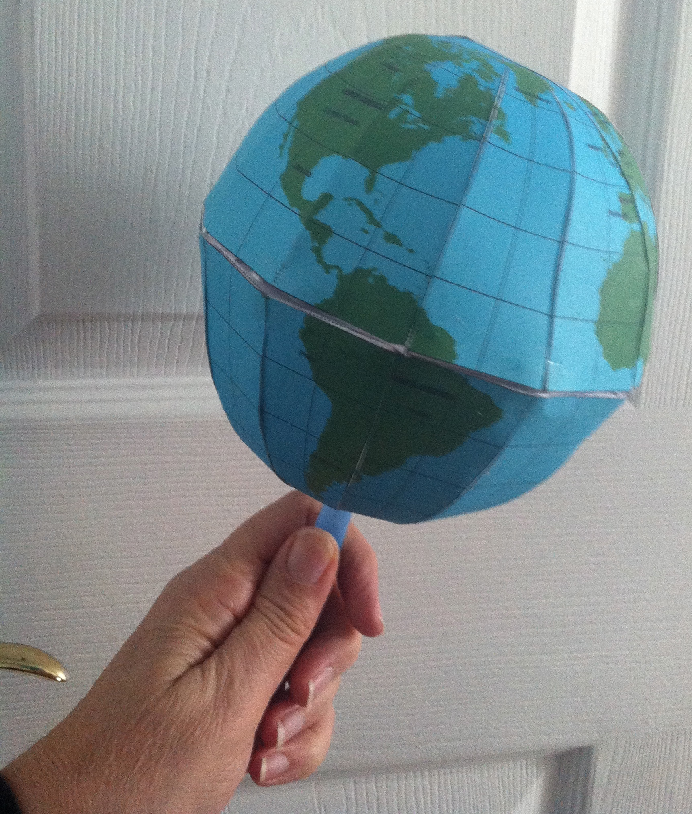
2. Two versions of a globe marked with latitude and longitude lines are available in the folder of resources. One is black and white, one is colored with green and white land masses and blue water features. They can be printed on card stock and assembled by the teacher or a volunteer who particularly enjoys model making. These models are a little fussy to put together, but they are convenient and inexpensive. One will need quick drying glue, sharp scissors, and some binder clips to assist in the construction. The colored globe has a hole for a stick to hold it so all of the surface is visible. A bubble straw cut ¾ of the length lengthwise will fit nicely in the hole and stabilizer.

A flat map for reference is also available here:
