Unit 5: Investigation 5 (2 Days)

Angle Bisectors and Inscribed Circles

CCSS:

G-C.3. Construct the inscribed and circumscribed circles of a triangle, and prove properties of angles for a quadrilateral inscribed in a circle.

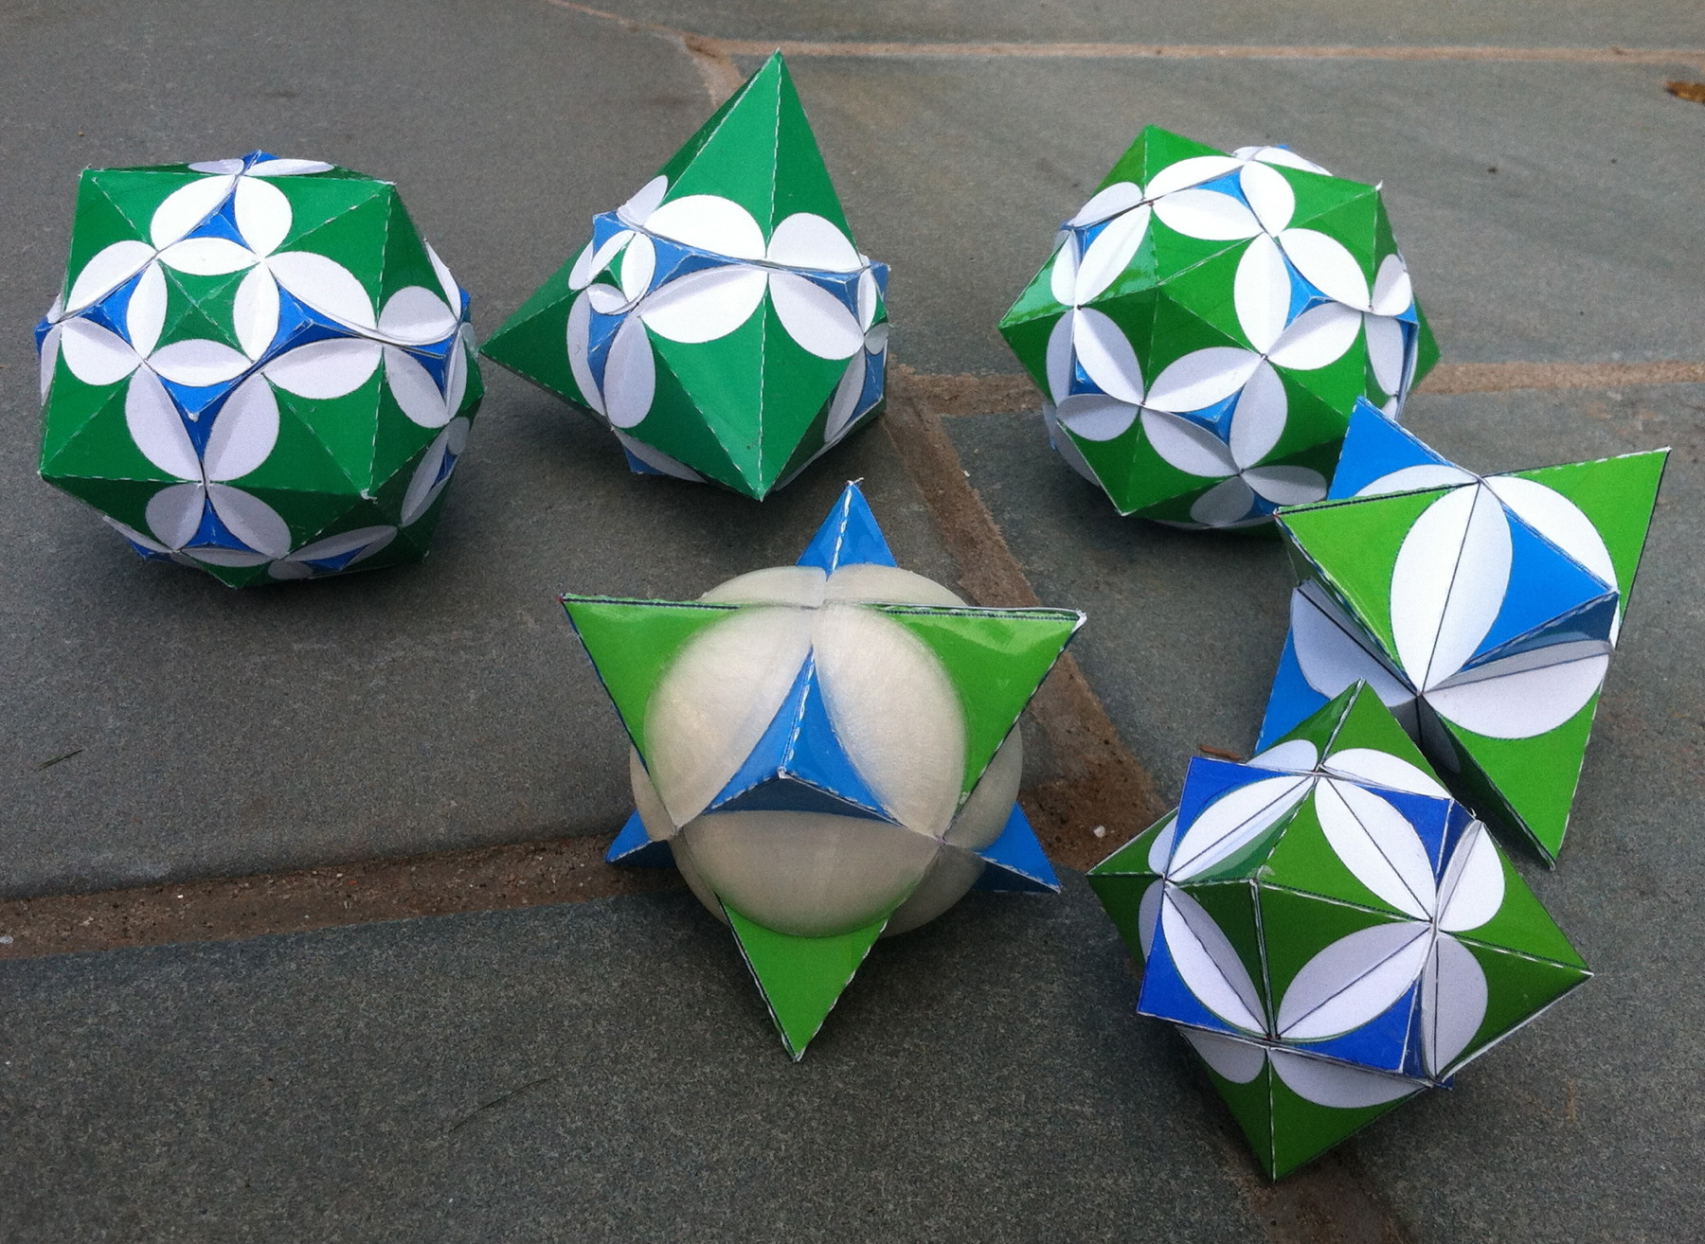
Overview

Each shape in this collection shows the intersection of two polyhedra called dual polyhedra. The circles on the faces of the polyhedra are inscribed in triangular faces and show where a sphere that passes through all of the intersections would intersect each face.

Investigation 5 leads to the construction of the center of the inscribed circle in a triangle, using the property that the bisector of an angle is the locus of points equidistant from the sides.

Assessment Activities

Evidence of Success: What Will Students Be Able to Do?

- Explain why the bisector of an angle is the locus of points equidistant from the sides of the angle.
- Inscribe a circle in a triangle

Assessment Strategies: How Will They Show What They Know?

- Exit Slip 5.5 asks students to apply the properties of tangents and angle bisectors in a triangle with an inscribed circle.
- Journal Entry asks students to explain how to inscribe a circle in a triangle.

Launch Notes

The teacher begins with a launch on the computer. Use either the GeoGebra or Geometers Sketchpad versions of “Inscribed Circle Experiment.” You are given a triangle, a center of a circle joined to two of the vertices and a point on the circle that determines the radius. You are provided with measures that the lines make with the sides of the angles and the length of the radius. Your task is to move the center of the circle and change the radius in such a way as to have the circle touch each of the sides of the triangle in one point. Move the vertices of the triangle in such a way as to create a variety of triangles. Look for data to support “good solutions”. “Does anyone have an idea about where to put the center of the circle? “ How could we get the radius of the circle just right?”

Teaching Strategies

In Activity 5.5.1 The Angle Bisector Theorem students discover that the bisector of an angle is the locus of points equidistant from the sides of the angle. The discovery and proofs come into two parts. First they discover and prove that if a point is equidistant from the sides of an angle, then it lies on the ray bisecting the angle. Then they discover and prove the converse: if a point lies on the bisector on an angle, then it is equidistant from the sides.

Group Activity
Have students work in pairs on a single computer in the discovery phases of Activity 5.5.1 using the files ctcoregeomACT551a and ctcoregeomACT551b.

If students do not have access to individual computers or computers they can share in pairs, the teacher may use the GeoGebra files for a classroom demonstration to generate conjectures but still have students complete the proofs on the activity sheet.

Activity 5.5.2 Inscribing a Circle in a Triangle uses the Angle Bisector Theorem to find the center of a circle inscribed in a triangle, with compass and straightedge. Then use the construction of a perpendicular from that center to a side of the triangle to find the radius. Knowing the radius and the lengths of the three sides enables us to find the area of the triangle.

Differentiated Instruction (For Learners Needing More Help)
Some students may initially believe that the bisector of an angle of a triangle is perpendicular to the opposite side. Thus it is important to use a scalene triangle the first time this construction is made, so that $\overline{FG}$ and $\overline{FD},$ for instance, are distinct. You may also want students to color-code the lines: one color for the bisectors of the angles and another for the lines from the center of the inscribed circle perpendicular to the sides.

Exit Slip 5.1 may be given after this activity.

Activity 5.5.3 Applying Tangents and Inscribed Circles asks students to apply what they have learned in Investigations 5.4 and 5.5 to solve problems involving tangents and segments. Some examples include: Finding the radius of a circle inscribed in a 3-4-5 right triangle. A point is 10 units from the center of a circle with radius 5, how long is a tangent segment drawn to the circle?

Differentiated Instruction (Enrichment)
Students have now observed three points of concurrency in triangles: medians in Unit 3 Investigation 6, perpendicular bisectors in Unit 5 Investigation 2, and now angle bisectors in this investigation. A fourth point of concurrency is the orthocenter, where the altitudes meet. Some students may use the internet to research its properties and the proof that the three altitudes are concurrent.

Journal Entry
Explain to another student how to inscribe a circle in a triangle and why the construction works. Look for students to use the locus property of angle bisectors.

Closure Notes

Ask students to compare and contrast circles that are circumscribed and inscribed about triangles. In both cases three lines in a triangle are concurrent. In both cases bisection is involved (perpendicular bisectors of the sides and angle bisectors) and the locus property of these lines is used in the proof. One significant difference is that the center of the circumscribed circle may lie outside the triangle, whereas the center of the inscribed circle always lies inside the triangle.

Theorems

Angle Bisector Theorem: The locus of points equidistant from the sides of an angle is the bisector of the angle.

Inscribed Circle (construction)

Vocabulary
inscribed circle (of a triangle)

Resources and Materials

Inscribed_circle_experiment.ggb or Inscribed_circle_experiment.gsp for launch.
Students will need GeoGebra for Activity 5.5.1. In this activity they will use the files ctcoregeomACT551a and ctcoregeomACT551b.

Compass and straightedge are used in Activity 5.5.2
Activity 5.5.1 The Angle Bisector Theorem
Activity 5.5.2 Inscribing a Circle in a Triangle
Activity 5.5.3 Applying Tangents and Inscribed Circles

