Unit 5: Investigation 3 (2 Days)

Central Angles and Arcs

Common Core State Standards

- G-C.5. Derive using similarity the fact that the length of the arc intercepted by an angle is proportional to the radius, and define the radian measure of the angle as the constant of proportionality; derive the formula for the area of a sector.

Overview

In this investigation, students will first be introduced to the concept of radians as a way to measure angles and arcs and the relationship between radian measure and degree measure. The investigation will then examine central angles and arcs. Students will discover that, given the measure of a central angle, the ratio of the length of the intercepted arc to the radius of the circle is constant. This will allow them to find the length of an arc given the radian measure of the central angle: arc length = $rθ$, where $θ$ is measured in radians. Also the sector area $=\frac{r^{2}θ}{2}.$

Assessment Activities

Evidence of Success: What Will Students Be Able to Do?

- Find the measure of an angle in degrees given its measure in radians and vice versa
- Derive an equation that relates the measure of the central angle, the length of the radius, and the length of the intercepted arc (arc length = $rθ$)
- Calculate arc length given the radius of the circle and the measure of the central angle.
- Derive an equation that relates the area of a sector, the length of the radius, and the measure of the central angle (sector area $=\frac{r^{2}θ}{2}$).

Assessment Strategies: How Will They Show What They Know?

- Exit Slip 5.3.1 asks students to convert from degrees to radians and vice versa.
- Exit Slip 5.3.2 asks students to use formula for arc length to solve problems.
- Journal Entry asks students to think of one or more situations where it would be more helpful to use degree measure than radian measure.

Launch Notes

Ask students if they have ever ridden on a Ferris Wheel. Explain that one of the largest wheels is in London and is called the London Eye. Here is a picture of it:



Image from destinationtravels999.blogspot.com.

You may want to show a video of the London Eye. Here is one that lasts for about a minute:
https://www.youtube.com/watch?v=3rMJadxEjWU.

Now ask, what would happen if we needed to replace a piece of the frame? How would we know how long it would need to be? The next picture shows the beginning and ending points of the fictional piece we need to replace:



There should be a class discussion about how that piece of the circle isn’t linear and the difficulty that will cause in measuring. Explain that this piece of the circle is called an arc and that we need some way to measure the length of an arc.

Teaching Strategies

Activity 5.3.1 Radians and Degrees is an investigation of the relationship between degrees and radians. Have students open the file ctcoregeomACT531, which displays angles measuring 45°, 90°, 180°, 270°, and 360°. They follow instructions on the activity sheet to find the radian measure of each of these angles and create a table that looks like this:

Angle Measure | Radians
45° | 0.79
90° | 1.57
180° | π
270° | 4.71
360° | 6.28

Using the results, have students work together to come up with an equation that relates degree measure to radian measure. Noticing the relationship between 180° and π radians is helpful in deriving an equation.

After they have explored the relationship between angle measure and radian measure, we can define what a radian is and why we use it. A simple definition for radian is: the measure of an angle at the center of a circle that intercepts an arc whose length is equal to the radius of the circle. See http://www.mathopenref.com/radians.html, which has a nice interactive demonstration.

Through a visual demonstration and reasoning, students should conclude that 1 radian is slightly less than 60°. To the nearest 0.1 degrees, 1 rad ≈ 57.3°. To convert from radians to degrees students can multiply the radian measure by 57.3° or by 180°/π. To convert the other way, use the reciprocal π/180° ≈ 0.0175. Ask students which form of the conversion factors is easier to remember; hopefully they will opt for 180°/π and π/180°.

At the end of the first day, you may give students Exit Slip 5.3.1 which asks them to convert from degrees to radians and vice versa. You may also assign this group activity.

Group Activity
Have students work in groups of four. Have them draw 4 circles with a compass. Student #1 picks two points on a circle, draws the radii to these points and highlights an arc. Student #2 states whether the highlighted arc is a major arc, a minor arc, or a semicircle. Student #3 estimates the degree measure of the central angle intercepting the arc. Student #4 estimates the radian measure of the central angle. The group needs to come to consensus on the accuracy of the estimates and modify them if necessary. They may use protractors for this. Do this activity four times, rotating the roles so that everyone plays each role.

Note for teachers: Although GeoGebra uses the label “rad” to indicate radians, since a radian is the ratio of two lengths (arc to radius) it is actually a “unit-less” real number. In more advanced courses units are not used for radian measures.

In Activity 5.3.2 Radians and Arc Length students explore the relationship between the measure of a central angle in radius and the length of its intercepted arc. This activity uses the Geogebra file ctcoregeomACT532.ggb.

By the end of the activity, you want students to recognize (on their own) that the measure of the central angle in radians will also be the same as the ratio of the intercepted arc and the radius. Note that in the algebra window below that the angle measure, α is equal to the ratio that was computed. The power of dynamic software is that these two values will be equal no matter the changes made to the circle. Use dilations and relate to the concept of similarity developed in Unit 4.

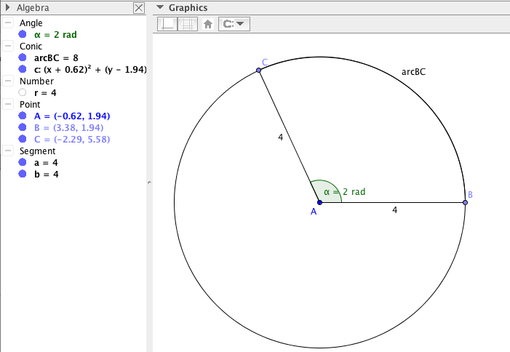

Differentiated Instruction (Enrichment)
In activity 5.3.2 students discover that GeoGebra will not measure an angle that is greater than 2π radians or 360°. You might ask some students to speculate about what meaning if any these angle measures have. This will prepare them for the more expansive notion of angle needed for the trigonometric functions in Algebra 2 and beyond.

If computer access is not available to individual students, use the two files ctcoregeomACT 531 and ctcoregeomACT532 to demonstrate the concept of radian and its relationship to arcs in preparation for the next activity. You may also want students to do a hands-on activity developing the concept of radian measure. One example is Activity 6.1.2 in the Connecticut Core Algebra 2 curriculum.

Activity 5.3.3 Arcs and Sectors introduces students to the classification of arcs as major arcs, minor arcs, or semicircles and the relationship between the length of an arc, the measure of its central angle, and the circumference of the circle. Because all circles are similar, the ratio of arc length to radius is constant for a given measure of the central angle. The concept of an arc as part of the circumference of a circle is extended to a sector and the area of a circle.

Following this activity you may formalize the relationship between central angles, the lengths of arcs, and the areas of sectors with the following theorems:

Arc Length Theorem: The length of an arc of a circle is equal to the product of the radius and the radian measure of the central angle that intercepts the arc.
Area of a Sector Theorem: The area the sector of a circle is equal to the half product of the square of the radius and the radian measure of its central angle.

Differentiated Instruction (for students needing more help)
Some students may have difficulty either with the technology from the previous activities or in recognizing the relationship between arc length and radius length. You might have to prompt these students more to come up with the formula.

Activity 5.3.4 Applications of arc Length is an extension of the previous activities to real world problems, such as calculating the length of a piece of the Ferris wheel.

At the end of the second day you may give Exit Slip 5.3.2, which asks students to use the formula for arc length to solve problems.

Closure

Discuss advantages and disadvantages of the two ways we have to measure angles. An advantage of degrees is that we can think in terms of whole numbers, e.g. 90° for a right angle.
An advantage of radians is that the formula for finding arc length is simpler (arc length =$rθ)$ vs.
$r\frac{θ}{180}π$ when $θ$ is measured in degrees.

Journal Entry: Give one or more examples of situations where it would be more helpful to use degree measure than radian measure. Look for students to come up with examples where the angle measure in degrees is a factor of 180° (e.g. 30°, 45°, 90°) or where one needs to use a protractor calibrated in degrees. For example, a blueprint may give the degree measure of an angle. Instruction for a geocache may give degree measurements on a compass like 10° North of East, etc.

Vocabulary

arc
arc length
central angle
intercepted arc
major arc
minor arc
sector
semicircle
radian

Theorem
Arc Length Theorem: The length of an arc of a circle is equal to the product of the radius and the radian measure of the central angle that intercepts the arc.
Area of a Sector Theorem: The area the sector of a circle is equal to the half product of the square of the radius and the radian measure of its central angle.
Resources and Materials

Picture of London Eye:
http://en.wikipedia.org/wiki/London_Eye#/media/File:London-Eye-2009.JPG

Video of London Eye: https://www.youtube.com/watch?v=3rMJadxEjWU.

Interactive demonstration of radians:
http://www.mathopenref.com/radians.html

Activities:
Activity 5.3.1 Radian Measure
Activity 5.3.2 Central Angles and Arc Length
Activity 5.3.3 Arcs and Sectors
Activity 5.3.3 Applications of Arc Length and Sector Area

GeoGebra is used in Activities 5.3.1 and 5.3.2

Prepared GeoGebra files: ctcoregeomACT531 and ctcoregeomACT532

Compass and protractor for the group activity.

Radian protractors may be found at www.proradian.net.

