Activity 6.7.1 Three-Dimensional Modeling: Understanding the Problem

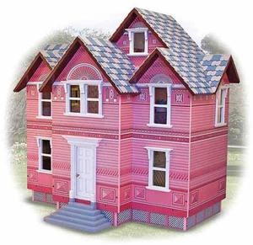
Eleanor's seven-year-old cousin is a budding interior designer and recently got a Victorian doll house for a birthday present.

The toy company describes the house this way:

"This classic doll house features Victorian styling and a pretty pink coat of paint... Use the available furniture sets to outfit the six rooms and move right in with our Victorian Doll House Family, or play with any 1:12 scale dolls (about 5 in. tall) and furniture. However your family chooses to play with it, this elegant home is sure to be cherished for many years to come!"

Unfortunately, the model Eleanor’s cousin received included the dolls but did not come with furniture, so Eleanor has agreed to help her make some.

Eleanor’s local library has a new 3-D printer and the librarian is looking for volunteers to plan after-school programs for middle school students to learn how to use this equipment. Eleanor talked to the librarian who thought making doll house furniture would be a good project for middle school students to do.

Eleanor decided it would be good idea to start by designing a couch for her cousin. Her plan was to make a sketch using the solid shapes we have been studying in this Unit. She would then use one of the 3-D design tools to create a virtual 3-D image that would produce the files that could be sent to the 3-D printer. She would print out the couch and help her cousin "upholster" it by gluing some fabric scraps to it. The dolls that came with the house are between 3 and 5 inches tall. They have joints at the knees and hips so they can sit on a couch.

In this investigation you will follow Eleanor's task along the way and answer some questions that she encounters as she solves her problem. Then you will have a chance to design another piece of furniture for the house yourself.

Your group will design a plan to solve this problem. Begin by considering the following questions. Provide answers to them in the spaces below each question.

- What is our task? State this in one clear sentence.

- What do we need to know to complete this task? We may need to do some research. What resources do we have to do this research?

- What mathematics do we need to use to solve this problem? Are there any special measuring tools we might need to use?

- Do we need to prepare a rough sketch to help us get started?

- What are the steps we will need to follow to reach an appropriate conclusion?

- How will we know if our modeling is successful?

