Activity 6.6.5 How Global Positioning Systems (GPS) Work

GPS uses trilateration to help you determine where you are on earth. Here is a link to a video that will give you a head start on understanding how this works.

https://www.youtube.com/watch?feature=player_embedded&v=3zRlbboMvb0

Below are some problems to help you understand how it works.

- Suppose you live on a flat earth (in our case the xy-plane). You have been wandering around, and have lost your place. However, with your Flat Earth Positioning System (FEPS) you can tell me how far away you are from any point in the plane.
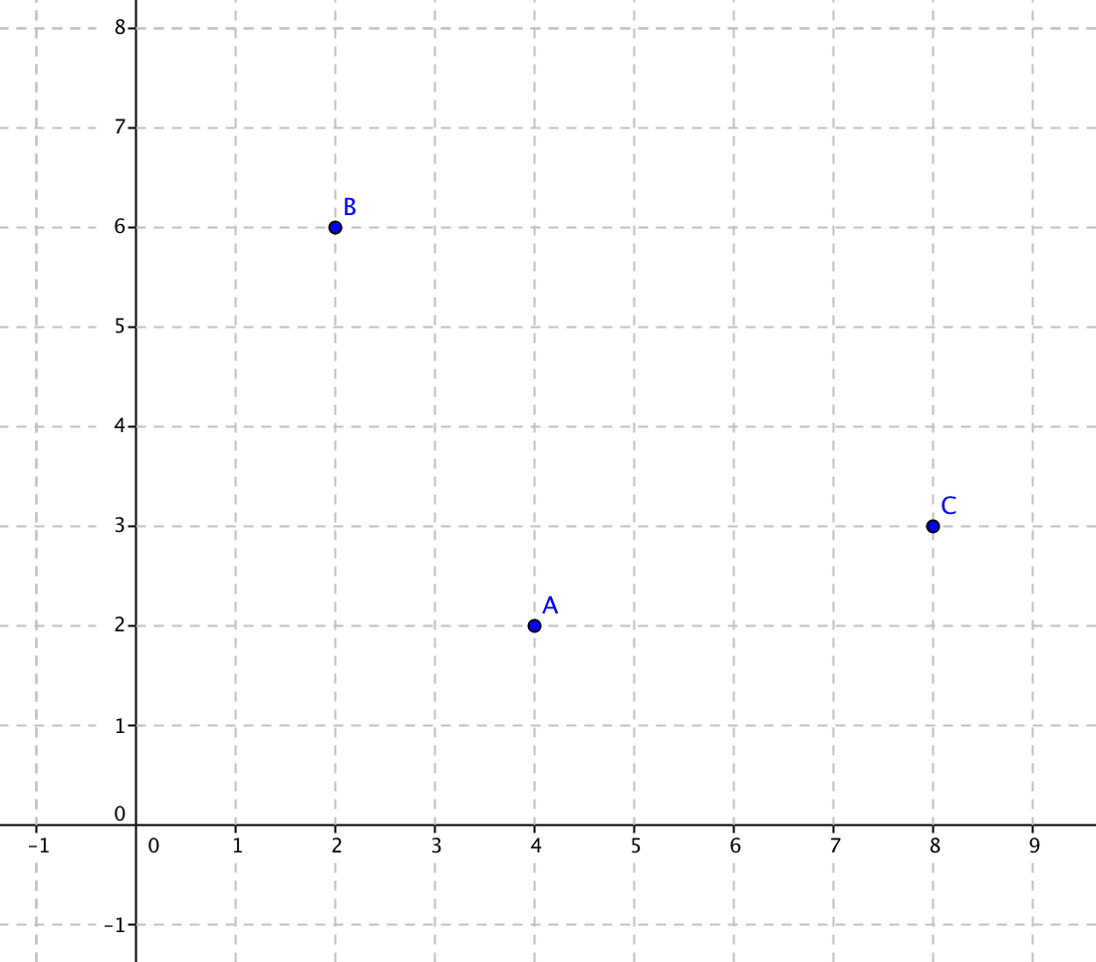
Here is a graph of this flat earth. Satellites are located at points A, B and C. The FEPS tells you that you are approximately 4.24 units from A, 5.10 units from B, and 2.23 units from C.

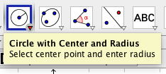
Use a compass and ruler with this graph or open the file ctcoregeomACT665 to answer the questions below. If you use the GeoGebra file, use the tool Circle with Center and Radius.

a. Find the coordinates for each of the points A, B and C.

A,(____,____) B(____,____) C(____,____)

b. Where are all the points located 4.24 units from point A? How many points are determined so far?

c. Locate the set of points 5.10 units from point B. Graph them. How many points are there in the intersection of this locus with the set of points identified in part (b) above?
d. We still need to find the points that are 2.24 units from point C. Graph them. Why do we need these points?
e. Do you know where you are now? Find the coordinates of your location. Call this point P and plot it on the graph.
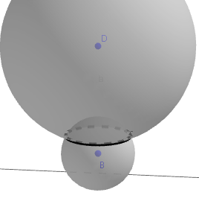
- The diagram at the right shows intersecting spheres with centers at B and D.

  - Describe the figure formed by their intersection.
  - In Unit 5 you learned that a circle in the coordinate plane with radius r and center (h, k) has equation ${(x-h)}^{2}+{(y-k)}^{2}=r^{2}.$ Earlier in this unit you learned that a sphere with center at the origin has equation $x^{2}+y^{2}+z^{2}=r^{2}$. Now put these two ideas together an write an equation for a sphere with radius r and
center (h, k, l).
The two spheres shown above have these equations:
(1) $x^{2}+y^{2}+{(z+1)}^{2}=4$
(2)$x^{2}+y^{2}+{(z-5)}^{2}=28$
  - Find the center and radius of each sphere.
  - Take (1) and (2) as a system of equations and solve for z.
  - In part (d) you showed that z = 0 is the solution to the system of equations. This means that the intersection of the two spheres lies in the xy-plane. Now substitute z = 0 in one of the original equations, to get an equation in x and y.
  - Describe the set of points in the xy-plane that satisfy the equation found in part (e).
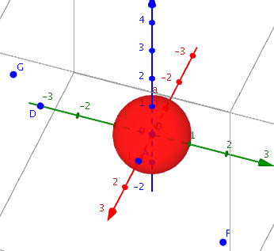
- Now suppose you live on a sphere centered at the origin O and passing through the point B(1,0,0). Satellites are points in space with coordinates F(–3,3,0), G(2,–3,3), and D(0,–3,0). This time you have a 3-Space Graphical Positioning System (3-SGPS). The sphere you live on doesn’t move, nor do the satellites move. Readings from the positioning system show the following. F is 4.359 ≈ $\sqrt{19 }$units from your position, G is 4.123 ≈$\sqrt{17}$ units away, and D is 3.162 ≈ $\sqrt{10}$ units away.

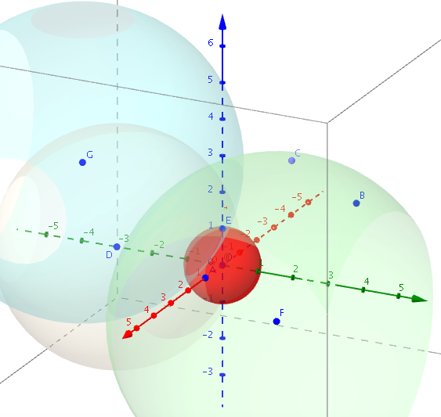
  - How would you describe the set of points that are on your sphere and also 4.359 units away from F?
  - If you now find the points of the sphere that are 4.123 units away from G, it is a set similar to the set described in part (a). What will the intersection of those two sets be?
  - Now find the set of points on the sphere 3.162 units from D. What does this tell you?

  - Set up a system of equations you could use to find the coordinates of your location. Do not attempt to solve the system.

  - Verify the point (0, 0, 1) satisfies all four equations in the system.

