Activity 6.6.3 Triangles on a Sphere

1. When three points on a sphere are connected with arcs of great circles, a spherical triangle is formed. Using a plastic sphere, pick three points on the sphere that are fairly close to each other. Draw the great circles going through each pair of points and identify the triangles formed. You should find more than one triangle.

a. Sketch what you see in the space below.
b. How many triangles are formed by the three intersecting great circles?

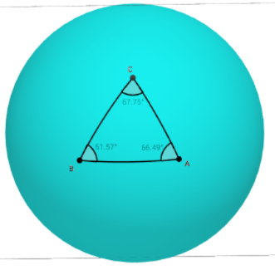
2. Let’s find the sum of the interior angles of a spherical triangle.
Go to this site: https://tube.geogebra.org/student/m698865.
You will see a sphere and three points on the sphere. There are three buttons on the left: Unrestricted, Right angle and Equilateral.

Click on the Equilateral button. You will be able to click on each point and, by moving the cursor, modify the size of the triangle, all while the sides stay equal. Play with the cursor and create each of these triangles. Note the lengths of the sides in the spaces below as well as the sum of angle measures
a. a triangle with each angle measuring close to 90 degrees:
AB = ______ AC = _______ BC =______ Sum of angle measures = _______
b. a triangle with each angle measuring close to 120 degrees:
AB = ______ AC = _______ BC =______ Sum of angle measures = _______
c. a triangle with angle measures close to 60 degrees (you won't be able to get a triangle with angle measures exactly 60 degrees):

AB = ______ AC = _______ BC =______ Sum of angle measures = _______

- Using the same program, click on the Right angle button. Play with the cursor and create each of these triangles. Note the lengths of the sides in the spaces below as well as the sum of angle measures
a. a triangle with one angle measuring close to 30 degrees:
AB = ______ AC = _______ BC =______ Sum of angle measures = _______

b. a triangle with one angle measuring close to 60 degrees:
AB = ______ AC = _______ BC =______ Sum of angle measures = _______
c. a triangle with one angle measuring close to 45 degrees:
AB = ______ AC = _______ BC =______ Sum of angle measures = _______

4. Based on your observations so far make conjectures to answer these questions.

- The sum of the interior angle measures of a plane triangle is always 180°. What can you say about the sum of the interior angle measures of a spherical triangle?
- How is the size of a spherical triangle related to the sum its interior angle measures?

5. Let’s see how large we can make the sum of the interior angle measures of a spherical triangle. In the figures below we have spherical triangles with right angles at A and B. Points A and C are fixed. B is free to move around a great circle passing through A.
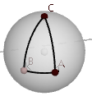
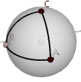
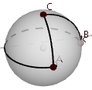
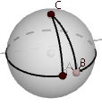
Figure 1 Figure 2 Figure 3 Figure 4

- In figure 1, m$∠ACB$ = 45°. The sum of the angle measures is _________.
- In figure 1, m$∠ACB$ = 90°. The sum of the angle measures is _________.
- In figure 1, m$∠ACB$ = 270°. The sum of the angle measures is _________.
- In figure 1, m$∠ACB$ = 340°. The sum of the angle measures is _________.
- Make a conjecture about the largest possible sum of the interior angle measures in a spherical triangle. Explain your thinking.

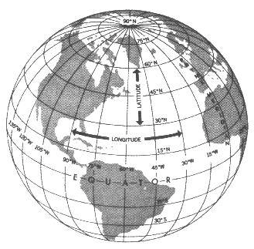
- On a globe find the triangle that joins the North Pole to these two points: (a) the intersection of the equator with the prime meridian, in Atlantic Ocean off the coast of Africa, and (b) the intersection of the equator with the 90°W meridian, in the Pacific Ocean off the coast of South America.
http://www.navfltsm.addr.com/basic-nav-general.htm
a. Find the measure of each angle in this spherical triangle.
b. Find the sum of the angle measures.
c. Subtract 180° from the sum found in (b). This is called the spherical excess of the triangle.
d. What fraction of the surface area of the sphere is the area of this triangle?
(Hint: imagine extending the sides of the triangle to form three great circles.

e. Recall that the radius of the earth is 3963 miles. Find the area of this spherical triangle.

f. The great circles containing the sides of this triangle form 8 congruent triangles covering the entire surface of the sphere. Find the total spherical excess of these triangles.
g. Let E represent the spherical excess of a triangle. A formula for finding the area of any spherical triangle is Area = $\frac{E}{____}∙4πr^{2}$. Fill in the blank in the denominator of the fraction.

- Use the formula from question 6g to complete this table:

Radius of the sphere | Sum of the angle measures of a spherical triangle | Area of the spherical triangle (in unit²)
1 | 200°
2 |  | 4π
5 | 400°
10 |  | 10π
R | S

