Activity 6.6.2 Geodesics on a Sphere

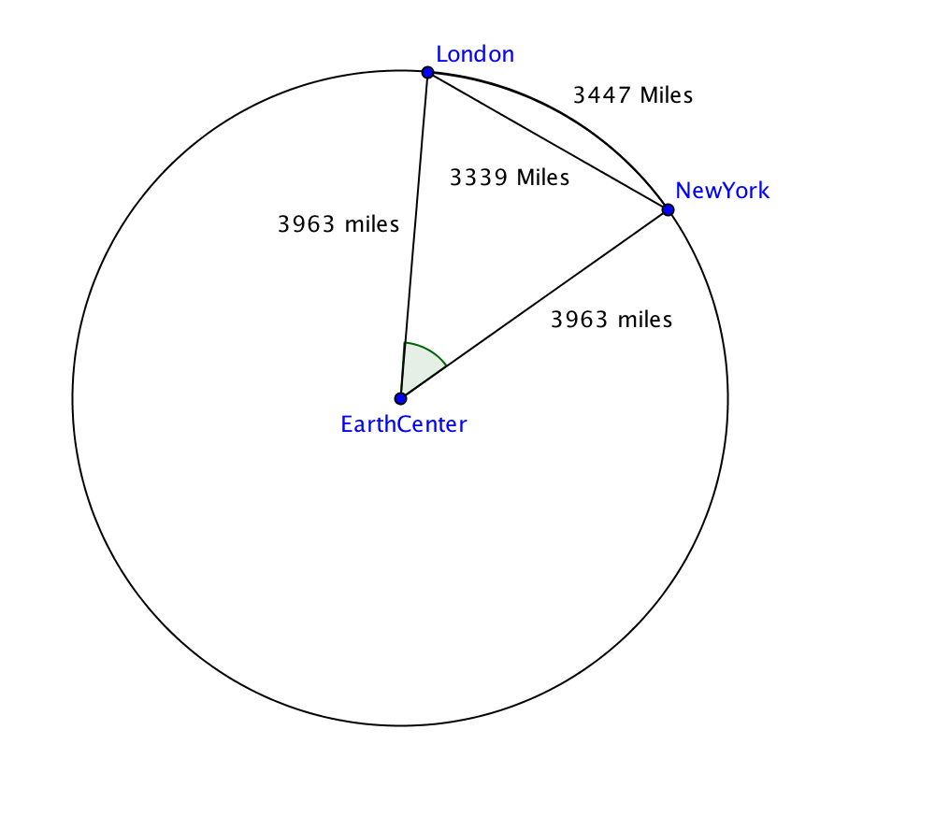
It is well known that on a plane, the shortest path between two points is the line segment joining the points. What about paths on the surface of the sphere? We can’t use the line segment joining the points since that would take us into the interior of the sphere. For example to travel from New York to London, England, we normally take an airplane that flies just above Earth’s surface. A shorter path would be through a tunnel beneath the surface, but one has never been built!

1. The firgure above shows a cross section of Earth containing the center and the location of New York and London. How much distance would be saved if the tunnel between the two cities were built? What percent of the suface distance between New York and London would that be?

2. Find, to the nearest degree, the measure of the angle at the Earth’s center formed by the two radii shown.

The shortest path between two points on any surface is called a geodesic. On a plane the geodesics are straight lines. On a sphere, the geodesics are great circles. A great circle of a sphere is one that contains the center of the sphere.
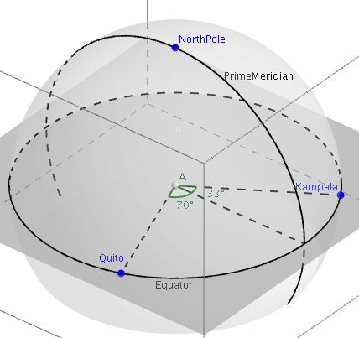

3. Find the distance on the Earth’s surface between Quito, Ecuador, and Kampala, Uganda. Both cities line on the Equator, which is a great circle. The longitude of Quito is 70°W and the longtitude of Kampala is 33° E. Assume Earth is a sphere with radius = 3963 miles.

4. Boulder, Colorado, and Beijing, China have the same lattitude, 40°N. All points with that lattitude lie on a circle that is parallel to the Equator as shown on the left belwo

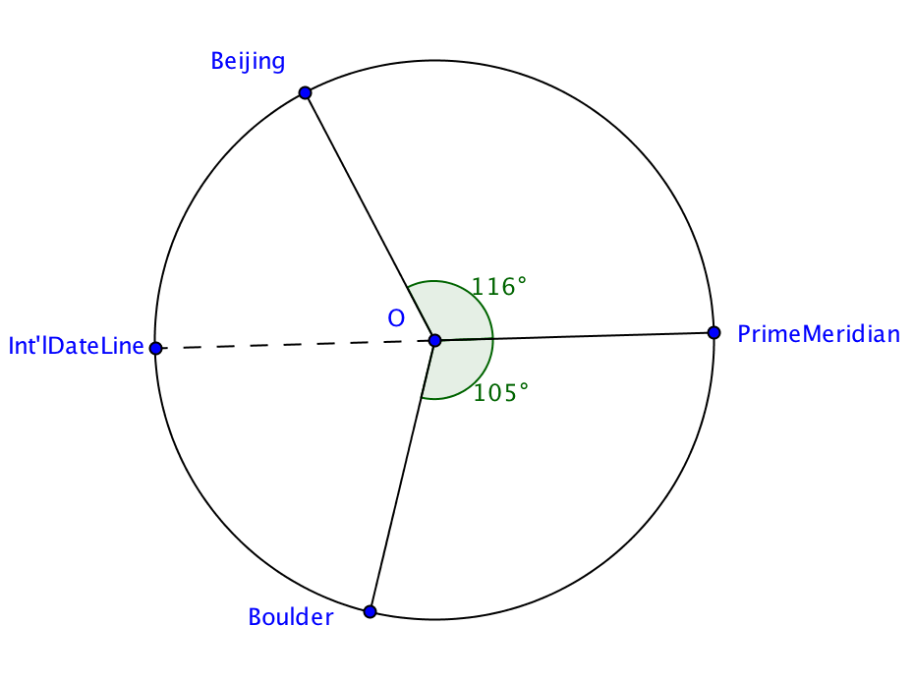
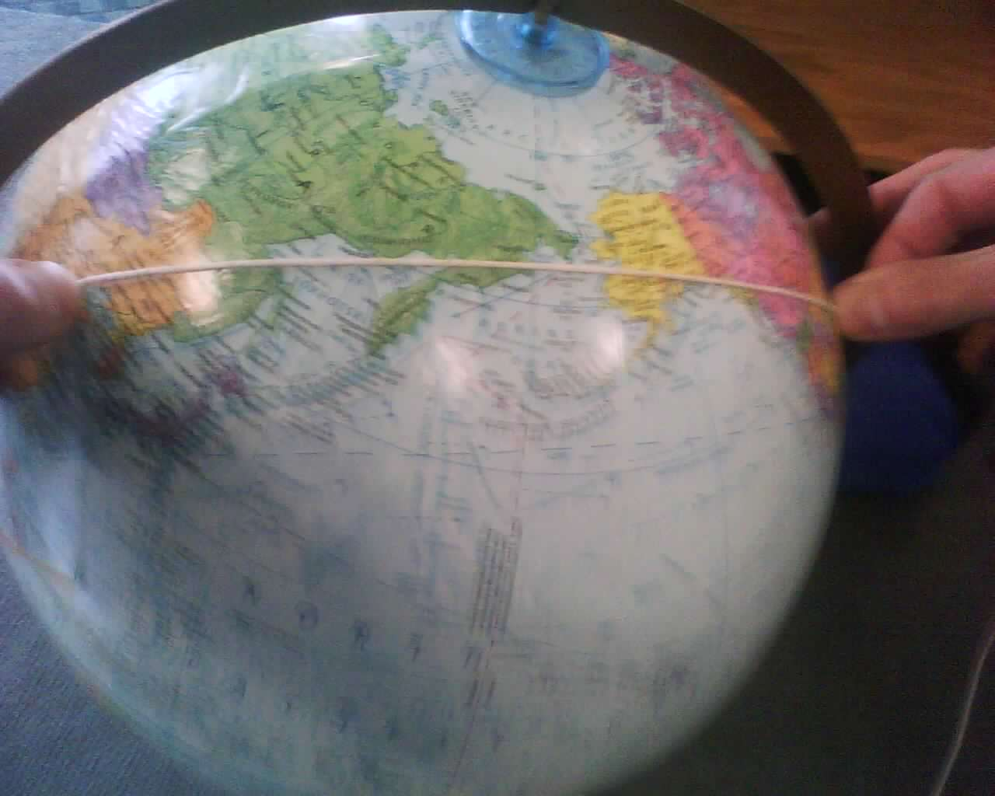
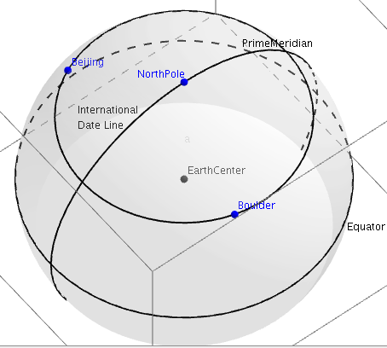

a. Is the 40°N circle a great circle? Explain.

b. Locate Boulder and Beijing on a globe. Work with a partner to place a piece of string on the globe in both locations and pull it tight. This will give you the geodesic passing through Boulder and Beijing. See photo above. Does it lie along the 40°N circle?

c. The longitude of Boulder is 105°W. The longitude of Beijing is 116° East. If you travel west along the 40°N circle from Boulder to Beijing, you’ll cross the International Date Line. How many degrees of longitude will you pass through? See cross-section of the sphere above right.
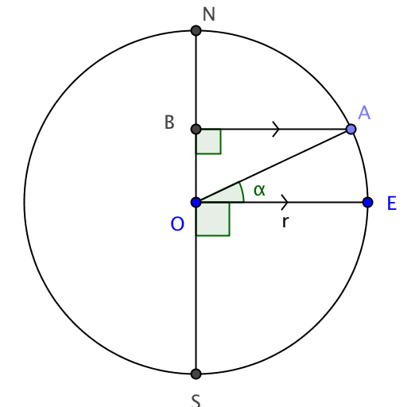

d. The figure at the right shows a cross-section of Earth. O is the center, r is the radius, N is the north pole, S is the south pole, E a point on the equator, and A is a point with latitude $α$° North. $\overline{AB}$ is parallel to $\overline{OE}$. Show that AB = r cos $α.$

e. As shown in part (d) the radius of the 40°N circle is cos(40°) times the radius of the earth. Again assume Earth is a sphere with radius = 3963 miles. Find the length of arc from Boulder to Beijing along the 40°N circle.

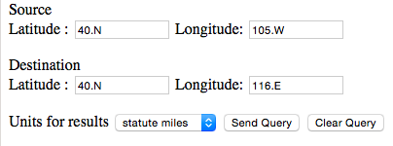
f. To find the great cicle distance between Boulder and Beijing, visit http://jan.ucc.nau.edu/~cvm/latlongdist.html#formats.
Enter Latitudes and Longitudes as shown and click on Send Query. What is the great circle distance and how does it compare with what you found in question 4e?

5. You may be curious about how the calculator on the web site in question 4e works. Here’s how you can find the great circle distance with only a hand held calculator.
Convert latitude and longitude in spherical coordinates. Recall the rules from Activity 6.6.1. Use these rules in reverse to find φ and θ:
Latitude = 90° – φ. Positive numbers indicate degrees North of the Equator and negative numbers indicate degrees South of the Equator.
For 0° ≤ θ ≤ 180°, Longitude = θ measured in degrees East of the Prime Meridian.
For 180° < θ < 360°, Longitude = 360° – θ, measured in degrees West of the Prime Meridian.
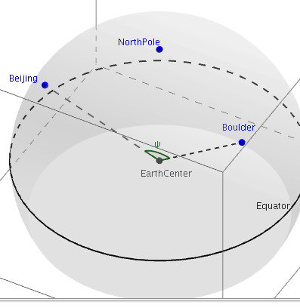

a. Find φ₁ and θ₁ for Boulder.

b. Find φ₂ and θ₂ for Beijing.

c. Use this formula to find cos ψ where ψ is the angle formed by the radii from the center of Earth to Boulder and Beijing:

cos ψ = cos φ ₁cos φ ₂+sin φ ₁sin φ ₂cos(|θ ₁− θ ₂|).

d. Now find the length of the sector of the great circle passing through Boulder and Beijing, using this formula: distance = 2πr$∙$ $\frac{ψ}{360°}$ where r is the radius of the sphere.

6. Boulder and Beijing have the same latitude. However, you found that the shortest path between the two cities does not lie along the circle containing all locations with that latitude. What happens if two cities have the same longitude? For instance, Windhoek, Namibia is located at 23°S 17°E whereas Bratislava, Slovakia is located at 48°N 17°E.

- Use the fact that meridians of longitude lie on great circles, to find the distance between the two cities directly.
- Verify you calculation in (a) using the web site in question 4e or the formula in question 5.

7. The techniques you have learned for finding distance on the surface of Earth, apply to any sphere. Find the great circle distances between points P and Q, where both lie on a sphere with center at the origin.

  - Point P: r =4, φ₁= 30°, θ₁=60°, Point Q: r =4, φ₂= 135°, θ₂=90°
  - Point P: r =3, φ₁= 45°, θ₁= 120°, Point Q: r =3, φ₂= 90°, θ₂= 180°

- You are given the rectangular (x, y, z) coordinate of two points lying on a sphere with center at the origin. Find the great circle distance between them:

  - P=(0, 3,0) and Q=(3, 0, 0)
  - P=(0, $\sqrt{2}$, $\sqrt{2}$) and Q=($\sqrt{2}$, 0, $\sqrt{2}$)

