Activity 6.6.1 Coordinates on a Sphere
Spherical Coordinates

In Activity 6.4.3 you found that any point in three-dimensional space may be described with three variables, x, y, and z. Because these are based on three perpendicular axes, they are called rectangular coordinates. Another method of describing a point in space uses spherical coordinates. Here is how this method works.
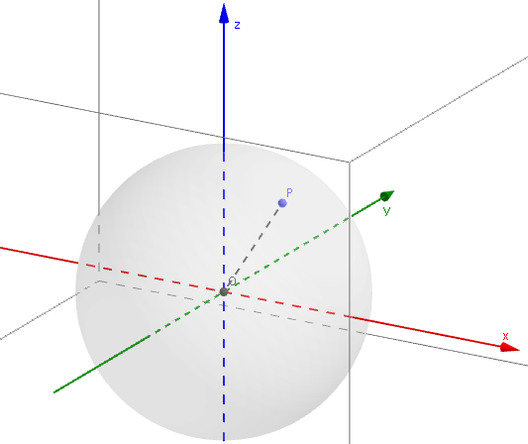
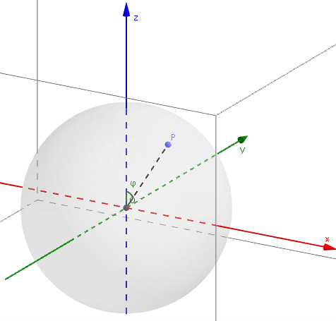
Consider a point P on a sphere of radius r (which is fixed). In the figure below $\overline{OP}$ is the radius. The center of the sphere is the origin of the rectangular coordinate system; that is, the point where the x-, y-, and z-axes meet.
We measure an angle φ starting from the positive z-axis. φ is between 0 and 180 degrees.
Then we draw a line through P perpendicular to the xy-plane. In the figure at the right, this line interests the xy-plane at point D.
D is called the projection of P onto the xy-plane.
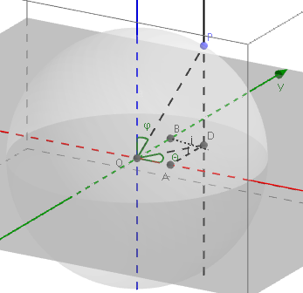
Note the angle that $\overline{OD}$ makes with the positive x-axis. We call this angle θ, which is between 0 and 360 degrees, when measured from the x-axis in the counter-clockwise direction.

1. Explain why m $∠OPD$ = φ.
2. Show why OD = r sin φ and PD = r cos φ.

3. Let the rectangular coordinates of P be (x, y, z). What are the rectangular coordinates of D? (Hint: since D lies in the xy-plane, one of its coordinates is 0. Which one?)
Now let’s look at the xy-plane. Recall that θ is the angle $\overline{OD}$ makes with the positive x-axis.

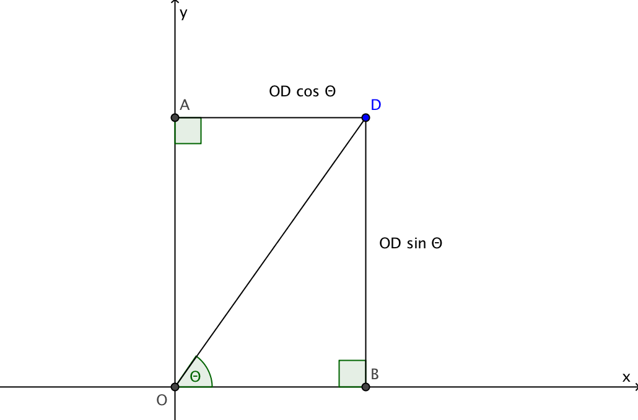
4. Explain why OA = OD sin θ and OB = OD cos θ.

5. Let OB = x and OA = y where x and y are coordinates of point D. The rectangular coordinates of a point (x,y,z) on the sphere can now be written in terms of r, φ, and θ.
x = ___________ y = ____________ z = ______________

Check your answers with your classmates to be sure your equations are correct.

- The spherical coordinates are given. Find the rectangular coordinates of the point. If you use your knowledge of special right triangles, you don’t need a calculator.
  - r =6, φ= 60°, θ=30°
  - r =3, φ= 30°, θ=45°
  - r =4, φ= 45°, θ= 60°
- The angles in question 7 are all between 0° and 90°. In another course you will learn to find sine and cosine for angles that are greater than 90°. For now use a calculator and realize that some of your answers may contain negative numbers. Again find the rectangular coordinates of each point.

  - r =5, φ= 60°, θ=120°
  - r =3, φ= 150°, θ=180°
  - r =2, φ= 135°, θ= 270°
- On a plastic sphere locate the points in questions 7 and 8.

- Now let’s reverse the process. The rectangular coordinates are given. Find the spherical coordinates of the point. Hint: first use the equation of the sphere, $x^{2}+y^{2}+z^{2}=r^{2}$ to find r. Next find φ and then find θ. Use a calculator.
  - x = 0, y = 3, z= 0
  - x= –1 y = 1, z=$\sqrt{2}$
  - x = $\sqrt{3}$, y = 1, z =$2\sqrt{3}$

Latitude and Longitude
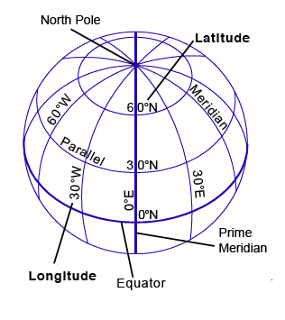
If we are only focused on the surface of a sphere, we can ignore the radius since for all points on the sphere, r is the same.

For example, we inhabit the planet Earth, which is a three dimensional object, but because we live only on its surface, to specify a certain point on the globe, the radius is redundant. (Actually the radius is slightly smaller at the North and South poles than at the equator, but for our purpose we can assume that Earth is a perfect sphere.)

Thus the two angles φ and θ give us all the information we need to locate a point on Earth’s surface. The terms latitude and longitude are related to φ and θ as follows:
http://www.gisteam.de/ftp/Tutorial/project.pdf, p. 8.
Latitude = 90° – φ. Positive numbers indicate degrees North of the Equator and negative numbers indicate degrees South of the Equator.
For 0° ≤ θ ≤ 180°, Longitude = θ measured in degrees East of the Prime Meridian.
For 180° < θ < 360°, Longitude = 360° – θ, measured in degrees West of the Prime Meridian.

- The latitude and longitude of Boston, Massachusetts are 42° 21’ N and 71° 3’ W.
a. The symbol ‘ indicates minutes. There are 60 minutes in one degree. Express the latitude and longitude of Boston to the nearest 0.1 degrees.

b. Knowing that all of Connecticut lies south and west of Boston, which measurement would you expect to be greater for towns in Connecticut, latitude or longitude? Explain your thinking.

11. For this question may use www.worldatlas.com/aatlas/indlatlong.htm.

a. Find latitude and longitude of your town. Does this agree with your conclusion in question 10(b)?

- Find the latitude and longitude of five other cities on at least three different continents. Give measurements to the nearest 0.1 degrees.
City | Latitude | Longitude

12. Find the spherical coordinates (φ and θ) for each of the six cities in question 11.
- Assuming the radius of the earth is 6371 km find the corresponding x, y and z coordinates for the six cities considered above.

