Activity 6.5.2 Cavalieri’s Principle and the Volume of a Sphere

This is a more formal development of the formulas for the volume and surface area of a sphere.

Consider a hemisphere with radius r and a cylinder with the same radius and height also equal to r. Inside the cylinder there is a cone with the same base and height. The base of the cone coincides with the upper base of the cylinder and the apex lies on the lower base.
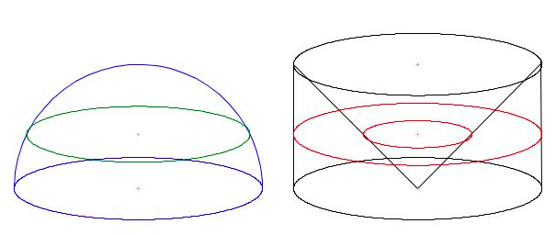
images from easingthehurrysyndrome.wordpress.com/tag/volume-of-a-sphere/

1. Pass a plane parallel to the bases intersecting the hemisphere, cylinder, and cone. The GeoGebra file ctcoregeomACT652 shows a vertical cross section of the situation above.
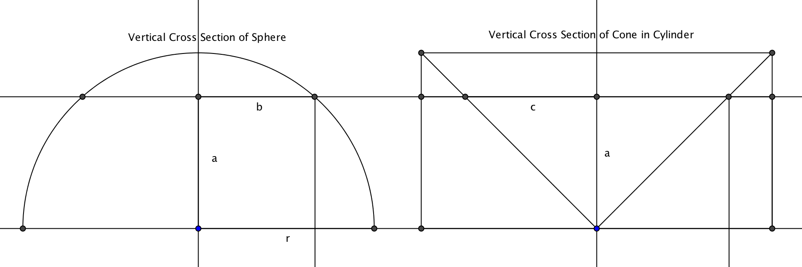
a. The diagram above is a screen shot from the GeoGebra file. The slider controls the distance, a, from a horizontal plane slicing the solids to the plane on which the solids lie. As a increases what happens to the value of b?
b. As a increases, what happens to the value of c?
c. For which of the three solids (sphere, cylinder, or cone) does the area of the cross section stay the same as the slider changes the value of a?
2. Now scroll down in the GeoGebra file to observe the horizontal cross sections of the two figures.

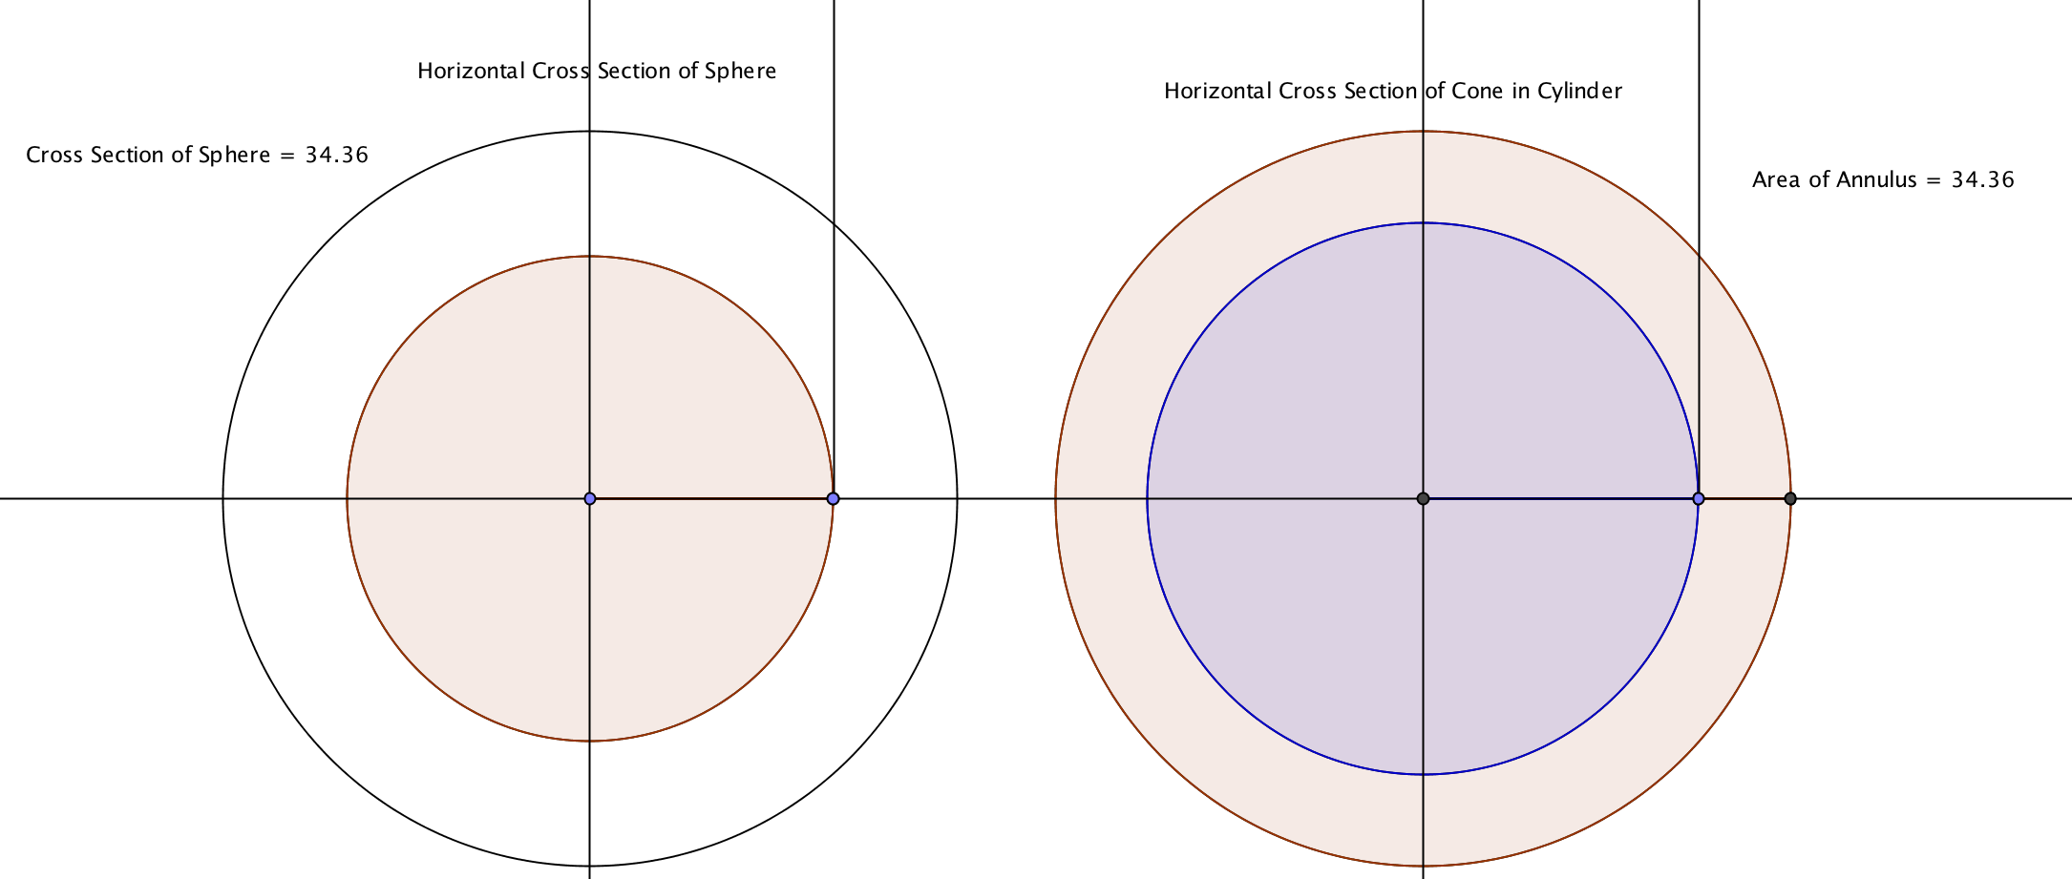

- As the slider increases the value of a, what happens to the area of the cross section of the hemisphere (on the left)?
- What happens the area of the inner circle on the right?
- What happens to the area between the two circles on the right (the annulus or “washer”)?

3. We will use the diagram at the top of the next page to prove that the area of the cross section of the hemisphere is equal to the area of the annulus.

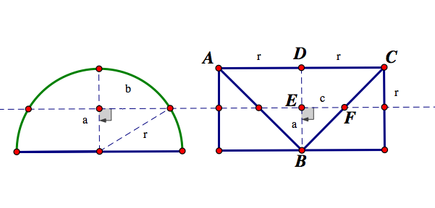
    - In the diagram we see that a² + b² = r². Why?
    - We notice also that ∆DCB is an isosceles triangle Why?

    - We also notice that triangle EFB is similar to ∆ DCB. Why?

    - This leads us to conclude that since DB=DC, a=c. Why?

    - Use the results in (a) and (d) to show that b²= r² - c².

    - Multiply both sides of the equation in (e) to get π b²= πr² - πc². This means that the cross-sectional area of the __________ is equal to the cross-sectional area of the ____________ minus the cross-sectional area of the __________________.

    - Applying Cavalieri’s principle, what can we now conclude? State this as a theorem.

    - Write expressions for the volume of the hemisphere and for the volume of the sphere.

4. What about the surface area of the sphere? Let S represent the surface area.

As we did in Activity 6.5.1, imagine the sphere to be made of n very small cones that have a height of r and a base of $\frac{1}{n}S$. Since the volume of any cone is $\frac{1}{3}Bh$, each of these cones has a volume of $\frac{1}{3}∙\frac{1}{n}S∙$ r.

a. Find the volume of n of these cones.

b. Set the volume of n cones equal to$\frac{4}{3}πr^{3}$, which is the volume of the sphere.

c. Solve the equation in (b) for S.

- You should now have a formula for the surface area of a sphere. Does it agree with your experiment with the orange?

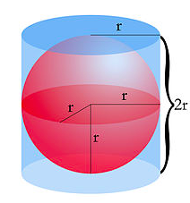

5. Archimedes was so proud of his discovery of the formulas for the volume and surface area of a sphere, that he asked for a picture of a sphere inscribed in a cylinder to be placed on his tombstone. The radius of the sphere and the cylinder are the same, and the height of the cylinder is twice its radius.

        - Find the volumes of the sphere and cylinder.

        - Find the surface areas of the sphere and cylinder. Be sure to include both bases of the cylinder.

        - Archimedes noticed that the ratio of the surface areas and volumes of the two solids is the same. Show that he was correct.
6. Here is another proof of the formula S = 4πr², based on Archimedes’ cylinder and sphere. Show that the surface area of the sphere is equal to the lateral surface area of the cylinder by dividing both into horizontal strips. The radius of the sphere is designated by R, and the radius of each strip on the sphere is r. The height of the strip on the cylinder is h_{c} and the height of the strip on the sphere is h_{s}.
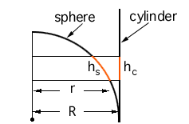
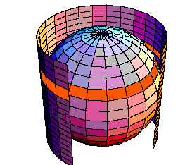

Images and proof from http://mathcentral.uregina.ca/qq/database/QQ.09.99/wilkie1.html

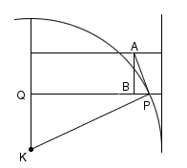
a. Show that the area of a strip on the sphere is 2πrh_{s}.
b. Show that the area of a strip on the cylinder is 2πRh_{c}.
c. The figure at the right shows a vertical cross-section of the sphere and cylinder. $\overset{⃡}{AP}$ is tangent to the circle. KP = R and QP = r. AP = h_{s} and AB = h_{c.}. Show that $\frac{QP}{KP}=\frac{AB}{AP}.$

d. Use the result from (c) to show that the area of the strip on the sphere is equal to the area of the strip on the cylinder.

e. Complete the proof to show that the surface area of the sphere is 4πr².
7. For yet another proof of the surface area formula for a sphere, visit
www.youtube.com/watch?v=6EzQEdBX_30.

