Activity 6.5.1 Surface Area and Volume of a Sphere

Materials: an orange, a plastic knife, play dough, dental floss, pencil and paper.

So far we have discovered formulas for the volumes of prisms, pyramids, cylinders, and cones. In this exercise we will find formulas for the surface area and volume of a sphere. Later we will prove that the formulas we discover here are valid.

- To find the surface area of a sphere we will use an orange, which is approximately the shape of a sphere.

- Step 1. Draw five circles with the same radius as the orange. Choose one of these two methods:
i. Place the orange on a sheet of paper. Hold a pencil tightly next to the surface and move it around he “equator” of the orange to trace a circle. Be sure the pencil is pointing straight down in order to get the correct size for the circle.
ii. Cut the orange in half, and place the hemisphere, circle down on the paper. Trace the circle directly on the paper being careful to squeeze as little juice as possible on the paper.

- The next thing we will do is to take the peel off of the orange, tear it into many small pieces and put the pieces in the circles. Before you start, how many circles do you think can be filled with the peel?
Write you guess here:______________.
- Now peel the orange and arrange the pieces to fill the circles. How many circles are filled?
- If the radius of the sphere (and one of the circles) is r, then the area of the circle is _________. Therefore this experiment suggests that a formula for the surface area of a sphere is ___________________.
- To find the volume of a sphere, make a ball of one color of Play Dough then cover it with a thin layer of another color. Then use dental floss held firmly between fingers of both hands to make a sharp cut forming two hemispheres. Continue to cut the resulting pieces in half until they begin to look like cones. You will end up with “cone pieces” like those in the last picture below.
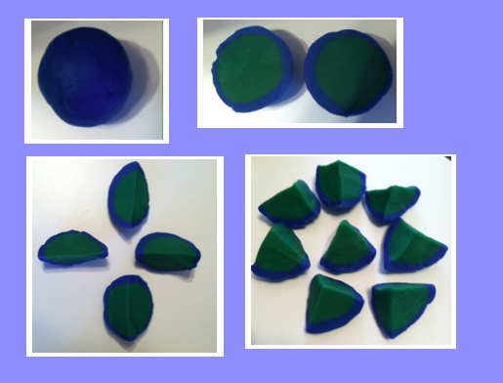

- The volume of each cone is $\frac{1 }{3 }$ the area of its ________ times its _____________.
- Suppose there are N cones with equal bases. Then N times the area of each base should give us the _______________________ of the sphere.
- Let S represent the surface area of the sphere. Write an expression for the area of the base of each cone.
- The height of each cone is the _____________ of the sphere.
- Use your results from (c) and (d) to write an expression for the volume of each cone.

- Now write an expression (in terms of r and S for the sum of the volumes of all the cones.
- But from our first experiment how can we find S if we know r?
- Put all this together to find a formula for V, the volume of a sphere.

