Activity 6.4.2 Axis of Rotation

Materials needed: Five 3” by 5” index cards, compass, scissors
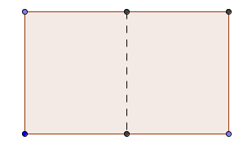
- Holding the short side of the first index card, fold the 3 by 5 inch index card in half so that the short side on the left meets the short side on the right.

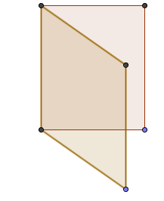
- Imagine that the fold is an axis of rotation., Visualize the cylinder formed by rotating the card.
Given that the dimensions of the index card are 3 inches by 5 inches, the radius of the base of that cylinder is _______ inches, and the height of the cylinder is _______ inches.

- Sketch the cylinder and label the dimensions in the space below. Calculate the surface area and volume of the cylinder to the nearest square inch and cubic inch.

- Holding the long side of the second card, fold the 3 in by 5 in index card in half so that the long side on the left meets the long side on the right. Visualize the cylinder formed by rotating the card.
Given that the dimensions of the index card are 3 inches by 5 inches, the radius of the base of that cylinder is ______ inches, and the height of the cylinder is ______ inches.
- Sketch the cylinder and label the dimensions in the space below. Calculate the surface area and volume of the cylinder to the nearest square inch and cubic inch.

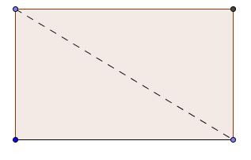
- Fold and cut the third index card along a diagonal creating two congruent right triangles such that each leg measures 3 and 5 inches respectively.

- Use one of the triangles with the short leg as an axis of rotation. Sketch the resulting solid and label the dimensions in the space below. Calculate the surface area and volume to the nearest i square inch and cubic inch.

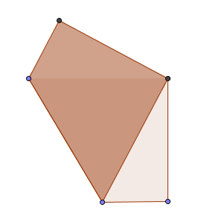
- Fold and cut the fourth index card so that opposite diagonal corners coincide with each other each other, creating two congruent trapezoids.

- Using the long base of the trapezoid as an axis of rotation, draw the resulting solid in the space below.

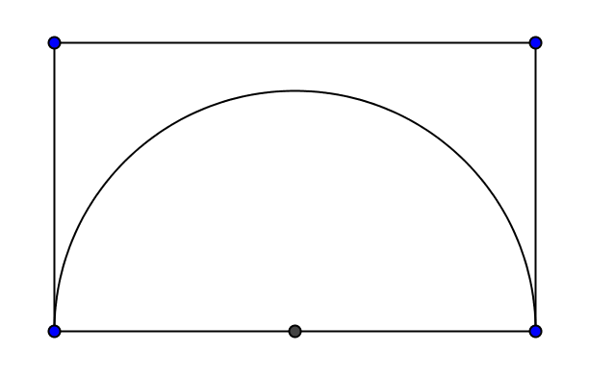
- Take the fifth card. Find the midpoint of the five-inch side. With a compass draw a semicircle. Cut out the semicircular sector, and use the diameter as the axis of rotation. Draw the resulting shape in the space below.

- In summary, what two-dimensional shape can be rotated to produce each of these three-dimensional figures?

- a cone
- a sphere
- a cylinder
- a frustum

