Activity 6.4.1 Seeing Cross-Sections

When we cut a solid with a plane the resulting 2 dimensional intersection is called a cross-section. We are going to explore the possible cross-sections of different solids by using clay and dental floss. You may use the camera on your phone to document your solutions to the problems below.

- Let’s begin with a simple figure. Roll your clay into a ball, then flatten the ball so that you have a cube. It should look something like the figure on the left. The figure at the right shows two possible places that you could cut the cube with a straight down cut with the dental floss. You could cut off a vertex, forming a triangular face or you might cut off an edge to form a rectangular face. Try to see if you can do both of those cuts. You may need to re-form your cube to do the remaining problems about the cube.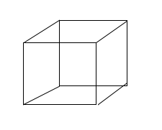 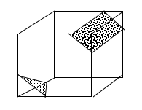

  - Can you cut it so the face is an equilateral triangle? Explain your method.

  - Can you cut it so the face is an isosceles triangle, but not an equilateral triangle?

  - How could you cut it to form a right triangle?

  - Can you find a way to cut it so there will be an irregular pentagon? Describe or illustrate how you made your cut.

  - Is it possible to cut it so there will be a trapezoidal face?

  - Can you cut it to form a cross-section that is a hexagon?

- Try this again starting with a right rectangular prism that is not a cube. See how many different kinds of cross-sections you can create. Sketch pictures of them or take pictures of them with your phone. List all of the different kinds of cross-sections you were able to make here:

- Now try this with a cylinder. Which of these are you able to make: A circle, rectangle, ellipse? Did you find others that you can share with your classmates?

- If you use a ball of clay, you will have a sphere. What kinds of cross-sections can you make with it?

- Now form a square pyramid. What kinds of cross-sections can you make with it?

- Finally, form your clay into a cone. What kinds of cross-sections can you make with it? What connections can you make with previous units?

