Activity 6.3.6 Frustums of Pyramids and Cones

When a plane cuts a pyramid or cone parallel to the base, the solid is cut into two parts, a small pyramid or cone similar to the original one and a new solid called a frustum which has two bases and lateral surfaces that are part of the original solid.
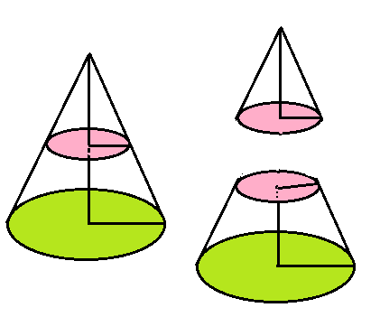
- Here is a diagram showing a picture of a cone cut into a smaller cone and the frustum formed.

  - Suppose that the height of the original cone is 8 cm and its radius is 6 cm. A plane parallel to the base cuts through the cone 4 cm from the apex. The height of the frustum (shown bottom right) is what remains of the height of the large cone. What is the height of the frustum?

  - Find the radius of the cross section.

  - Find the volume of the frustum by finding the volume of our original cone and subtracting the volume of the small cone that is removed. Show your calculations for the volume here:

- To find the surface area of the frustum we have to find the area of the part of the annulus (the region between two concentric circles) that forms the lateral area. Our strategy is to take the area of one small circle from a larger circle and then take the appropriate fraction of the area. Here is the plan in action: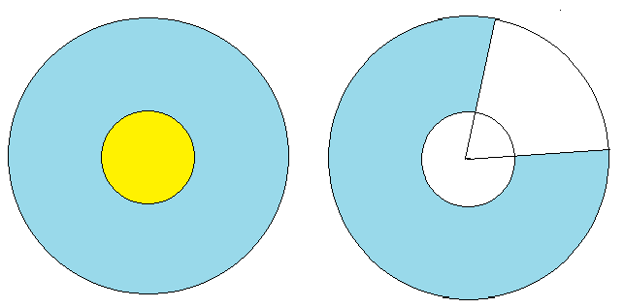
    - First we need the radius for the circle that forms the lateral area of the large cone. Hint: Use the Pythagorean Theorem to find the slant height.
    - Now find the radius for the lateral area for the small cone.
    - Show how you find the area of the annulus (left diagram).

    - Find the appropriate fraction for the part of the annulus used for the lateral (shown on the right)

    - To find the surface area of the frustum we need to add the areas of the two bases to the lateral surface area. Show your calculation here:

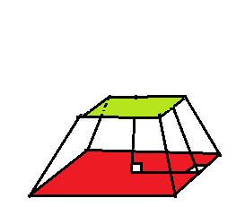
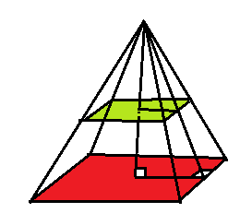
- Similarly we can find the volume and surface area for the frustum of a pyramid. This is a right square pyramid. The sides of the squares bases are 8 inches and 10 inches respectively. The height of the frustum is 2.4 inches. Label you diagram with the lengths of the sides of the bases.
  - What is the height of the original pyramid? Show your work here:

  - What is the slant height of the original pyramid?
  - What is the slant height of the small pyramid that was removed?

  - What is the slant height of the frustum?

  - Find the volume of the frustum.

  - Find the surface area of the frustum:

- Historical connection. The ancient Egyptians came up with this formula for the volume of a frustum: $V = \frac{1}{3}h\left(B_{1}+{\sqrt{B_{1} B_{2}}+B}_{2}\right).$ where h is the height of the frustum and B₁ and B₂ are the areas of the upper and lower bases. Apply this formula to the pyramid in question 3 and check to see if you get the same result as in question 3(e).

- Here is the frustum of a pyramid with bases that are equilateral triangles. The sides of the base of the large pyramid are 8 inches and the height is 10 inches. The height of the frustum is 5 inches.

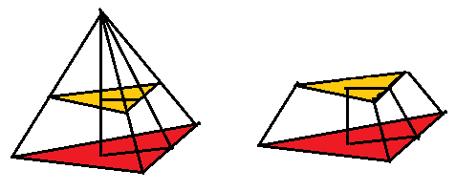

  - Find the volume of the frustum:

  - Find the surface area of the frustum:

- In a previous activity you compared the volume formula for a prism, V = Bh, with the area formula for a parallelogram. (a) Is there a two-dimensional figure that is analogous to a pyramid? (b) Is there a two-dimensional figure analogous to a frustum? Explain your reasoning.

