  - The original pyramid: ∆ABC is yellow, ∆CBD is green.
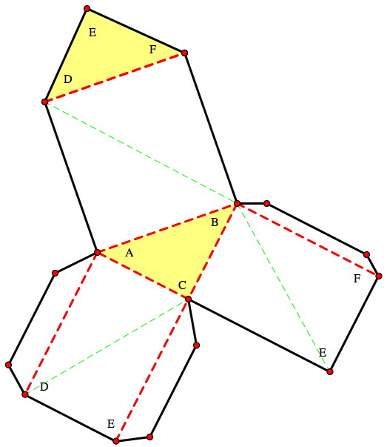
  - The prism “box.” ∆ABC and ∆DEF are yellow. ∆DEF is a flap that opens and closes.

  - A second pyramid. ∆DEF is yellow, ∆DBE is purple.

  - A third pyramid. This pyramid is in the interior of the prism. ∆DCB is green and ∆DEB is purple.

