Activity 6.2.3 Building Packaging Nets

As you saw in the movie about packaging the plastic skull, many product producers have to be concerned about how to package awkward shaped items. Your task is to construct a package for an odd shaped item. The package designer wants an attractive design that uses minimal materials so that the packages will fit in standard shipping boxes for long-range transportation.

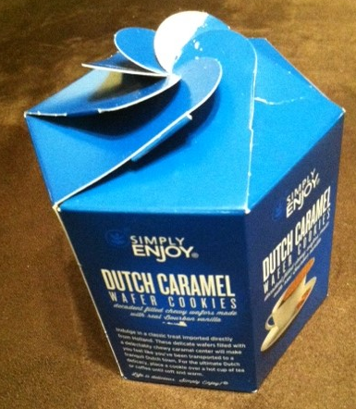
- Your teacher has given you an object to package. You will need to collect essential measurements to use in designing your package. Think about the basic shapes we have studied so far as you make your choice.
  - Decide what solid shape might best fit your object. For example, you might package a shell in a cylinder or you might package a stack of cookies in a hexagonal box. Try to be efficient with the design so you can cut it from one piece of cardboard and minimize waste. Plan for folds and tabs for your package. Make a rough sketch of your plan:

  - Now use the actual measurements of the object you are packaging to make the box. You may need to use a protractor, a ruler, or a compass to do a precise design. You may use card stock for this, but you may need to crease the net along a folding edge.

  - Put your object in your box. How well does it fit?

  - If you were doing this again, would you design it the same way? If not, what would you change?

  - Calculate the surface area of your box.

- Boxes of individual items sometimes need to be placed in cartons for shipping. UPS provides a list of standard carton sizes:
8”x8”x8” | 10”x10”x10” | 14”x14”x14”
16”x16”x16” | 18”x18”x18” | 20”x20”x20”
24”x24”x24” | 12”x12”x20” | 15”x15”x48”
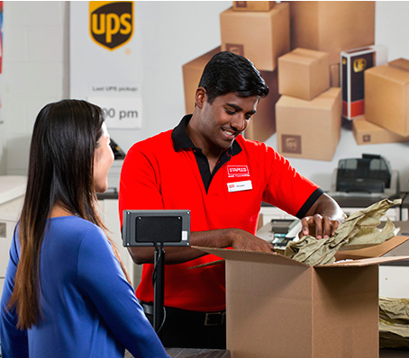
Assume that you are going to ship four of your packaged items to one location. Which carton listed above would work and be the most inexpensive to use?
Note: the price of a shipping carton is based on its surface area. Boxes with larger surface area cost more than those with a smaller surface area.
Explain your choice of box.

Image from staples.com

