Activity 6.2.1 Exploring Nets

Open http://illuminations.nctm.org/Activity.aspx?id=3521
  - Select the shape “Tetrahedron” and choose “Solid” from the top menu. Grab the Tetrahedron and rotate it around in space. Then fill in each triangular face with a different color. Select colors from the palette icon, which is located at the right end of the row at the top of the panel on the left of the screen. Switch from “Solid” to “Net” a few times and notice what happens to the colored faces of the tetrahedron as its edges split to form the net. Using colored pencils or abbreviations (R= red, etc.) sketch your net in the space below.

  - The net formed by the program is only one way to form a net of the tetrahedron. Can you think of another way to dissect the tetrahedron along its edges to form a different net? Record your response here:

  - Based on your observations, how many distinct nets can be created for the tetrahedron? Compare your response to that of your partner.

  - Next select the shape “Cube” and “Solid” from the top menu. Grab the cube and rotate it around in space. Then fill in each square face with a different color. Switch from “Solid” to “Net” a few times and notice what happens to the colored faces of the cube as its edges split to form the net. Using colored pencils or abbreviations (R= red, etc..) record your net in the space below.

  - The net formed by the program is only one such to form a net of the cube. Can you think of another way to dissect the cube along its edges to form a different net? Record your response here making sure to show which faces are which colors.

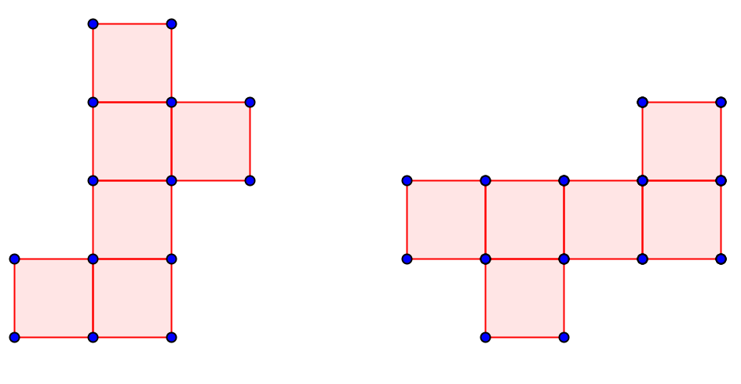
  - Here are two possible nets for a cube. Do you consider them distinct? Why or why not?

  - Based on your observations, how many distinct nets can be created for the cube? Discuss your ideas with your classmates.
  - Suppose each edge of the cube measures 5 cm. Find the surface area of the cube.
  - Suppose each edge of the regular tetrahedron measures 8 cm. Find the surface area of the regular tetrahedron. (Hint: use the special properties of 30°-60° right triangles to find the altitude of a triangular face.)

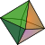
  - Sketch three distinct nets for a regular octahedron.

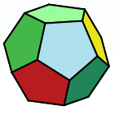
  - Find at least 2 distinct nets for a regular dodecahedron.

  - Explain how you would find the surface area of a regular dodecahedron.

13. For homework find a box of cereal or some other box in your kitchen. Measure the dimensions and draw a net of the box. Then calculate its surface area.

