Activity 6.1.4b Euler’s Formula

Materials: You will need access to a number of polyhedra. These nay be the same ones you used or made in previous activities of this investigation.

- For each Polyhedron provided count the number of faces, vertices, and edges, then fill in each chart below.
Number of Polyhedron | Number of Faces  (F) | Number of Vertices  (V) | Number of Edges  (E) | F + V
Cube  (regular hexahedron) | 6 | 8 | 12 | 14

- Based of the data gathered make a conjecture on the relationship between the number of faces, vertices, and edges of any polyhedron. (Hint: Look at the last two columns.)

- Write your conjecture as a formula with F, V, and E as the variables. This formula is known as Euler’s formula.

- Can you come up with three numbers satisfy the formula but where no polyhedron has these properties?

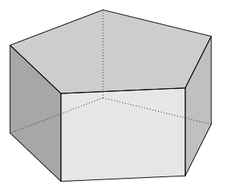
- Here is a sketch of a pentagonal prism. Count faces, vertices, and edges, Verify that Euler’s formula holds.

F = _____, V = ____, E = ______

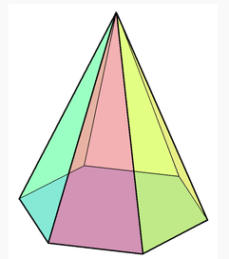
- Here is a sketch of a hexagonal pyramid. Count faces, vertices, and edges, Verify that Euler’s formula holds.

F = _____, V = ____, E = ______

- Here is a sketch and a net for a square antiprism. Two squares are joined by eight triangular faces. Count the edges and vertices and verify Euler’s formula:

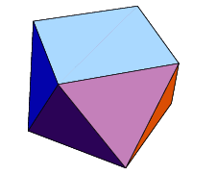
F = _____, V = ____, E = ______

