Activity 6.1.2b Isometric Perspective Drawing
Use GeoGebra for this activity.
- Make sure you start in the Graphics view.
- Click the drop down arrow to the left of the word “graphics” and select the grid paper icon.

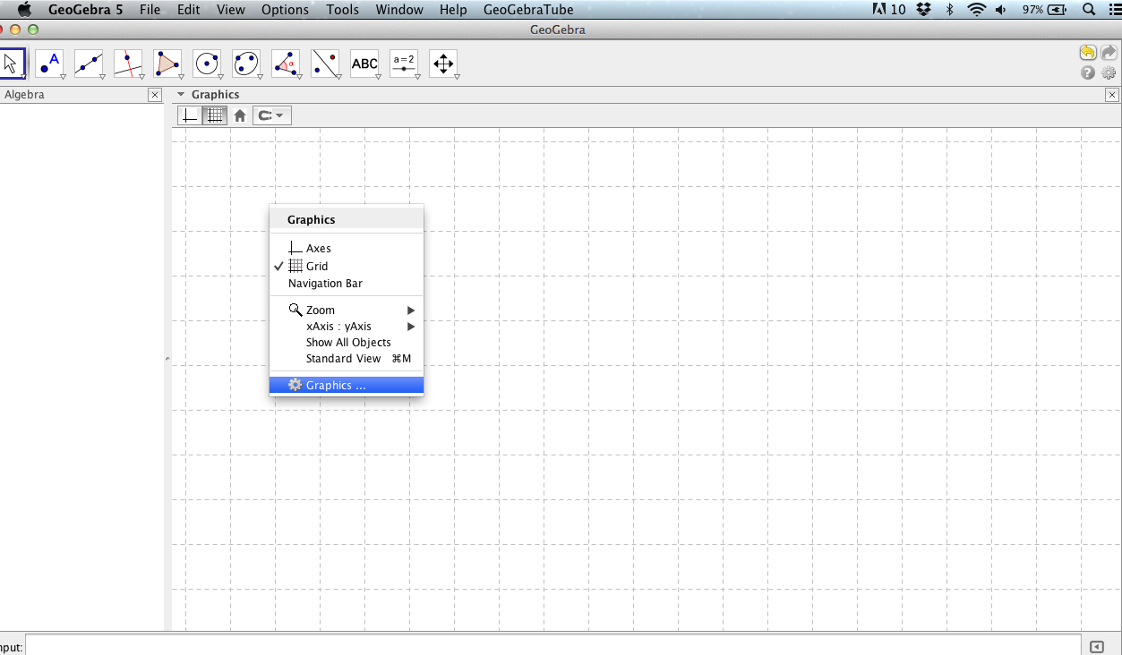
- Select “snap to grid” under the magnet icon.
- Right click in the graphics screen and select graphics. (Control-click on a Mac).

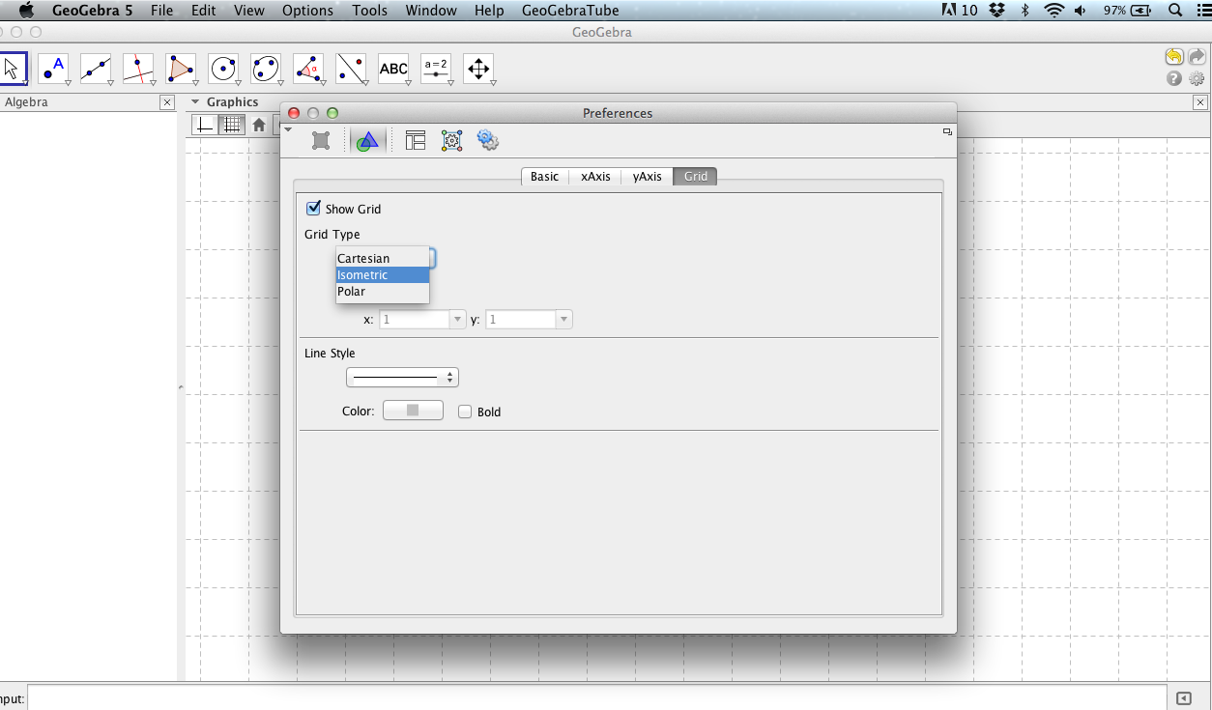
- Under the Grid tab change Grid type to Isometric.

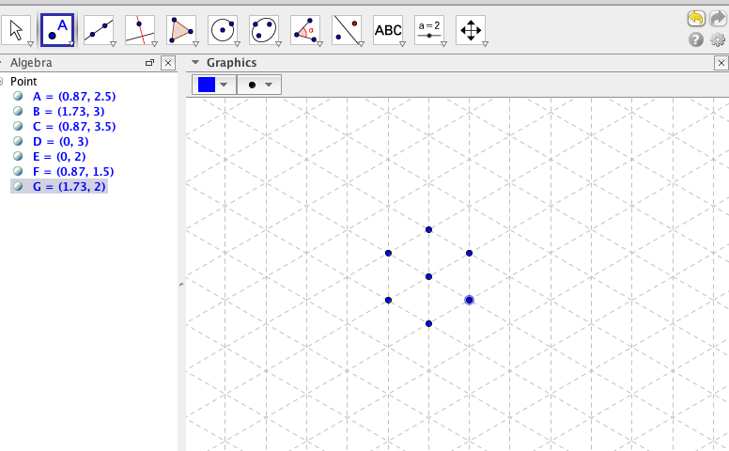
- Turn off labeling of objects by going to the Options menu, selecting Labeling and checking “no new labels.”
Use the point tool to locate the seven vertices of a cube. (Actually there are eight, but the point in the center represents both the visible upper front corner and the lower back corner, which is hidden from view.)
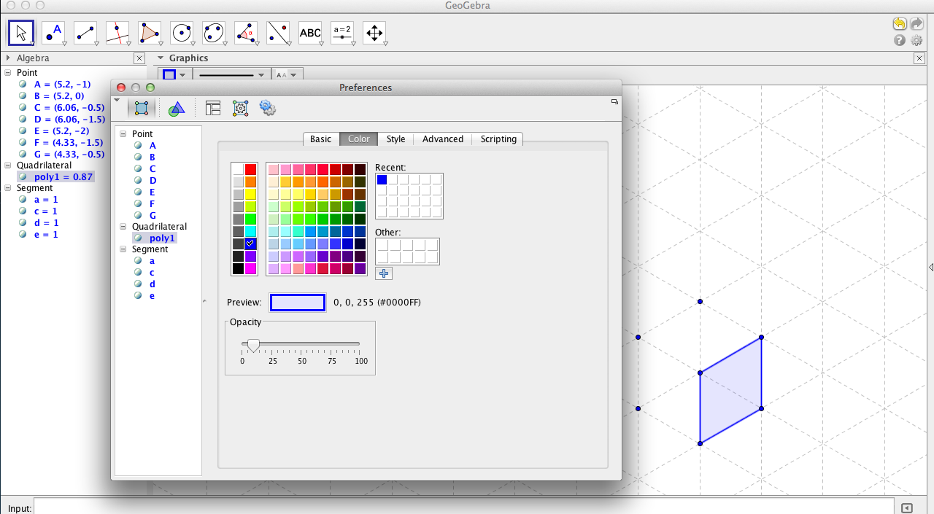
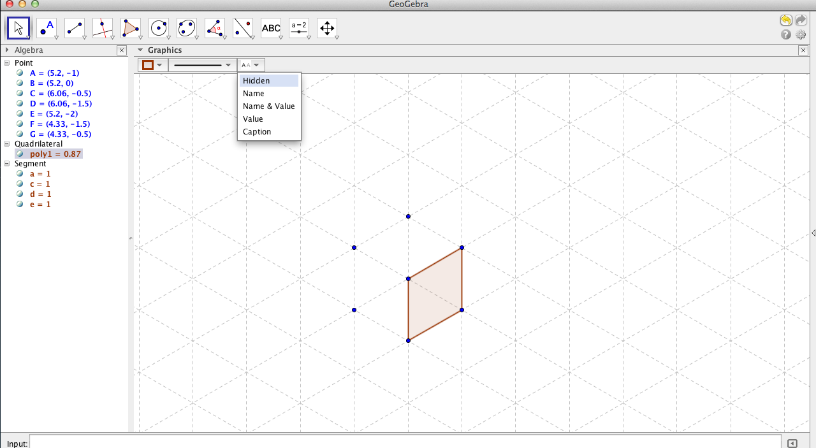
- Use the polygon tool to draw one face. In two-dimensions it is a non-square rhombus, but in our drawing it will represent the square face of a cube.
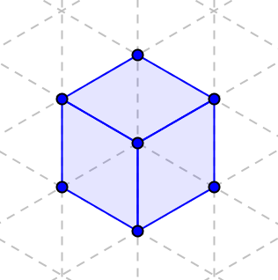
- To change the color of the face, right click on polygon. Select object properties; then select color and opacity. Complete all three faces of the cube.

- Here is how to draw a cube connected to an already drawn cube.
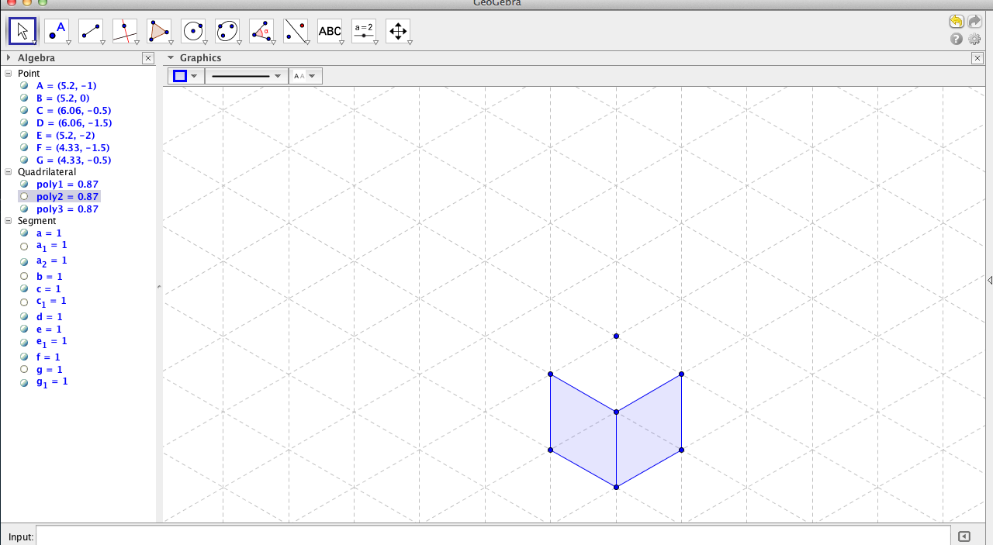
  - First delete the face that the two cubes share.
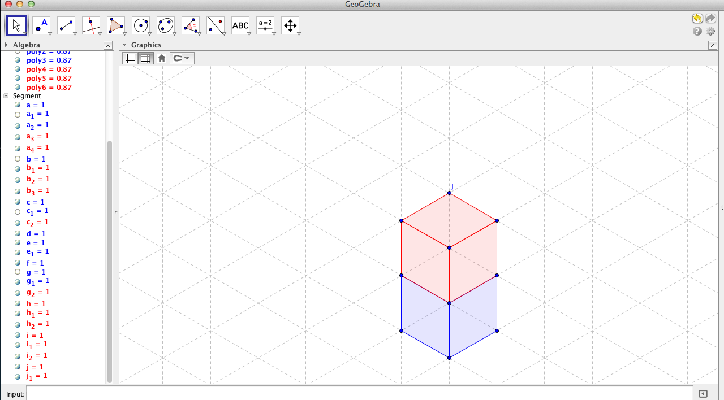
  - Then locate additional vertices for the second cube and use the polygon tool to draw the faces. Use a different color to distinguish the two cubes.

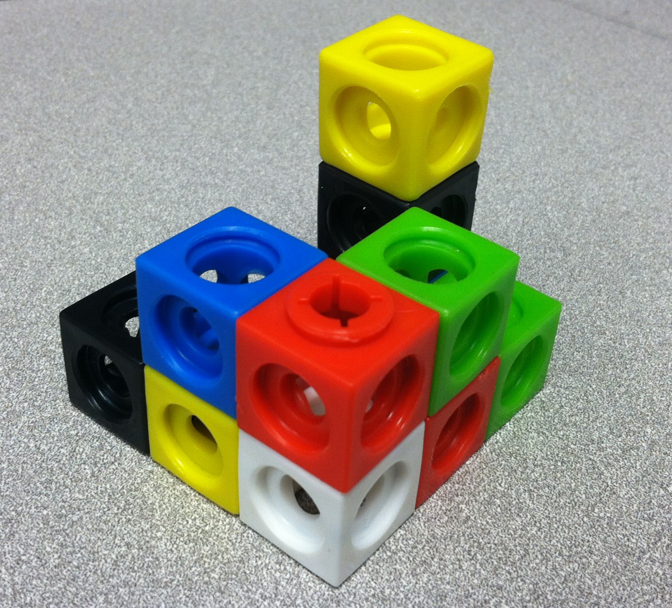
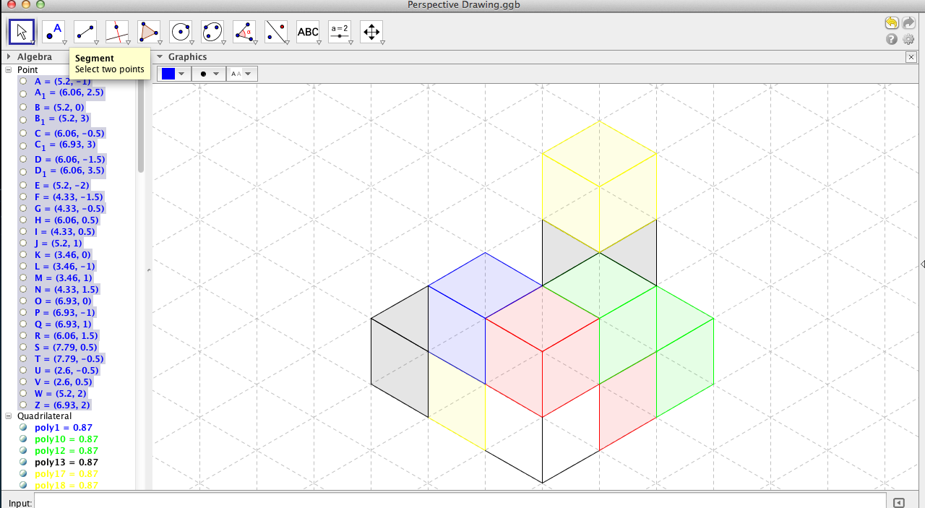
- Now draw a non-convex shape made up of small cubes, like the one shown below. Your teacher may give you a model to work with.

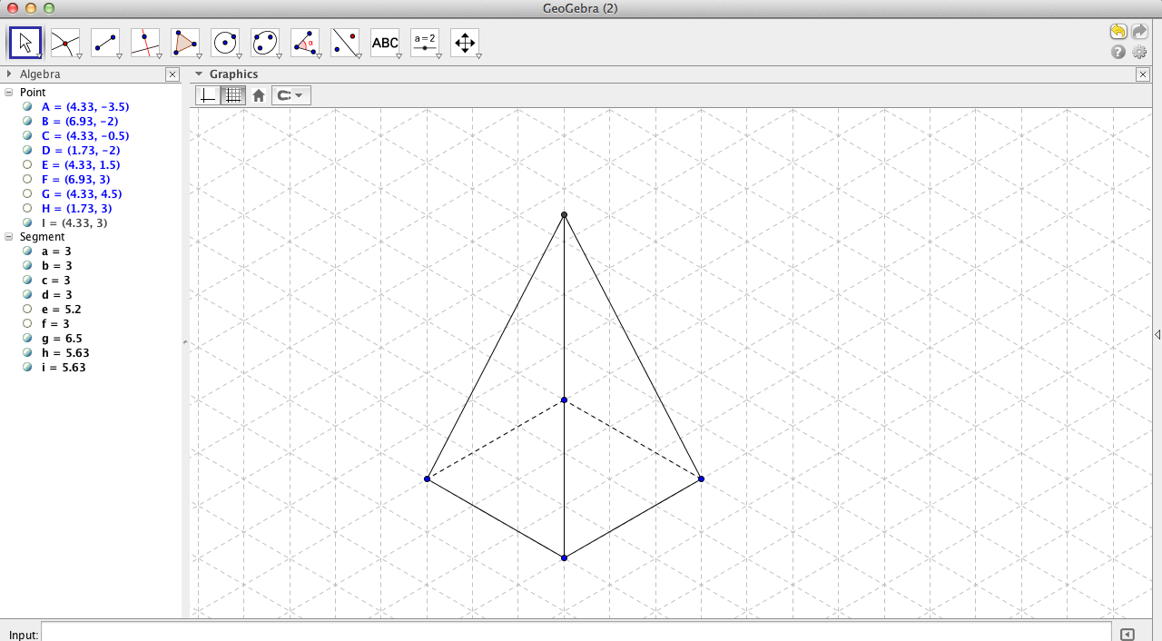
- For further exploration of isometric drawing, try drawing pyramids and prisms with specific dimensions. (Below is a pyramid with a 3 x 3 square base and height 5.)

- Print your results and share them with your teacher and your classmates.

