Activity 5.8.1 Ellipses in the Coordinate Plane

An ellipse is defined as the locus of points the sum of whose distances from two fixed points (called the foci*) is a constant.
1. In the figure below, the foci are F₁ (–4,0) and F₂ (4,0). For each of the points labeled A through M find the distances to the foci from and their sum. Divide the work among members of your group and fill in the table.

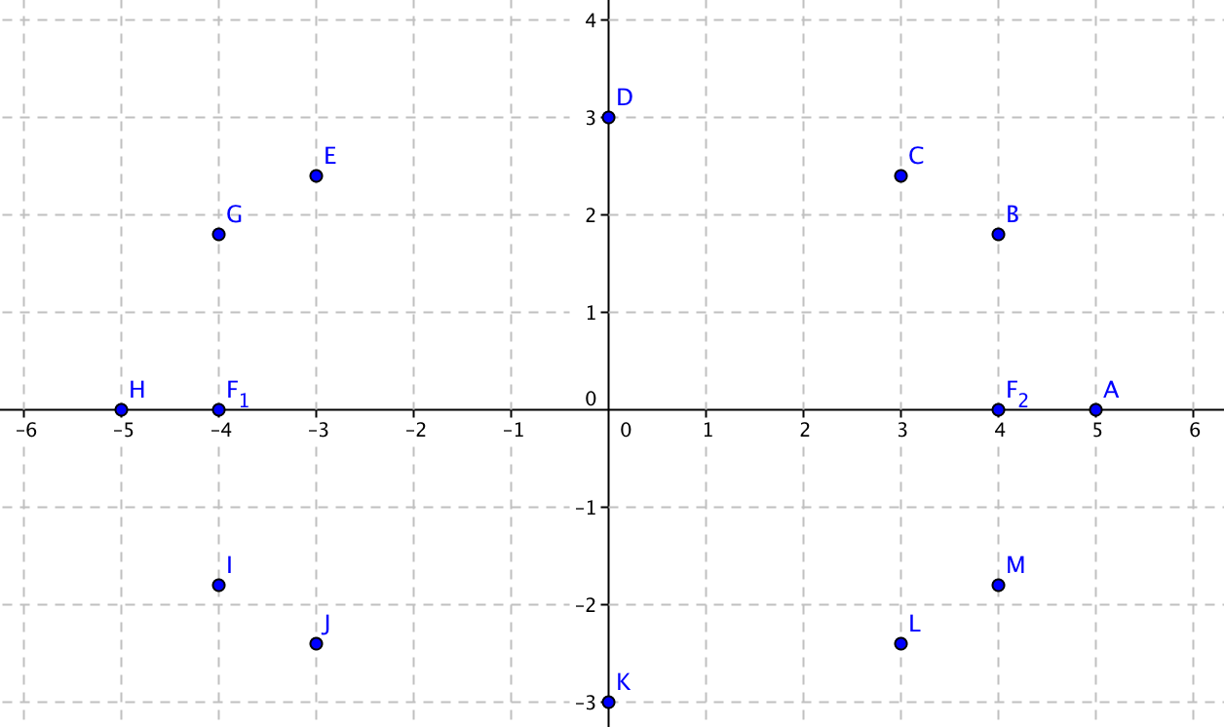
(Note: “foci” is the plural of “focus.”)

Point | Distance to F₁ | Distance to F₂ | Sum of distances
A(5, 0) | 9 | 1 | 10
B(4, 1.8)
C(3, 2.4)
D(0, 3)
E(–3, 2.4)
G(–4, 1.8)
H(–5, 0)
I(–4, –1.8)
J(–3, –2.4)
K(0, –3)
L(3, –2.4)
M(4, –1.8)

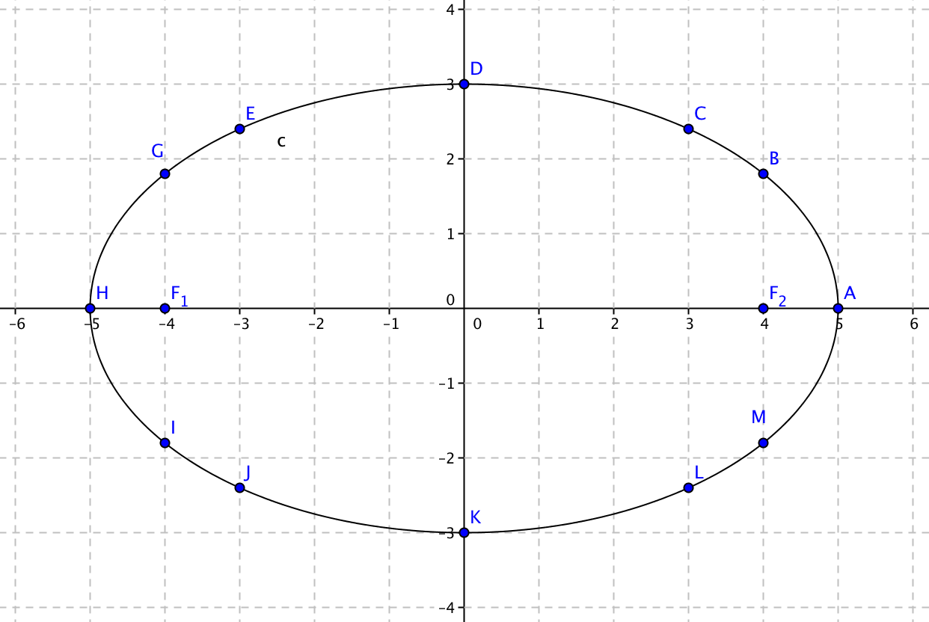
2. You found that for every point in the table the sum of the distances from F₁ and F₂ is __________. Therefore the points lie on the ellipse shown.

3. This ellipse has two lines of symmetry. What are they?

4. The ellipse has two axes that lie along the lines of symmetry. In the ellipse above the major axis is $\overline{HA}$. Identify the minor axis: __________
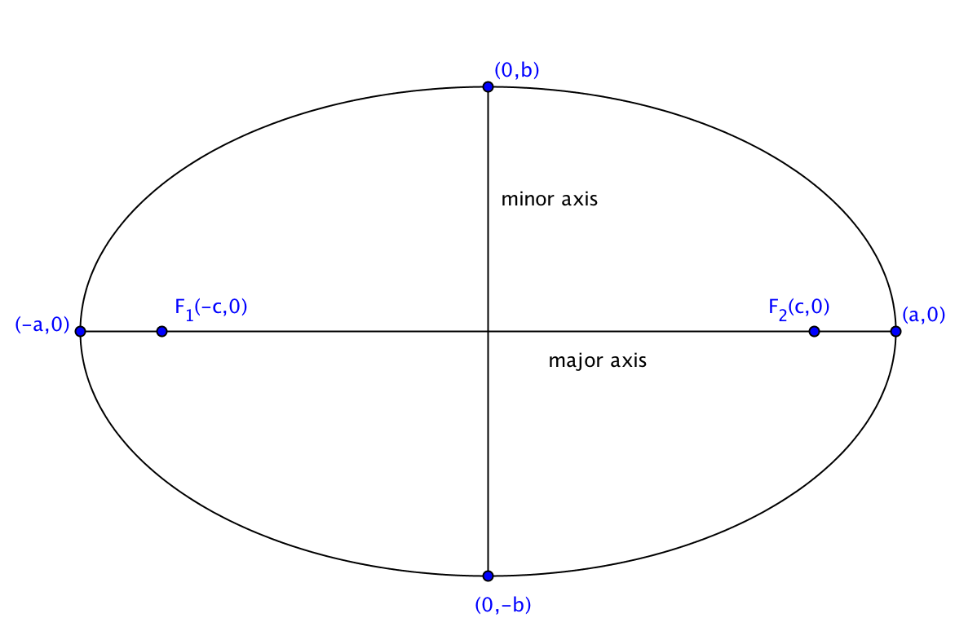
5. Explain why the length of the major axis must be equal to the sum of the distances from each point on the ellipse to the foci.
When the major axis is horizontal and its midpoint is at the origin, it is customary to use the parameters a, b, and c to describe the ellipse as shown in the figure at the right. This is considered the standard position for an ellipse.
6. For the ellipse at the top of the page, identify the values of a, b, and c:

a = _______ b = ________ c = ________

7. The length of the ___________ axis is 2b. The length of the _________ axis is 2a.

8. On the ellipse at the top of the page, draw segments $\overline{DF_{1}}$ and $\overline{DF_{2}}.$ Show that $a^{2}=b^{2}+c^{2}.$

9. An ellipses in standard position has an equation that can be written in the form $\frac{x^{2}}{a^{2}}+\frac{y^{2}}{b^{2}}=1.$ For the ellipse at the top of the page show that the endpoints of the major and minor axes satisfy this equation.
10. Pick one more point on the ellipse at the top of the page and show that it satisfies the equation $\frac{x^{2}}{a^{2}}+\frac{y^{2}}{b^{2}}=1.$

