Activity 5.7.4 Applications of Parabolas
In a more advanced course you may prove the special properties of the focus of a parabola listed below.
Special Properties of the Focus of a Parabola

Light from the focus is reflected by the parabola in parallel lines.

Parallel beams of light hitting the parabola are reflected so they pass through the focus.

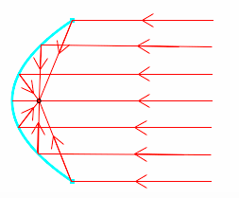
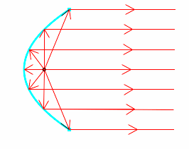

Images from jwilson.coe.uga.edu
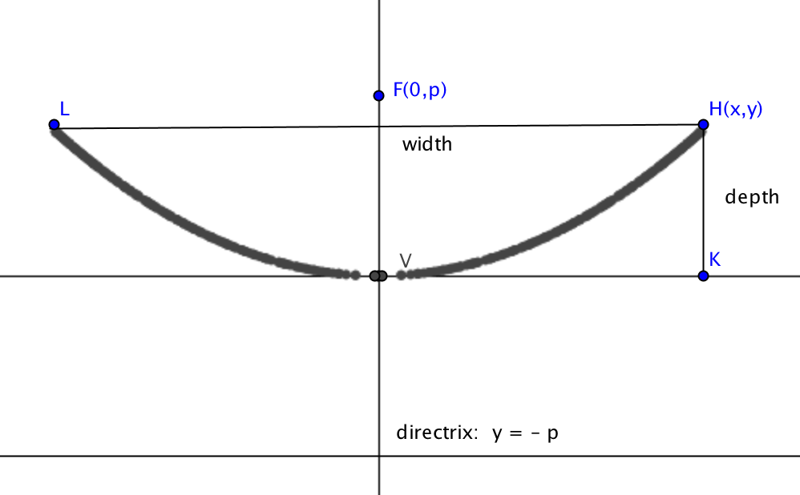
1. Since parabolas extend indefinitely in both directions, a parabolic mirror or dish is only a finite symmetrical piece of a parabola. In solving problems with parabolas it helps to place the parabola in the coordinate plane with the vertex at the origin as shown. If the height and depth of the dish are given, you should be able to use the equation in standard form, $x^{2}=4py$ to find the value of p and thus locate the focus and directrix.
a. Suppose the width of a parabolic dish is 20 feet and the depth is 4 feet. Find the coordinates of point H in the figure above.
b. Find the value of p and the coordinates of the focus in the above example.
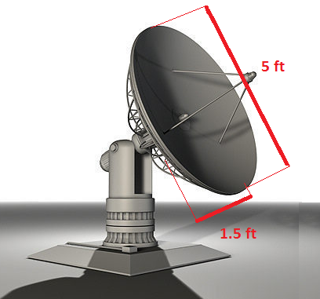
2-6. Use the special properties of the focus of a parabola and the method shown in question 1 to answer these questions.
2. The signals that a parabolic satellite dish receives strike the surface of the dish and are reflected to a single point, where the receiver is located. If the dish is 5 feet across at its opening and is 1.5 feet deep at its center, at what position should the receiver be placed?

Image from
www.dimensionsinfo.com/satellite-dish-dimensions/

- The parabolic cross section of a residential satellite dish measures 400 cm across and has a maximum depth of 50 cm. If the signal receiver is to be placed at the parabola’s focus, where should it be placed?

- A reflecting telescope contains a mirror that has a parabolic cross-section. If the mirror is 36 inches across at its opening and is 2 feet deep, where will the light concentrated?
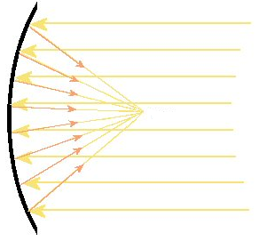

Image taken from
www.uni.edu/morgans/astro/course/Notes/section1/new4.html

- A reflecting telescope has a mirror with a cross-section shaped like a parabola. If the distance across the top of the mirror is 60 inches, and the distance from the vertex to the focus is 22 feet, how deep is the mirror in the center?

- An automobile headlight is placed 1.5 cm from the vertex of a parabolic mirror that is 6 cm deep. Find the width of the mirror.

