Activity 5.7.3 The Equation of a Parabola in Standard Form

A parabola is the locus of points in a plane that are equidistant from a fixed point (called the focus) and a given line (called the directrix).
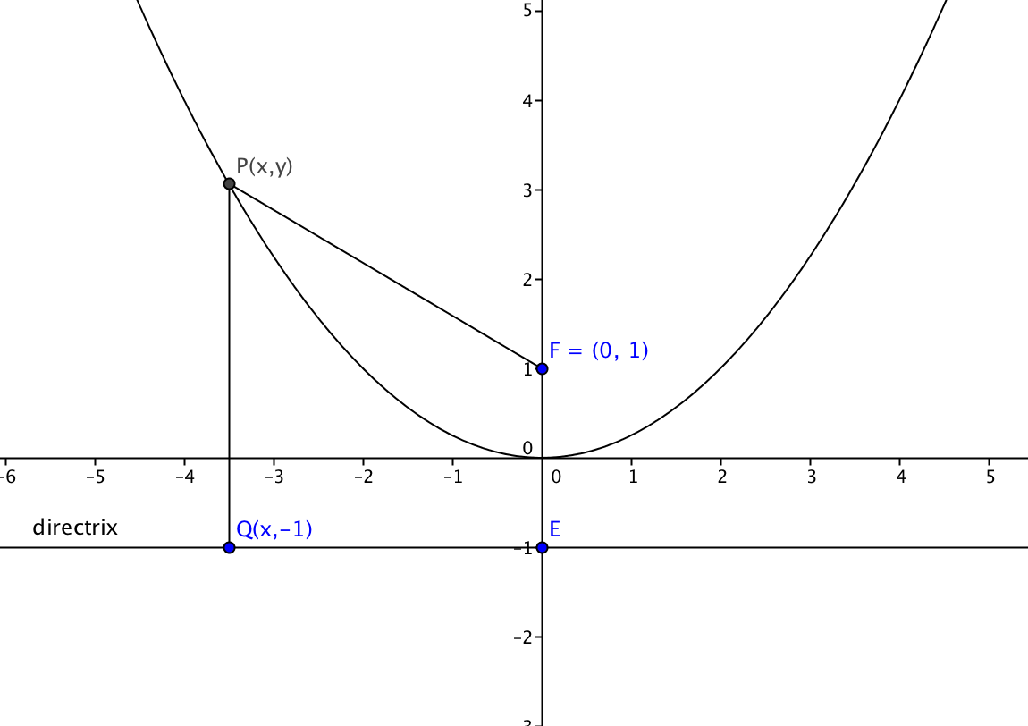
In Activity 5.7.2 we looked at a parabola with focus at F(0,1) and directrix y = – 1. We noted that the vertex of this parabola is the origin, (0,0). Now let’s derive its equation using the locus definition of parabola in the box above.

Let P(x, y) be any point on the parabola and
Q(x, –1) be the point on the directrix that is directly below P.

1. Use the distance formula to find an expression for PF: $\sqrt{{( )}^{2}+{( )}^{2}}$

2. Use the distance formula to find an expression for PQ: $\sqrt{{( )}^{2}+{( )}^{2}}$

3. Substitute both expressions into the equation PF = PQ and square both sides:
$${( )}^{2}+{( )}^{2}= {( )}^{2}+{( )}^{2}.$$

4. Now expand expressions on both sides to get:

$x^{2}+ y^{2}–2__+___$ = $y^{2}+2__+___$.

5. Solve the above equation for x²:

x² = ______

6. Now solve for y:

______ = y.

Now let’s derive an equation of any parabola with vertex (0, 0) and a horizontal directrix. Let the directrix lie below the x-axis at y = –p. The focus will then lie above the x-axis at the point (0, p). The equation we derived above was for the case when p = 1.

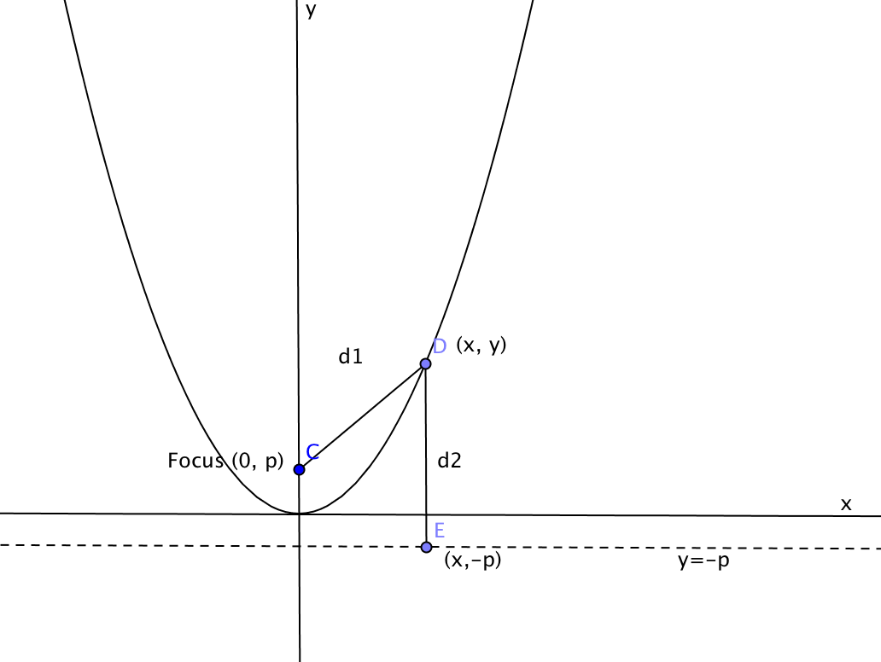
The dashed line represents the directrix.

Fill in the blanks below to derive the equation of the parabola.

7. The distance from any point on the locus to the focus is

d₁= $\sqrt{(x-____)^{2}+(y-{____)}^{2}}$ =__________________________

8. The distance from the same point on the locus to the directrix is

d₂=$\sqrt{(x-____)^{2}+(y-{____)}^{2}}$ =____________________________

9. Now substitute both expressions into the equation d₁ = d₂ and square both sides:

$${( )}^{2}+{( )}^{2}= {( )}^{2}+{( )}^{2}.$$

10. Show that the above equation can be simplified to $x^{2}=4py$:

Thus $x^{2}=4py$ is an equation of the parabola with focus (0, p) and directrix y = –p.

11. Let p = 1 and show that you get the same result you had in question 5.

12. Let p = –1. Sketch the location of the focus and directrix on the graph at the right. How is this parabola different from the one where p = 1?

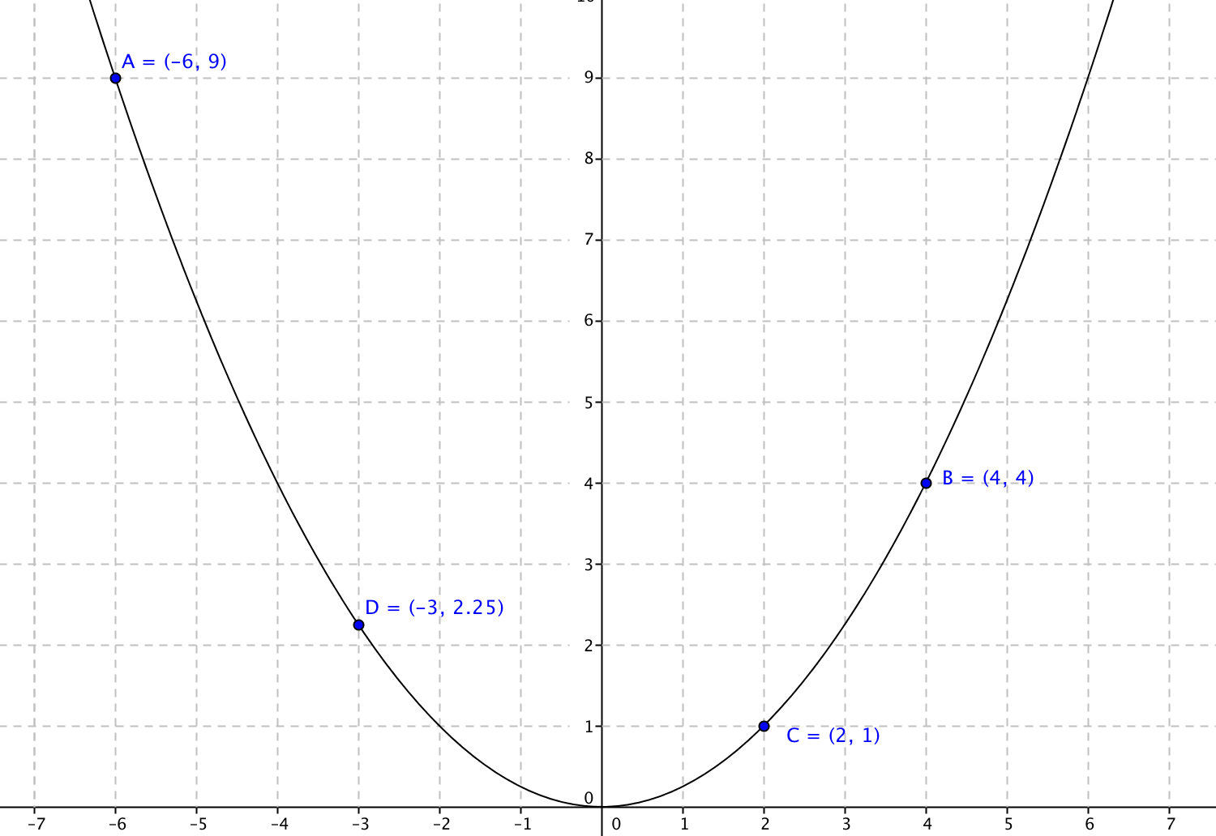
13. The parabola with equation $x^{2}=4y$ is shown in the figure at the right. Recall that reflection over the y-axis is given by the mapping rule: (x, y) (–x, y).

a. Find the image of each of these points when reflected over the y-axis and plot them on the graph:
A(–6, 9) A’(____, ____)
B(4, 4) B’(____, ____)
C(2, 1) C’(____, ____)
D(–3, 2.25) D’(____, ____)
b. Verify that the coordinates of each of the image points, A’, B’, C’ and D’, satisfy the equation $x^{2}=4y.$
c. Explain why the y-axis is a line of symmetry for this parabola.

14. Find the focus and directrix of the parabola with equation $x^{2}=y$.

15. Fill in the blanks with one of the given choices:
a. The axis of symmetry of a parabola is _______________ ( parallel/ perpendicular) to the directrix.
b. The focus of a parabola lies on the ________________(directrix/axis of symmetry).
c. The vertex of a parabola is midway between the directrix and the _______________ (focus/axis of symmetry).
d. If p > 0 then as p increases the parabola becomes __________________ (narrower/wider).

