Activity 5.7.2b Parabolas in the Coordinate Plane

Definition: A parabola is the locus of points in a plane that are equidistant from a fixed point (called the focus) and a given line (called the directrix).

Open the file ctcoregeomACT572.ggb.

- Find each of these distances:

P₁Q₁ = _______________ P₁F = _______________
P₂Q₂ = _______________ P₂F = _______________
P₃Q₃ = _______________ P₃F = _______________
P₄Q₄ = _______________ P₄F = _______________
- What do you notice about the pairs of distances found in question 1?

- In Activity 5.7.1 you learned the definition of parabola given in the box above. P₁, P₂, P₃, and P₄ lie on the same parabola.
a. What are the coordinates of the focus of this parabola? (___, ____)

b. What is the equation of the directrix of this parabola? y= _______
- Point V(0,0) is the vertex of this parabola.
a. Show that V lies on the parabola.
b. V is the midpoint of which line segment?
- The slider in the upper left corner of the screen sets the distance (d) of a point on the parabola to the focus and to the directrix. Move the slider. What do you observe?

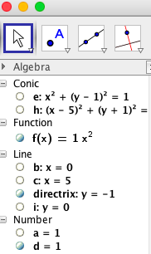
- Now turn on the function f(x) = ax² by clicking in the open circle next to f(x) in the algebra window.
How is this new parabola compare with the one you created with the slider?

- Experiment by changing the value of a. (Type a = in the input window). Find the value of a so that f(x) matches the parabola you created with the slider, and record that value here:
a = _____.

