Activity 5.7.1a Exploring the Parabola as a Locus of Points

Materials Needed: A piece of parchment paper, Pencil, Ruler

- Use your ruler to draw a long segment that appears to be parallel to the bottom edge of your parchment paper. Place this segment at most 2 inches away from the bottom of the paper. (Don’t worry if this segment isn’t “perfectly parallel” to the bottom edge of the paper.)

- Plot and label the left-most endpoint of your segment as A. Plot and label the right-most endpoint of your segment as X.

- Fold point A on top of point X. (This will create a vertical crease that serves as the perpendicular bisector of $\overline{AX}$.) Label the midpoint of $\overline{AX}$ as M. (See figure.)

- Plot and label a point F somewhere along the vertical crease created in step (3) but less than 3 inches from M.

- Fold point M onto point F and crease sharply creating a horizontal crease parallel to $\overline{AX}$. Label the intersection of this horizontal crease and the vertical crease formed in step (3) as V. (See figure.)
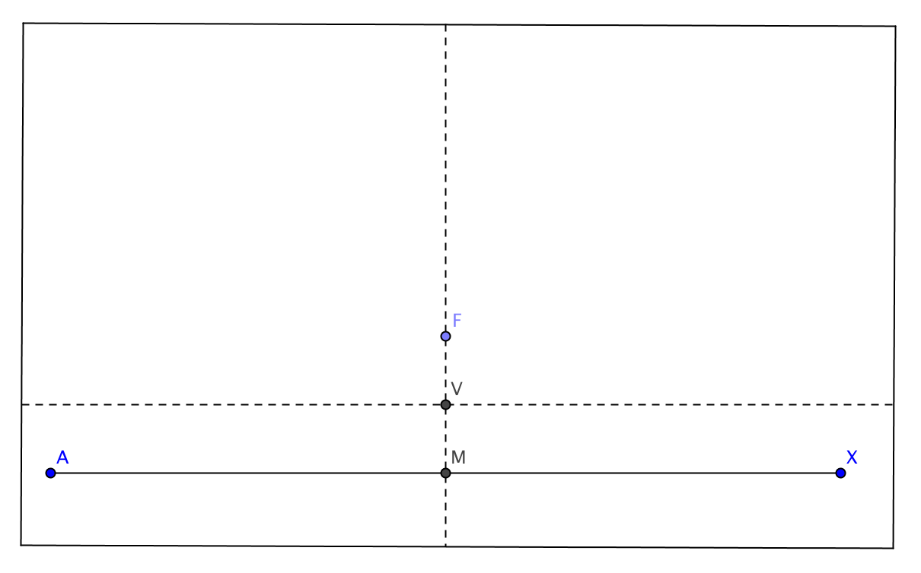

- This is the most important step here, so please read carefully!

- Plot any point (leave it unnamed) on $\overline{AX}$ that lies either to the left or right side of M. Fold point A directly on top of this point. Crease sharply. This should create a vertical crease on your paper (on the left side of M).

- Plot and label a point D at the intersection of $\overline{AX}$ and vertical crease you just formed.

- Fold point D onto point F. Crease sharply. This will create a diagonal crease somewhere on your paper.

- Plot and label a point P at the intersection of this diagonal crease and the vertical crease formed in step (a). (See figure.)
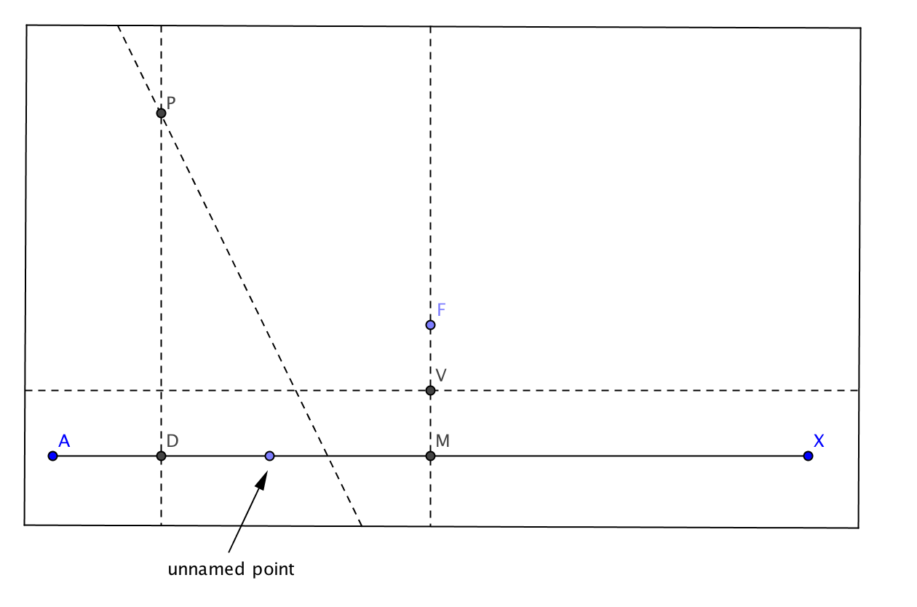

- Take your ruler and measure the lengths FP and PD (on the left side of M.) What do you notice?

- Why is your observation in step (7) above true? Can you think of a previously learned theorem that helps support your observation?

- Repeat the entire steps (6) and (7) at least 15 more times. Pick the unnamed points on $\overline{AX}$ on both the left and right side of M. The more folds you make, the easier it will be to observe a pattern.

- Draw a smooth curve through the set of points labeled P that you plotted by completing step (6) numerous times. If the shape of this curve is familiar, what do you call it?

- Now even though $\overline{AX}$ was a segment, we could keep generating more points (all with the label P) if our paper were large enough. So, as we complete this formal definition below, consider the segment with endpoints A and X to be a line instead.

After class discussion:

- Use your observation to help complete the following definition:

A is the locus of points in a plane that are from a fixed (called the ) and a given line (called the ).

