**Activity 5.6.1 Inscribed Angles and Intercepted Arcs**

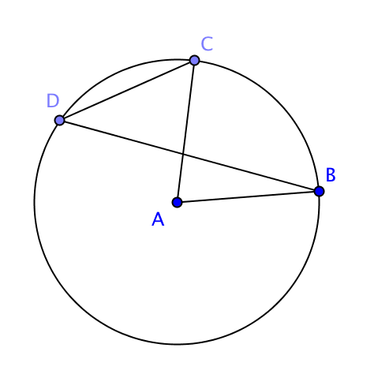

An angle is **inscribed** in a circle if its vertex lies on the circle and its side contain chords of the circle. In the figure at the right,

$∠CDB$ is an inscribed angle in the circle with center *A*.

$∠CAB$ is a central angle. The two angles $∠CDB$ and $∠CAB$**intercept** arc *BC.*

1. In each figure name an inscribed angle and the central angle that intercepts the same arc. Also classify the intercepted arc as a major arc, minor arc, or semicircle:

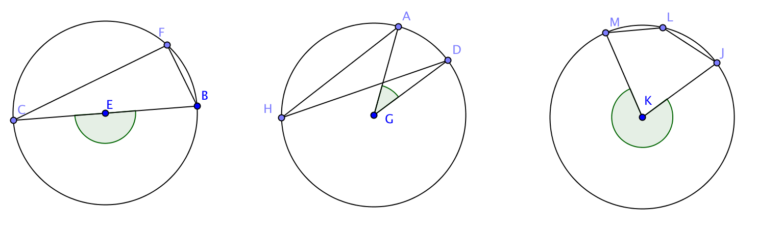

Inscribed $∠$_______ Inscribed $∠$_______ Inscribed $∠$

_______

Central $∠$_______ Central $∠$_______ Central $∠$

_______

Type of arc: Type of arc: Type of arc:



In this activity you will find a relationship between inscribed angles and the central angles that intercept the same arc.

1. Use a protractor to measure the central angle $∠$*ADC* and the inscribed angle $∠$*AEC* in each figure.

a. m $∠$*ADC* = __________

m $∠$*AEC* = __________  
  
  
  
  
  
  
b. m $∠$*ADC* = __________



m $∠$*AEC* = __________



c. m $∠$*ADC* = __________

 m $∠$*AEC* = __________

d. m $∠$*ADC* = __________

m $∠$*AEC* = __________

e. m $∠$*ADC* = __________

m $∠$*AEC* = __________

f. Looking at the five examples, above, what pattern do you notice?

g. State your observation as a conjecture: **The measure of an angle inscribed in a circle is** ____________________________________________________________________.  
  
3. The proof of this theorem is interesting because there are three cases to consider:  
  

Case 1 Case 2 Case 3   
What is different about each of these cases?

  
4. Let’s begin by considering Case 1. In Case 1 one of the sides of the inscribed angle lies along a diameter of the circle. That means that the center of the circle is on the diameter $\overline{CE}$.   
  
 a. How would you describe $∠$*ADC* as it relates to ∆ *ADE*?

* 1. What is the relationship between $∠$*ADC* and the remote interior angles $∠$*DAE* and $∠$*DEA*? How does this related to their measures?
  2. $∠$*DAE* and $∠$*DEA* are congruent. Why?
  3. If we label m $∠$ DEA as *x* we can write: *x* + *x* = m $∠$*ADC*. What does this tell us about *x*?
  4. What is our conclusion?

5. Now consider Case 2. Notice that if we draw the diameter of the circle through points *D* and *E* (the dotted segment) we can break $∠$ AEC into two parts.   
  
We can use our proof of the first case to show that m $∠$ AEC is the sum of the measures of two other inscribed angles and that m $∠$*ADC* is the measure of two other central angles.

Complete the proof in the space below:



1. Our Case 3 requires that we do something very similar to what we did in case 2. Think about how the two cases are different and then develop your own proof for the third case.