**Activity 5.5.3 Applying Tangents and Inscribed Circles**

1. 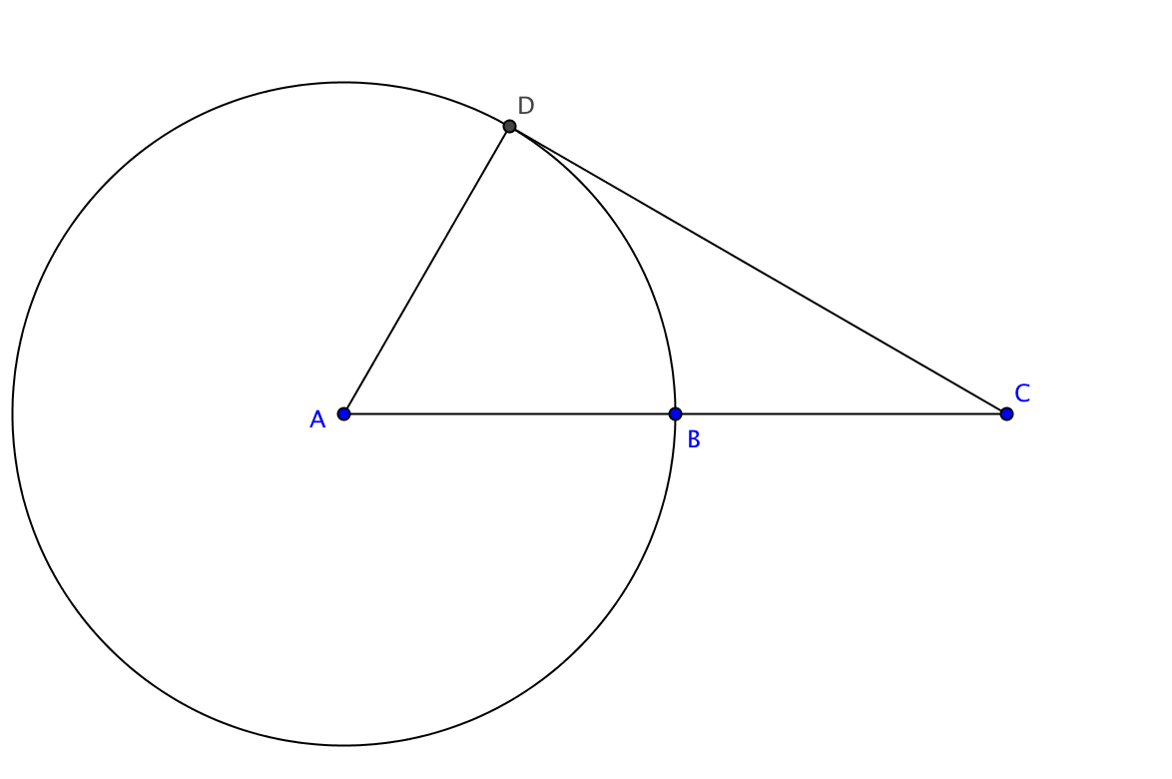The circle with center *A* has a radius of 5 cm.   
   The distance from *C* to *A* is 10 cm. $\overline{CD}$ 
    is tangent to the circle.  
     
   Find *CD*.



1. In the diagram $\overline{GJ}$, $\overline{JL}$ and $\overline{LG }$ are segments tangent to the circle. Lengths of certain segments are shown in the diagram. Find the perimeter of ∆*GJL*.
2. Given a triangle that has the length of the sides 3,4 and 5 centimeters, find the length of the radius of the circle inscribed in the triangle. Hint: What kind of triangle is this? Start by making a sketch.

1. a. Construct a triangle where the center of the inscribed circle and the center of the circumscribed circle are not the same.
2. Construct an isosceles triangle. Then construct the inscribed circle and the circumscribed circle. What do you notice about the centers of the circles?
3. Can you think of any kind of triangle where the centers of the inscribed and circumscribed circles are the same point? Try to construct one. What kind of triangle would it be?