**Activity 5.5.1 The Angle Bisector Theorem**

1. Open the GeoGebra file named ctcoregeomACT551a.

In this file, you will notice two rays $($ and ) that both form $∠BAC.$ Points ***G*** and ***D***both lie in the **interior** of $∠BAC$.



Recall that the distance from a point to a line is measured along the segment from the point perpendicular to the line. Therefore:

The distance from *G* to is ____________

The distance from *G* to is ____________



The distance from *D* to is ____________

The distance from *D* to is ____________

1. Observe that the length *JK* is the same as the lengths *DE* and *DF*. Now, use your mouse to drag point *K* around and observe what happens. What do you always notice about *DE* and *DF*?
2. Our observation in step (2) above indicates that point D is always

from the of $∠BAC.$

1. As you adjusted the length of *JK* in step (2), the GeoGebra file traced out all the locations point *D* moved throughout the screen. These traces appear as a series of black dots.

What does this collection of black dots look like?

How do you think this entire set of points relates to $∠BAC$*?*

1. Now, go to the **View** menu, and select **Refresh Views**. (This simply erases the trace of points you created in step (2).
2. Now, use the **Ray** tool to construct ray $\vec{AD}$.
3. Use the **Angle** tool to measure and display $∠FAD$ and $∠DAE$. What do you notice about these two angles?
4. Now, repeat step (2). Again, notice that *DE* and *DF* always remain equal. What do you still notice about $∠FAD$ and $∠DAE?$
5. According to our observation from steps (6) – (7), we can say that $\vec{AD}$ is the

of $∠BAC$.

1. Use your results from steps (2) and steps (6) – (8) to fill in the blanks to complete The Angle Bisector Theorem (Part I):

If a pointis equidistant from the of an angle, then that lies on the of that angle.

1. Drag point *G* around so that *GH* and *GI* are equal (or somewhat “close” to being equal). What do you notice?
2. Use the theorem you’ve just discovered to determine the following angle measures and segment lengths. Use trigonometry where appropriate.

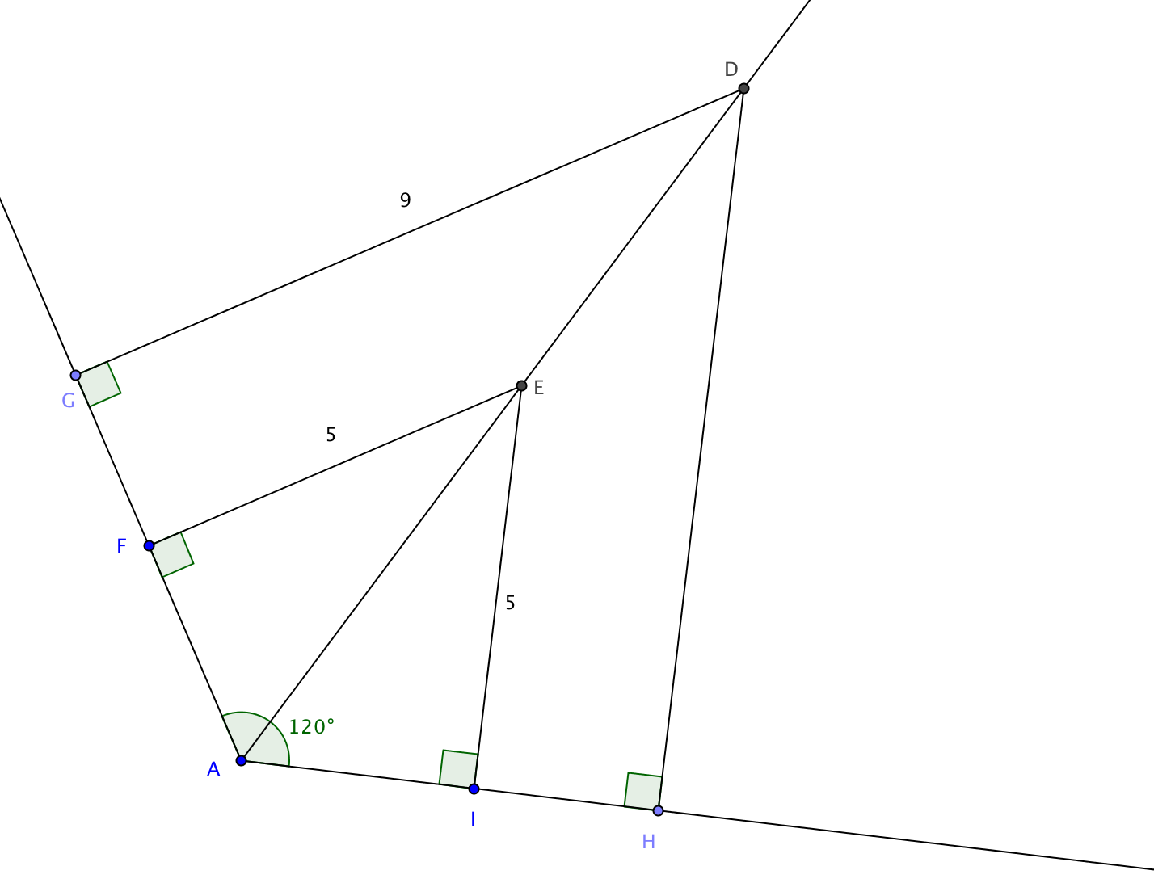a. $m ∠FAE$

b. $m ∠FEA$

c. $m ∠IAE$

d. $m ∠IEA$

e. *DH*

f. *AI*

g. *AE*

1. Let’s now proceed to a formal proof of **The Angle Bisector Theorem (Part I)**:

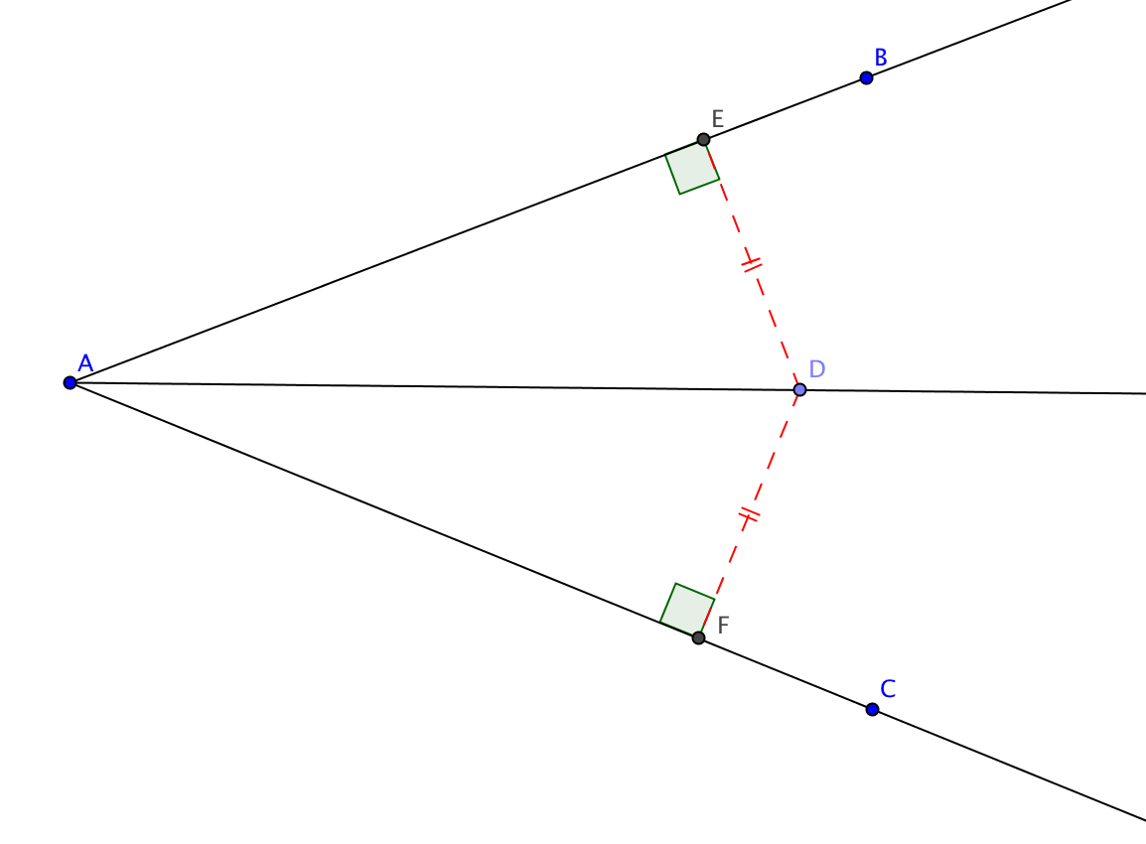

*We’ll use the format of a two-column proof.*

*Fill in the blanks in the proof below:*

**Given: $∠BAC$** with

$\overline{DE}⊥\overline{AB}$

$\overline{DF}⊥\overline{AC}$

*DE = DF*

**Prove: $\vec{AD}$** bisects $∠BAC$

|  |  |
| --- | --- |
| **STATEMENTS** | **REASONS** |
|  | Given |
|  | Given |
| $∠DEA$ and $∠DFA$ are right angles |  |
|  | Given |
|  | Reflexive Property |
| $$∆DEA≅∆DFA$$ |  |
|  | Corr. Parts of Congruent Triangles are Congruent |
|  |  |

1. Now, open the GeoGebra file entitled ctcoregeomACT551b.

In this file, you will notice two rays ( and ) that both form $∠BAC.$

is the angle bisector of $∠BAC$.

*DE* is the *distance from D to* .

*DF* is the *distance from D to* .

1. Now, move point *D* around and notice how it *always stays on bisector of $∠BAC.$*
2. Use GeoGebra to measure the lengths *DE* and *DF*. What do you notice?
3. Repeat step (15), this time paying attention to the lengths *DE* and *DF*. What do you notice as you do this?
4. Our results from step (17) imply that point *D* is always from the of $∠BAC.$
5. Let’s now use what we’ve started with in step (14) and use our conclusion from step (18) to complete

The Angle Bisector Theorem (Part II):

If a lies on the of an , then

it is from the of that angle.

1. Putting our results from questions 10 and 19 together we can say:

The locus of points _______________ from the sides of an angle is the __________ of the angle.

1. Let’s now proceed to formally prove **The Angle Bisector Theorem (Part II)**:

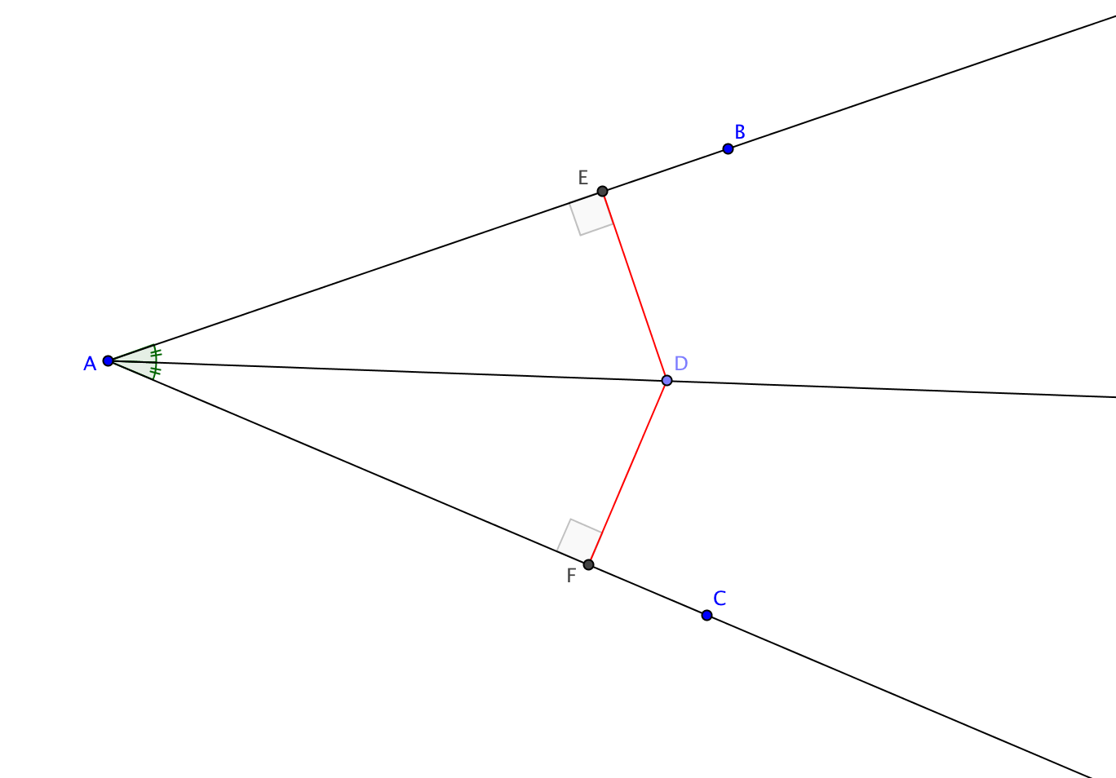

*Use the format of a two-column proof:*

**Given: $\vec{AD}$** bisects $∠BAC$

$\overline{DE}⊥\overline{AB}$

$\overline{DF}⊥\overline{AC}$

**Prove:** *DE = DF*

|  |  |
| --- | --- |
| **STATEMENTS** | **REASONS** |
|  | Given |
| $$∠DAE≅∠DAF$$ |  |
|  | Given |
| $$\overline{DE}⊥\overline{AB}$$ | Given |
| $∠DEA$ and $∠DFA$ are right angles |  |
|  | All right angles are congruent |
|  | Reflexive Property |
| $$∆DEA≅∆DFA$$ |  |
|  | Corr. Parts of Congruent Triangles are Congruent |