Activity 5.4.5 Tangents in the Coordinate Plane
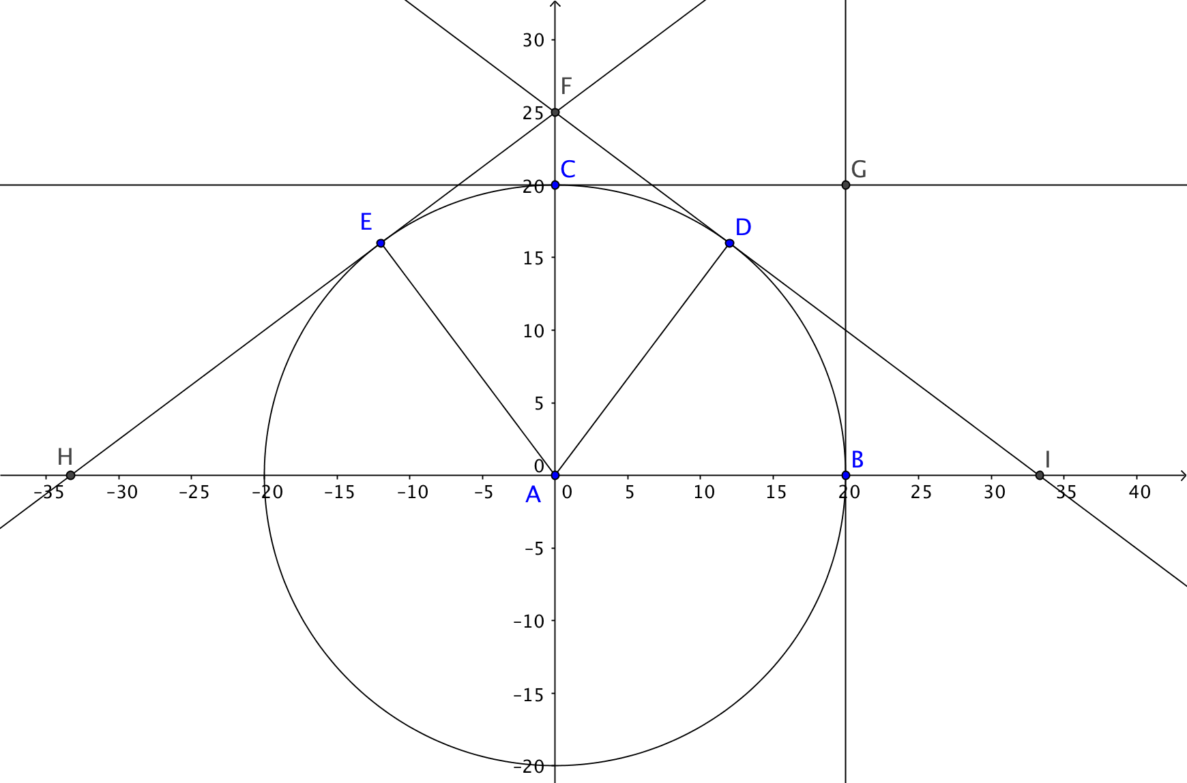

Circle A is centered at the origin with equation ${x^{2}+y}^{2}=400.$

1. Points B, C, D, and E lie on the circle. Their x-coordinates are given. Find the y coordinates.

B(20, _____)
C(0, _____)
D(12, _____)
E(–12, _____)

2. Find the slopes of each of the radii drawn:

Slope of $\overline{AB}$ = ___________ Slope of $\overline{AC}$ = _________
Slope of $\overline{AD}$ = ___________ Slope of $\overline{AE}$ = _________
3. $\overset{⃡}{BG}$, $\overset{⃡}{CG}$, $\overset{⃡}{DF}$, and $\overset{⃡}{EF}$ are tangents to the circle. Find the slopes of each of these tangent lines.

Slope of $\overset{⃡}{BG}$ = ___________ Slope of $\overset{⃡}{CG}$ = _________
Slope of $\overset{⃡}{DF}$= ___________ Slope of $\overset{⃡}{EF}$ = _________
4. What theorem did you use to answer question 3?

5. Find the equations of tangent lines $\overset{⃡}{BG}$ and $\overset{⃡}{CG}$:

Equation of $\overset{⃡}{BG}:$ ____ = 20 Equation of $\overset{⃡}{CG}:$ ____ = 20

6. Find the equations of tangent lines $\overset{⃡}{DF}$ and $\overset{⃡}{EF}.$ (Hint: recall the point-slope form of the equation of a line: $y-y_{1}=m(x-x_{1})$

Equation of $\overset{⃡}{DF}$: Equation of $\overset{⃡}{EF}$:

7. Find the coordinates of point F, the intersection of $\overset{⃡}{DF}$ and $\overset{⃡}{EF}.$

8. Find the lengths of tangent segments $\overline{DF}$ and $\overline{EF}$. What do you notice? What theorem does this illustrate?

