**Activity 5.4.3 Two Theorems Involving Right Triangles**

This activity asks that you show how to use transformations to prove the **Hypotenuse Leg Congruence Theorem:** If two right triangles have congruent hypotenuses and a pair of corresponding legs congruent, then the triangles are congruent.

Given ∆*ADC* and ∆*BEF* have right angles at *D* and *E*. Also *AC* = *BF* and *CD* = *FE*.

We begin with two cases depending on the orientation of the triangles.

1. *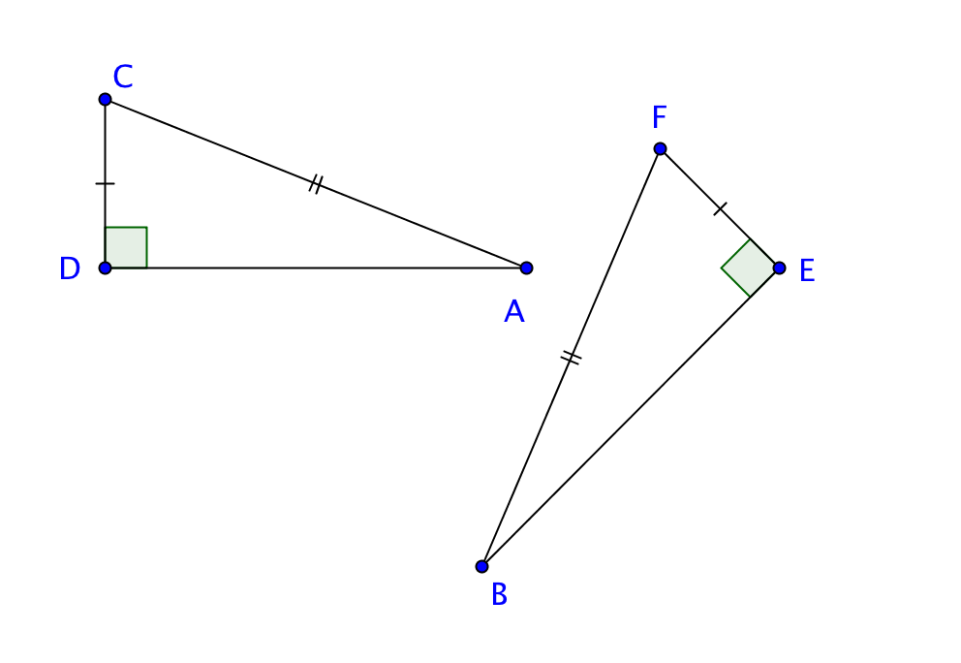Case One* involving only a translation and a rotation. Sketch the required transformations for the steps below:
   1. Use a translation from point *D* to point *E* to move ∆*ADC* so that the image shares a vertex with *E*
   2. Find an angle of rotation so that the image of $\overline{CD}$ lines up with $\overline{FE}$.
2. *Case Two* involving a reflection as well as translations and rotations. Sketch the required transformations for the steps below:

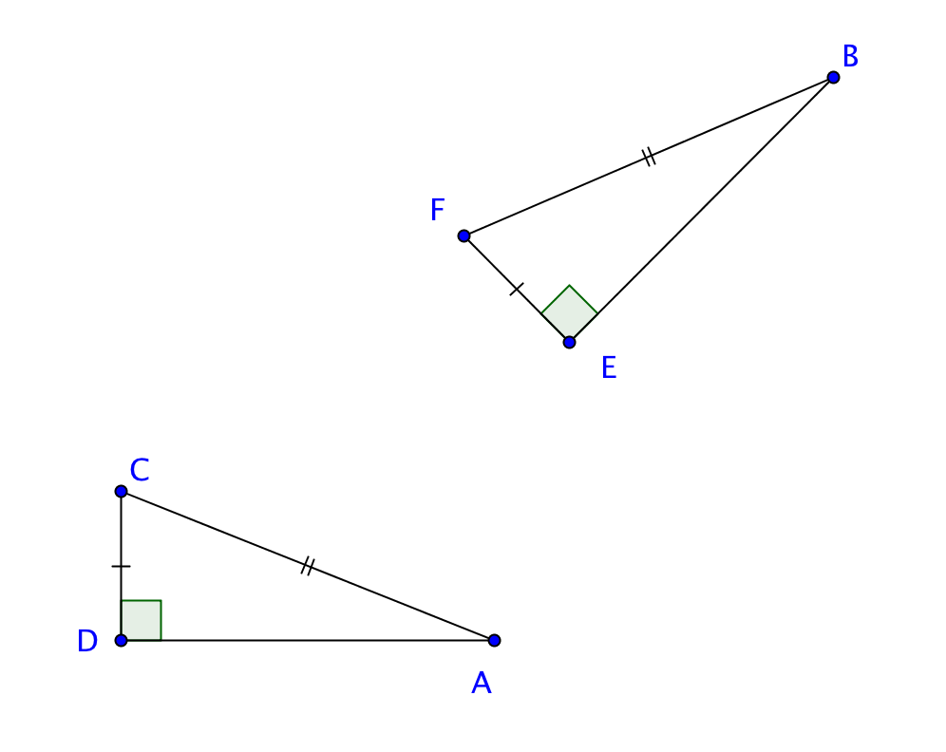

* 1. Use a translation from the vertex of the right angle in ∆*ADC* to the vertex of the right angle of ∆ *BEF* to translate ∆ *DAC.*
  2. Then holding the vertex *D* of the translated vertex of the new triangle, find the angle required to rotate the triangle so that $\overline{CD}$ coincides with *.*

* 1. Use as a mirror line to reflect the triangular image from step b.

1. 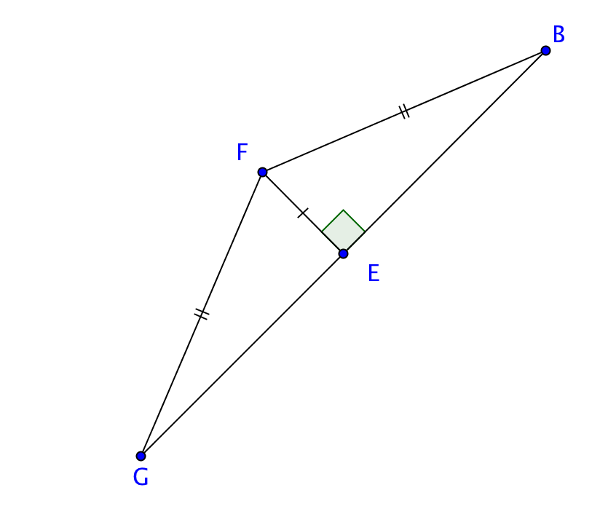Your resulting picture should look something like this:
   1. Why does point *E* lie on ?

* 1. Now we have a new triangle formed. It has two congruent sides $\overline{FB}$ and $\overline{FG}$. Explain why $∠$*FGE* *EBF*.

* 1. We know that in the small triangles the right angles are congruent and that the leg $\overline{FE}$ is now common to both triangles. Why are ∆*GEF* and ∆*BEF* congruent?

We have now proved that if two right triangles have congruent hypotenuses and a pair of corresponding legs congruent, the triangles are congruent. We may abbreviate this as the **HL Congruence Theorem**.

1. Use the marked diagrams below to determine which pairs are congruent by the HL Congruence Theorem. Explain how you reached your conclusion.
   1. Explanation:

  
 b. Explanation:

  
  
  
 c. $\overset{⃡}{CA}$ and $\overset{⃡}{ED}$ are both tangent to the smaller circle.   
   
 Explanation:



d. $\overset{⃡}{DA}$ and $\overset{⃡}{DC}$ are both tangent to the circle.

Explanation:

1. Part (d) above suggests a new theorem**:** If tangents are drawn to the same circle from a point outside the circle, then the segments joining the points of tangency to the point outside the circle are _________________.This theorem is called the **Tangent Segments Theorem.**
   1. Draw a sketch of the situation. Label the center of the circle, the point outside the circle, and the points of tangency.

* 1. Indicate what is given and what is to be proved in terms of your labeled diagram.

* 1. Complete the proof here: