Activity 5.3.1 Radians and Degrees
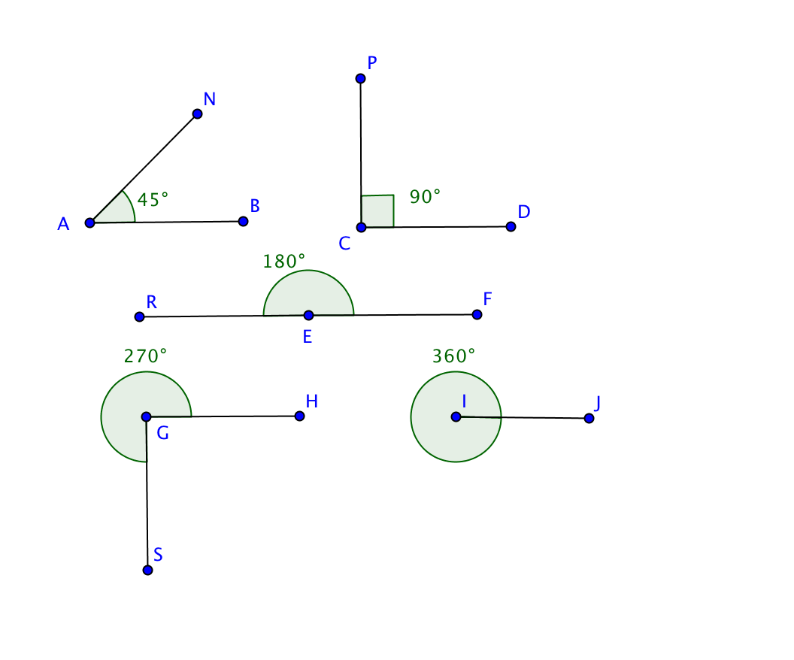
You are used to measuring angles in degrees. Another unit of angle measure is called a radian. This activity explores the relationship between degrees and radians.

- Open the file ctcoregeomACT531.gbb. Observe the five angles shown:

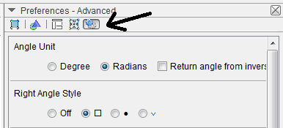
- From the View menu, select Algebra to reveal the Algebra Panel on the left side of the screen. Double click on the angle in the algebra window to select Object Properties. Look above the panel for the Properties of Angle α. You will see five buttons. Choose the rightmost button that looks like the one at the farthest right side.

- Click on Radians to convert from degrees to radians. Notice that the 45° angle measures approximately 0.79 radians, and that 180° = π radians. Record the other radian measures in the table below, both in terms of π and as decimal approximations.

Angles Measure in Degrees | Radians (decimal approximation) | Radians (in terms of π)
45° | 0.79

90°
180° |  | π

270°

360°

- Examine the results of your table and work with a partner to come up with an equation that relates degree measure to radian measure.

- Use your equation to convert the following angle measures to radian measures:

a. 30° b. 60°

c. 120° d. 75°

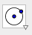
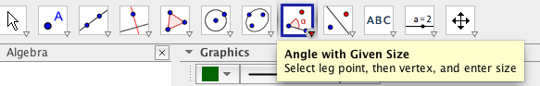
- A simple definition for a radian is: the measure of an angle at the center of a circle that intercepts an arc whose length is equal to the radius of the circle.
To visualize scroll down in the Geogebra file to find points K and L. Use the Angle with Given Size Tool in Geogebra to create a 1 radian angle with vertex K and side $\overline{KL}$, by typing “1 rad” in the window that asks for angle size.
Now draw a circle with Center K passing through point L. Draw segments $\overline{ KL }$and $\overline{KL’}$ to show radii of the circle.
- According to the definition of radian, the length of radius ______ should equal the length of the arc from point ____ to point ___.
- Now draw segment $\overline{LL'}$. Is ∆KLL’ equilateral? Explain your reasoning.

- Based on what you have observed in questions 6-8, explain why 1 radian must be slightly less than 60°.

- Follow the procedure used in question 2 to convert the angle measures back into degrees. Notice the degree measure of the angle named$γ$ (gamma).
Fill in the blank: 1 radian ≈ _______°.

11. Convert the following radian measures to degree measures:

a. 0.67 b. 0.5

c. 0.9 d. 1.31

