Activity 5.2.6a Circumscribing a Circle about a Triangle

Vocabulary
Concurrent lines –3 or more lines that intersect in a single point.
Point of concurrency – The point where concurrent lines intersect.

Part 1: Properties of the circumcenter of a triangle
Points A, B and C can be connected to form ∆ABC .  Given ∆ABC, the circumcenter is a point that has the following properties listed below | 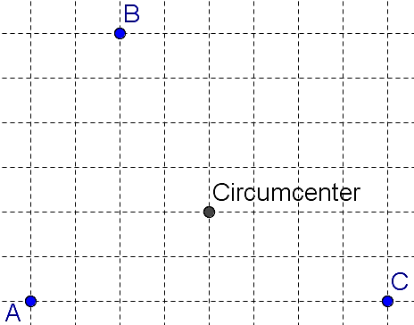
DEFINITION  The circumcenter is the center of the circle that passes through points A, B, and C. We say that the circle is circumscribed about the triangle. | 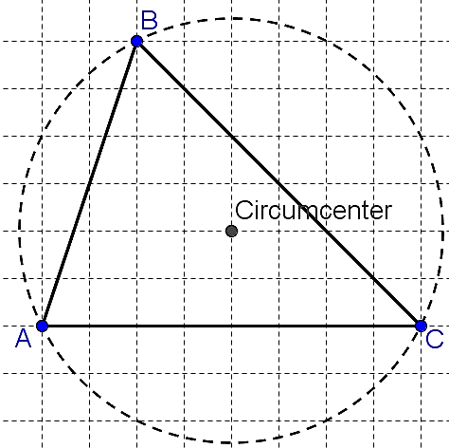
PROPERTY #1  The circumcenter is the point of concurrency of the perpendicular bisectors of the sides of the triangle. (The existence of this point is proved in part 6, below.) | 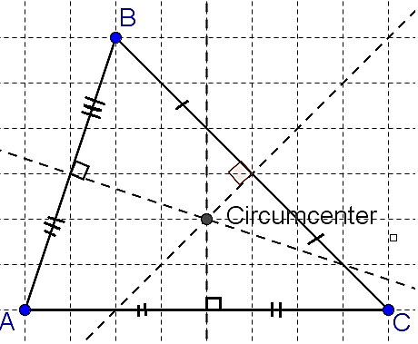
PROPERTY #2  The circumcenter is equidistant (the same distance) from points A, B, and C. | 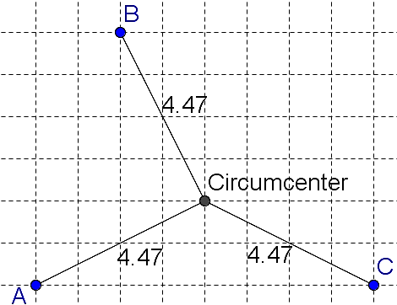
Part 2: Using constructions to understand the properties of a circumcenter
Use a compass and straightedge for these exercises.

How to construct the circumcenter of ∆ABC:

Construct the perpendicular bisectors of $\overline{AB, }\overline{BC}$ and $\overline{AC}$.
The point in which the three lines intersect is the circumcenter. Name this point X.

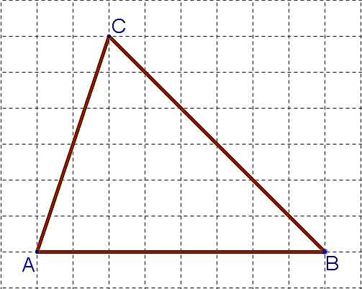
- Construct the circumcenter of an acute triangle.

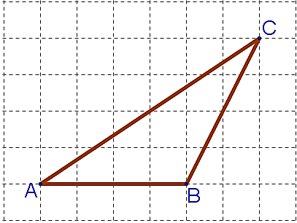
- Construct the circumcenter of an Obtuse triangle.

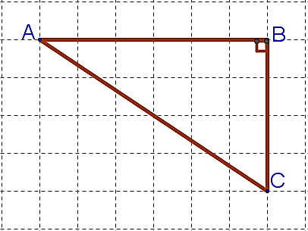
- Construct the circumcenter of a right triangle.

- What did you notice about the different locations of the circumcenters?

Part 3: Understanding Property #1 of a circumcenter

- Draw a circle, with center X and radius $\overline{XA},$ around the triangle acute triangle from
question 1. If done correctly, the vertices of the triangle lie on the circle. This is called the circumscribed circle (or sometimes “circumcircle.”)

- Name three radii of the circumscribed circle.

- Circumscribe a circle, with center X and radius $\overline{XA}$, about the triangles in questions 2 and 3.

- Explain why you only need to use the perpendicular bisector of two sides to find the center of the circle.

Part 4: Understanding Property #2 of a circumcenter

- Using the acute triangle from question 1, find the distance from the circumcenter to each vertex. Round to the nearest tenth of a centimeter.

AX = ________ BX = ________ CX = ________

- Using the obtuse triangle from question 2, find the distance from the circumcenter to each vertex. Round to the nearest tenth of a centimeter.

- Using the right triangle from question 3, find the distance from the circumcenter to each vertex. Round to the nearest tenth of a centimeter.

- Why does the definition (The circumcenter is the center of the circle that passes through each vertex in a triangle) explain why the distance from the center to each vertex has to be the same?

Part 5: Applying what you learned
Point G is the circumcenter of ΔABC. List any segment(s) congruent to each segment below.  (Not all segments are shown on the figure.)  - $\overline{AE}$  - $\overline{AG}$  - $\overline{BD}$  - $\overline{CF}$ | 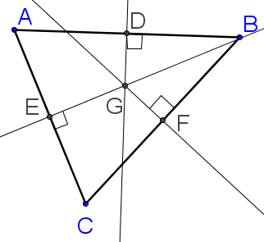

Error analysis: In the picture below, point G is the circumcenter. Explain why the student’s conclusions are false. Then state the correct conclusion that can be drawn

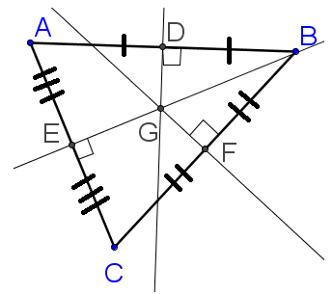

- ΔABC is an obtuse triangle

- $\overline{GD}≅\overline{GE}≅\overline{GF}$

- $\overline{BD}≅\overline{BF}$
Background: Many people forget that in November 1998, the New England Patriots signed an agreement with the governor of Connecticut to move the team from Massachusetts to the Nutmeg State. Unfortunately, the team backed out of the deal when the state of Massachusetts kicked in $70 million in highway improvements, NFL Loan guarantees, and commitments for luxury suits for Boston businesses.
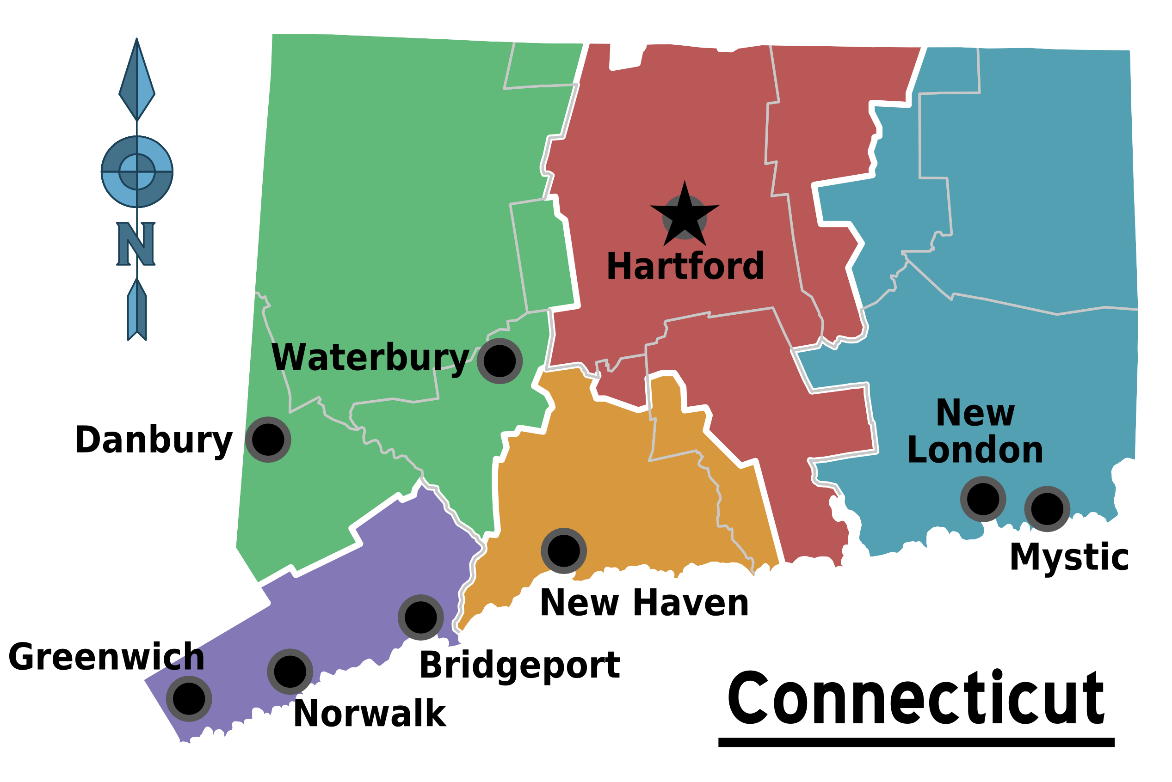
http://wikitravel.org/en/Connecticut

- In case a team does decide to come to Connecticut, you have been given the task to find the location of a brand new stadium. This stadium should be equidistant from three major cities. Choose any three cities on the map. (a) List them below and (b) connect the cities on the map by drawing a triangle.

- The building planners found the circumcenter of the triangle formed. Explain why using the circumcenter as the location of the stadium would be convenient for all the cities.

- Find the location of the stadium on the map. Explain the steps you took.

- How can you tell from the location of your stadium whether your three cities form a right, acute or obtuse triangle?

- Is the stadium located inside or outside of Connecticut?
Part 6: Proof

- Prove that the perpendicular bisectors of the sides of a triangle are concurrent.

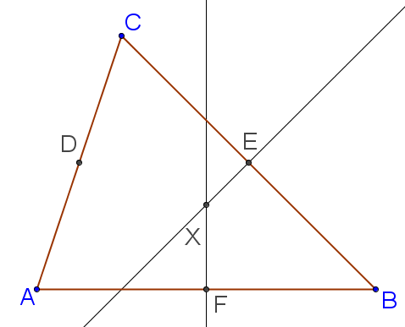
Given: ∆$ABC$
$\overset{⃡}{XE}$ is the perpendicular bisector of $\overline{BC}$
$\overset{⃡}{XF}$ is the perpendicular bisector of $\overline{AB}$

Prove: X lies on the perpendicular bisector of $\overline{AC}$. (Thus the three perpendicular bisectors are concurrent at X.)

