Activity 5.2.4 Radii and Chords
Definitions
- A chord of a circle is a geometric line segment whose endpoints both lie on the circle. Not all chords are the same length
- A diameter of a circle is any chord that passes through the center of the circle. All diameters in the same circle are equal in length.
- The radius of the circle is a line segment in which one endpoint is the center of the circle and the other endpoint is on the circle. All radii of the same circle are equal in length.

In the picture to the right, point C is the center of the circle. Use circle C to answer the following questions.  - Name 2 chords drawn in the circle  - Name 1 diameter drawn in the circle  - Name 6 radii in the circle (not all are drawn)  - Name 6 segments that are congruent to each other. | 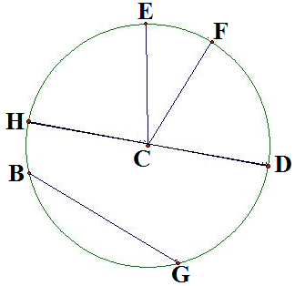
For Questions 5 through 9 you will need a compass and straightedge.

- On the grid provided to the right, draw circle with center A whose radius is 5 units.

- Draw a chord in circle A

- Construct the perpendicular bisector of the chord. Make sure the perpendicular bisector passes through both sides of the circle.

- Make a conjecture by completing this sentence: The perpendicular bisector of a chord in a circle passes through the ________________________ of the circle.

- Draw a second chord and its perpendicular bisector. Does it also pass through the center of the circle?

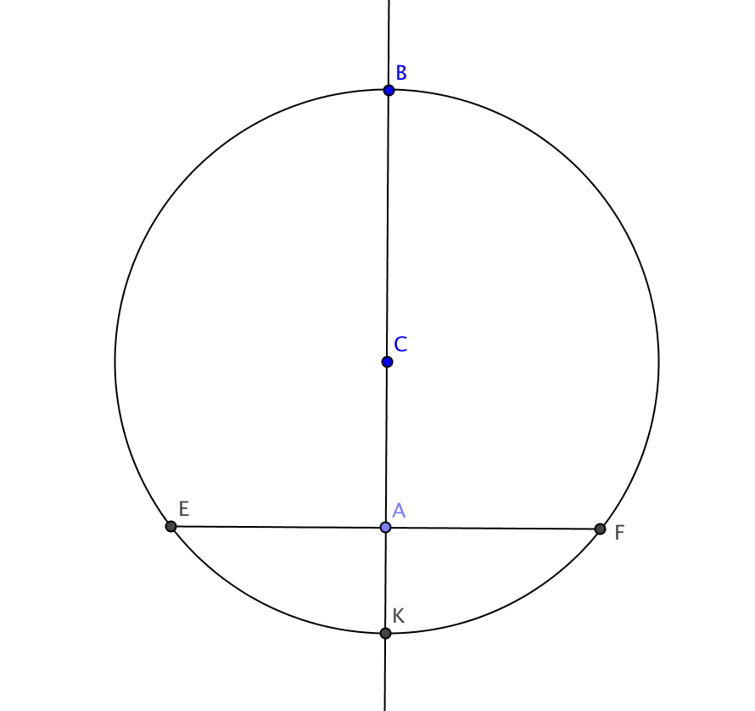
- Prove the Perpendicular Bisector of a Chord Theorem: The perpendicular bisector of any chord of a circle passes through the center.

Given: In circle C, $\overset{⃡}{BK}$ is the perpendicular bisector of chord $\overline{EF}$

Prove: C lies on $\overset{⃡}{BK}$

(Be careful with appearances – you don't know that $\overset{⃡}{KB}$ passes through C, although it certainly appears to. That's what you're trying to prove.)

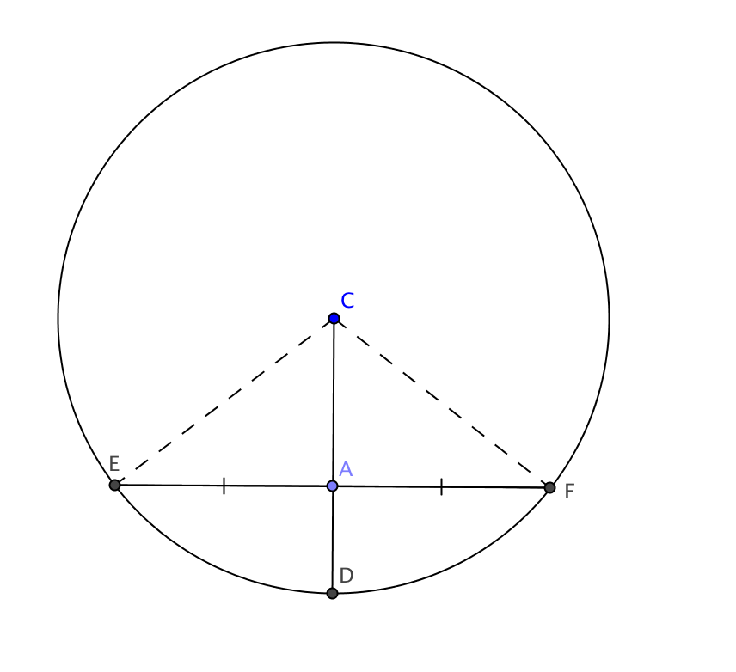
11. Prove the Radius Chord Midpoint Theorem: If a radius of a circle bisects a chord (that is not a diameter), then it is perpendicular to the chord.

Given: Circle C with radius $\overline{CD}$ intersecting chord $\overline{EF}$. A is the midpoint of $\overline{EF}$ and A lies on $\overline{CD}$.

Prove: $\overline{CD}$ $⊥$ $\overline{EF}$

(Hint: Draw radii $\overline{CE}$ and $\overline{CF}$ and prove two triangles are congruent.)

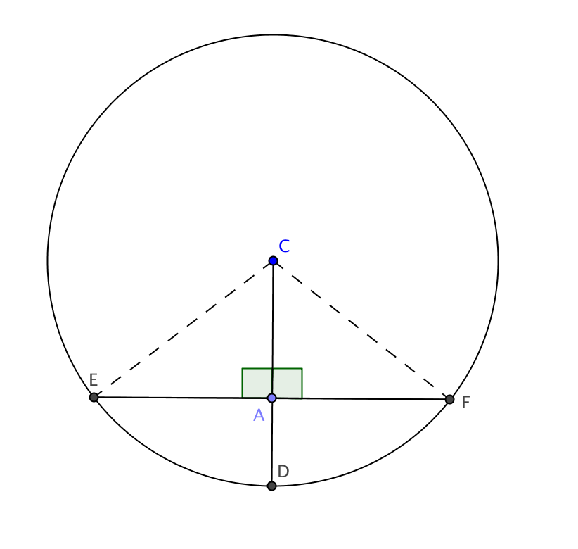
12. Prove the Radius Chord Midpoint Converse: If a radius of a circle is perpendicular to a chord then it bisects the chord.

Given: Circle C with radius $\overline{CD}$ perpendicular to chord $\overline{EF}$ at A.

Prove: A is the midpoint of $\overline{EF}$

(Hint: Draw radii $\overline{CE}$ and $\overline{CF}$. Then ∆CEF is isosceles.)

