Activity 5.2.3 Chords and Perpendicular Bisectors in a Circle

Definitions
- A chord of a circle is a geometric line segment whose endpoints both lie on the circle. Not all chords are the same length
- A diameter of a circle is any chord that passes through the center of the circle. All diameters in the same circle are equal in length.
- The radius of the circle is a line segment in which one endpoint is the center of the circle and the other endpoint is on the circle. All radii of the same circle are equal in length.

PART 1: The perpendicular bisector of any chord of a circle

- Open a new Geogebra document
- Draw a circle
- Press the “Circle with Center through Point” icon.
- Draw a chord
- Press the down arrow of the “Line” icon. 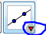
- Click on the “segment” option.
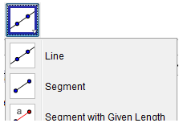
- Click on any two point on the circle to draw a chord.

- Draw the perpendicular bisector of the chord.
- Press the down-arrow button on the bottom right of the “Perpendicular Line” icon. 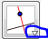
- Click on the “Perpendicualar Bisector” option
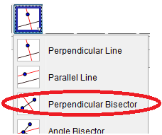
- Click on the chord you just drew

- Draw another chord and a perpendicular bisector of the new chord
- Follow the directions from steps 3 and 4.
- What did you notice?
- Drag the center of the circle
- Drag endpoints of the chords
- The perpendicular bisector of any chord in a circle passes through the _________ _________________________________________________________________

PART 2: A line passing through the center and perpendicular to a chord

- Open a new Geogebra window
- Draw a circle
- Press the “Circle with Center through Point” icon.
- Draw a chord
- Press the down arrow of the “Line” icon.
- Click on the “segment” option.
- Click on any two point on the circle to draw a chord.
- Draw a line perpendicular to the chord that passes though the center of the circle.
- Press the “Perpendicular Line” icon. 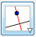
- Click on the chord and then
- Click on the center of the circle.
- Plot a point at the intersection of the chord and perpendicular line.
- Press the down-arrow button on the Point icon.
- Click on the “Intersect” option
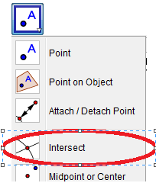
- Click once on the chord and once on the perpendicular bisector.
- Measure the length from the endpoints of the chord to the intersection
- Find the length of the radius by clicking the down-arrow of the Angle button 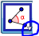
- Select “Distance or Length” button
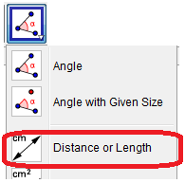
- Click on the intersection point and then on one endpoint of the chord
- Click on the intersection point again and then on the other endpoint of the chord.

- What did you notice?
- Drag the center of the circle
- Drag endpoints of the chords
- A line that passes through the center of a circle and is perpendicular to a chord… _________________________________________________________________

PART 3: If two chords are congruent

Visit the website: http://www.geogebra.org/student/m33124

You can change the lengths of chords $\overline{CD}$ and $\overline{EF }$by dragging either endpoint. Observe the effect on the distance from A to the midpoint of each chord.

- What relationship do you observe as the length of a chord increases? How about when the chord length decreases?

2. What is observed when the chords are congruent?

